

**ELD**

**User Manual**

Rev 1.2

October 2017

**POC: Ron Smith**

Information contained in this document is proprietary to ISR. This information must not be disclosed to any person or organization without the prior approval from an authorized ISR representative.

# General

ISR's Electronic Logging Device (ELD), model # HOS100, is an in-cab device that records critical data on vehicle movement, driving events and driver status. Data is collected, inter alia on hours of service (HOS), speed, engine runtime and idle time. Collected data can be exported to external devices as required for law enforcement spot inspections, and is sent to a back-office database where it can easily be retrieved, reviewed and processed on the computer.

# Login

As soon as the ELD is powered on, the following LOGIN screen is displayed.

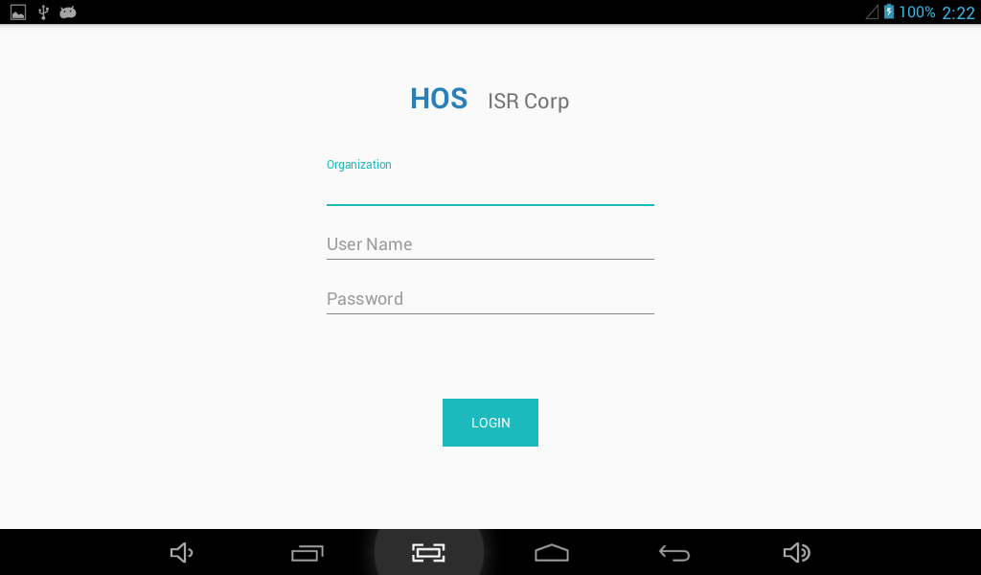

* Using the touch-screen, click on the active **Organization** field; the tablet keyboard appears.
* Enter the organization name as provided by your supervisor, then press the **Next** key; the **User Name** field then becomes active.
* Enter the user name that was provided by your Supervisor; the **Password** field is now active.
* Enter the password as provided by your Supervisor, then press **Done**; wait until login data is processed (several seconds); If the user is registered as a driver, the Dashboard screen appears. Otherwise (for Support Personnel or other Authorized users) see the section on Support Personnel Screens.

# Dashboard

The main Dashboard screen displays user information and all available options. To the right of the central Driver Status button, your current user name (as entered during login) and vehicle name directly underneath.

Trailer Name (up to three trailers can be entered simultaneously) and shipping document no. will appear to the extent that they were entered during the current login session.

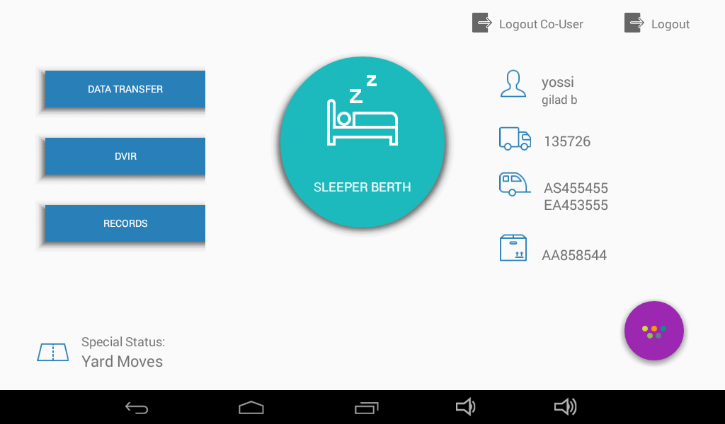

Menu Options

Your personal info

Driver Status button

Available Options

Increase volume

Decrease volume

Minimize/Maximize

Home Page

Return to previous screen

# Selecting Driver Status

When user logs in, HOS defaults to **Off-Duty**.

* Click on the Driver Status button to display available status options; the following options appear:   
    
  Driving, Sleeper Berth, On Duty Not Driving.
* Select desired option; the Driver Status button on the main Dashboard screen will reflect your choice.

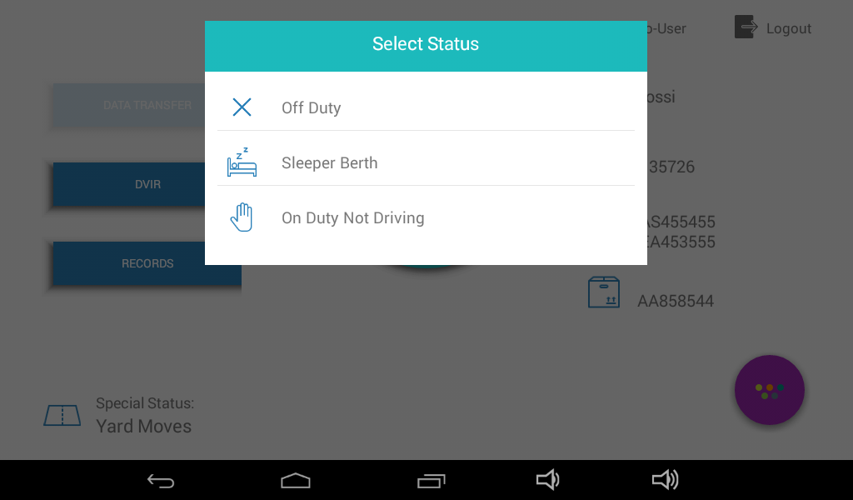

**In the above-displayed screen capture, the current status is Driving and therefore, the available status options are Off-Duty; Sleeper Berth; On Duty Not Driving.**

For every change in Driver Status, the ELD records the following details:

Date; Time; CMV geographic location information; Engine hours; Vehicle miles; Driver or authenticated user identification data; Vehicle identification data; and Motor carrier identification data.

# Select Special Status

Special Status is used when you want to change the way your ELD records movements and events. For example, when you are using the vehicle for personal use or for yard moves, GPS positions are reported less frequently.

* Click on **Special Status** at the bottom left corner of the main Dashboard screen; the following options are displayed:   
  None, Personal Use, Yard Moves.
* Choose the desired option; you will be prompted to enter a comment regarding the selected option, if you chose either **Personal Use** or **Yard Moves**.
* Type in your comment using the keyboard, then choose **Done**; the comment will be recorded in the database and the selected Special Status will appear on the main Dashboard screen.

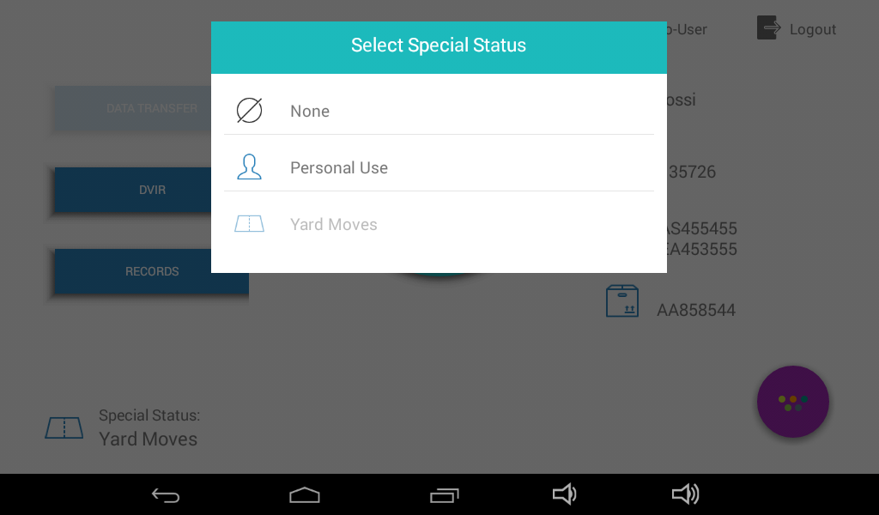

Here too, for every change in Special Status, the ELD records, along with the user-entered comment, the following details:

Current date; time; CMV geographic location information; engine hours; vehicle miles; driver or authenticated user identification data; vehicle identification data; and Motor carrier identification data.

# Edit Vehicle

The Edit Vehicle option enables the user to enter vehicle information such as license plate. The vehicle name and VIN are read from the SPM unit to which the ELD is connected, and cannot be edited on the ELD. In a situation where the ELD unit is transferred to a different vehicle, the Vehicle Name (also referred to as Power Unit Number) and the VIN are filled in automatically. The Edit Vehicle option allows the user to enter the license number of the vehicle.

The current vehicle name appears on the main Dashboard screen, on the right side, in the Personal Information section.

* Click on the vehicle icon; the Edit Vehicle screen appears.
* At the flashing prompt, type in the license plate number, then press **Done** on the keyboard.

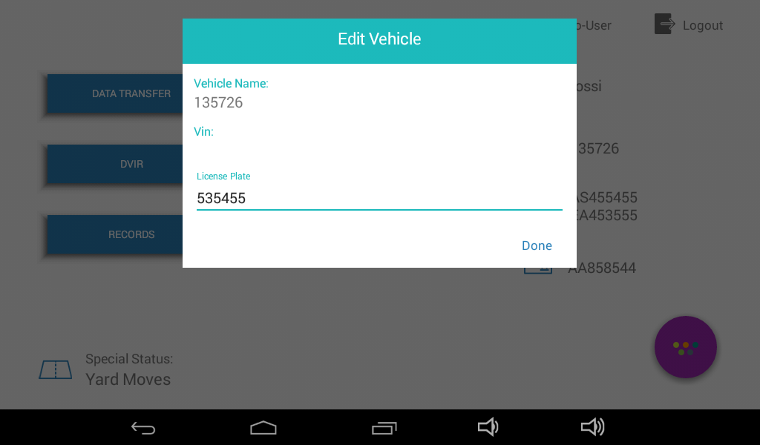

# Manage Trailers

The trailer information appears on the main Dashboard screen, on the right side, in the Personal Information section. The trailer icon is third from the top.

* Click on the trailer icon; the Manage Trailers screen appears.
* Click on **Trailer Name**; the keyboard appears.
* At the flashing prompt, type in the trailer ID, then press **Done**; the trailer name as entered will appear alongside the trailer icon on the main Dashboard screen.
* To enter additional trailer IDs (up to three total), press **Add** instead of **Done**, in the step above, then enter the second trailer ID.
* Edit the trailer name by clicking on the **X** to the right of the current name, then edit the name.
* Press **Done** to complete the editing and return to the main Dashboard screen.

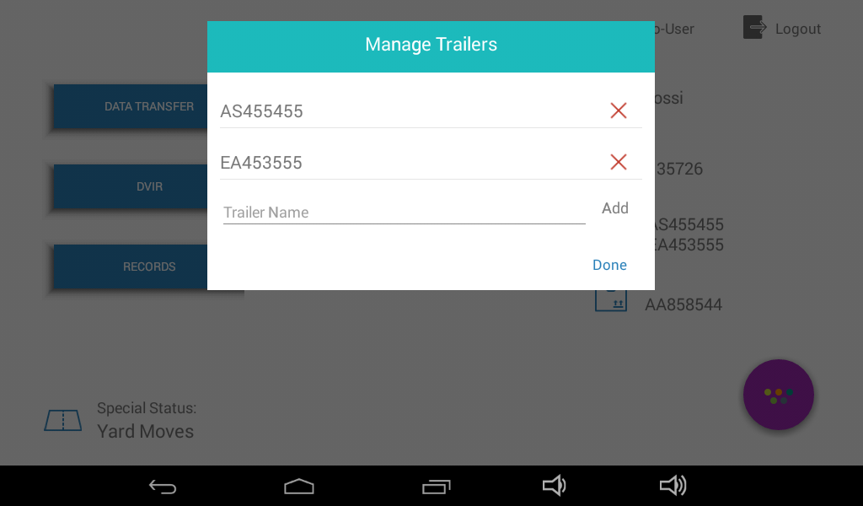

# Edit Shipping Document Number

The Shipping Document information appears on the main Dashboard screen, on the right side, in the Personal Information section. The Shipping Document icon is fourth from the top.

Only one shipping Document will appear on the screen. Previously entered documents will be saved to the database.

* Click on the Shipping Documents icon; the Shipping Document Number screen appears.
* At the flashing prompt, type in the name of the current Shipping Document, then press **Done**; the name you entered now appears alongside the shipping document icon.

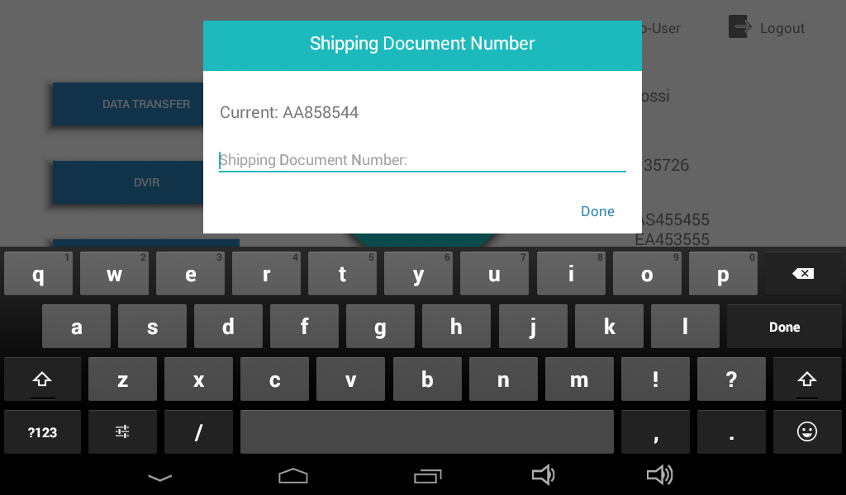

# Menu

On the main Dashboard screen, click on the Menu Options button in the lower right side; five menu buttons appear on the screen.

The menu options are as follows. Pressing a menu button will invoke these results:

* Shipping: Displays the Shipping Document Number screen;
* Records: Displays the Records screen, as will be described later on. On this screen you can view existing records (in List or Summary form), add new records or certify existing records.
* New Record: Displays the New Record screen, as will be described later on.
* Exception:
* Unidentified Records: Displays records that are "unidentified" if such records exist for the current day. Unidentified records are those records that represent automatic events (instigated by ELD) that occurred after power-on of the ELD but prior to driver login.
* Click on Menu Options button to return to main Dashboard screen.

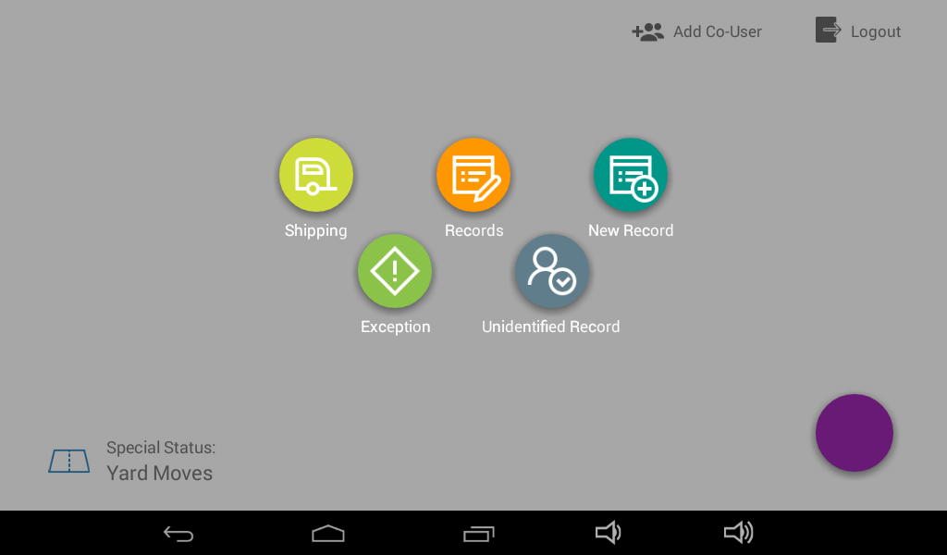

# Co-Driver Login

More than one driver can be registered during any given login. The Co-Driver (sometimes appears as Co-User) option appears at the top of the main Dashboard screen. Driver must be an authorized driver, as determined by Drivers list.

* Click on Co-Driver icon; the co-Driver screen appears.
* Enter user name and then password for added driver, then press **Done**; if an authorized driver name was entered, the name will appear on the main Dashboard screen. Otherwise, you will receive a **Login Failed** message.

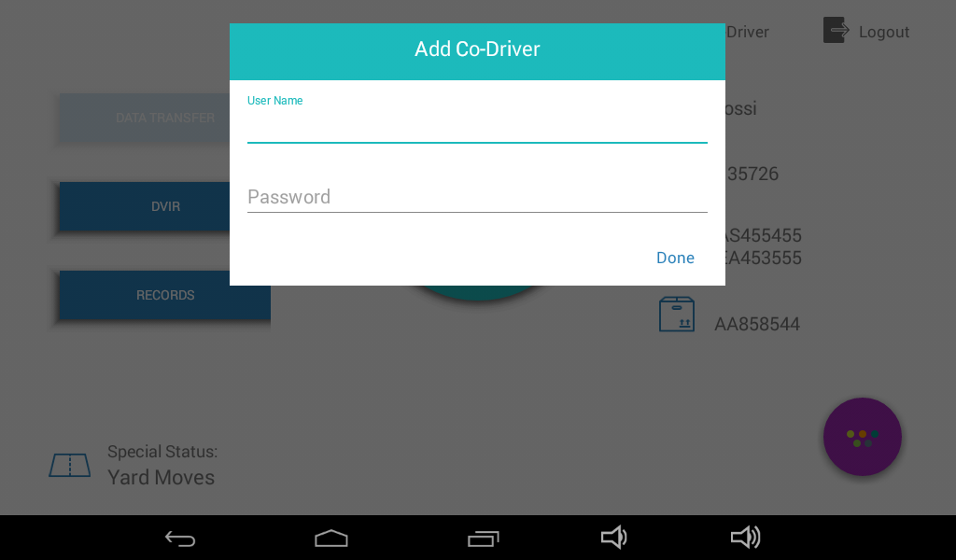

# Data Transfer Using USB

Data transfer from ELD is typically used for spot inspections by law enforcement personnel, where user is asked to produce data logged by the ELD. The USB device is connected to the USB port situated to the right of the ELD power cable on the tablet. User does not select the data to be transferred. When the **Data Transfer** option is selected, and the following steps are completed, all records for the current driver accumulated over the past seven days will be transferred to the selected media.

* On the main Dashboard screen, choose **Data Transfer**; the Data Transfer options appear.  
    
  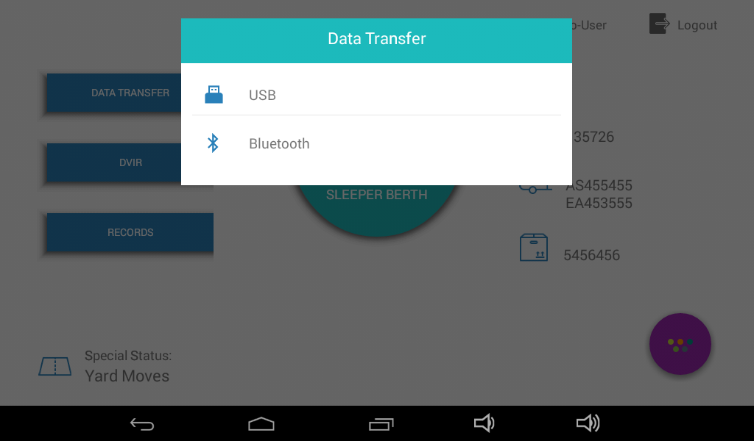
* Choose **USB** or **Bluetooth** depending on which option is currently available; you will be prompted for your password.  
    
  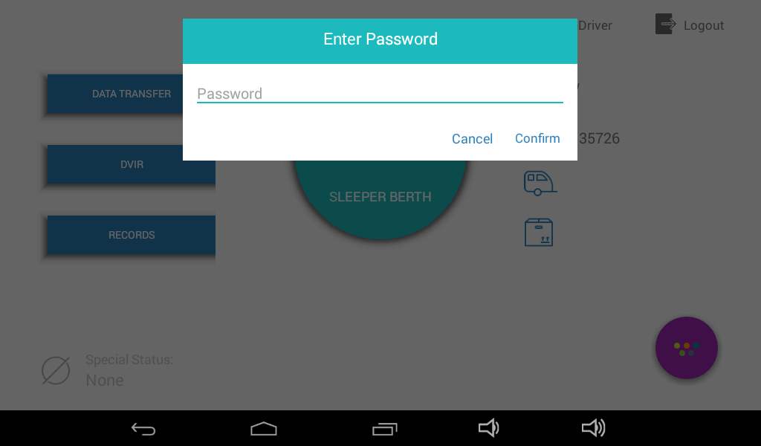
* Enter your password and then choose **Cancel** to return to main screen or **Confirm** to continue.
* If you chose **Confirm,** you will be prompted to enter a comment.  
    
  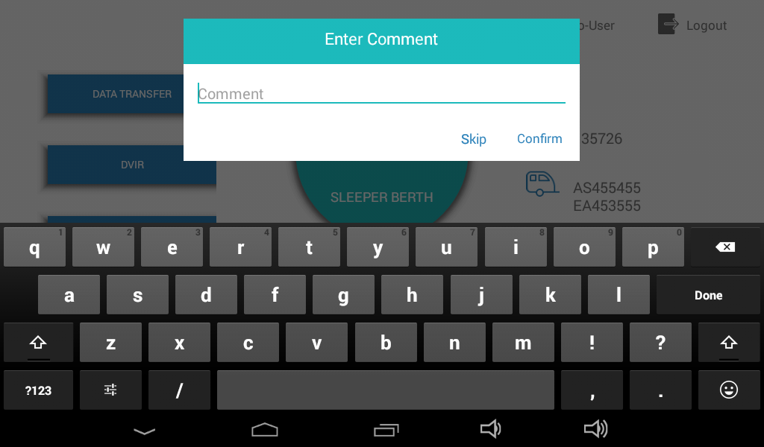
* Choose **Skip** if you do not wish to enter a comment, or type in a comment using the displayed keyboard at the flashing prompt.
* Click on **Confirm**; the ELD searches for the selected device, and then transfers the data. Data contains records associated with the current driver for the past seven days.

# DVIR

The DVIR option on the main Dashboard screen allows the user to conduct and log a Driver Vehicle Inspection Report.

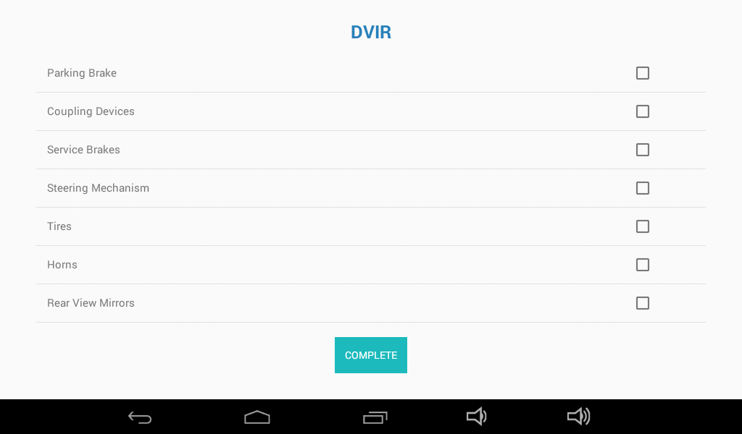

# Records

The **Records** option appears on the main Dashboard screen. Records are details of any one of the following types of events. Events are either ELD or driver invoked, as detailed below. For each event, the ELD will automatically associate the record to the driver, the vehicle, the motor carrier, and the shipping document number. Additionally, the following details are automatically logged by ELD:

* **Event Sequence ID Number** (assigned to record on the ELD database. You will not see this number on the screen).
* Event Record Status- **Active** or **Inactive** (assigned to record on the ELD database. You will not see this status on the screen).
* Event Record Origin
* Event Type
* Event Code
* Timestamp
* Accumulated miles
* Engine hours
* Location (Latitude/Longitude coordinates)
* Distance Since Last Valid Coordinates
* Driver's Location Information (Geo-coded address)

The defined events include:

Change in Driver’s Duty Status – invoked by driver, as described above

Intermediate Logs – invoked by ELD after an hour has passed with no status change

Change in Special Status- invoked by driver

Driver’s Certification of Own Records- prior to Logout, driver must certify his records. This event is logged.

Driver’s Login/Logout Activity- Driver's login or logout.

CMV’s Engine Power Up and Shut Down Activity- reported by ELD

ELD Malfunction and Data Diagnostics Occurrence- reported by ELD including malfunction code.

* Click on **Records** to display a list of the existing records.
* Click on a record from the list to display the record details.

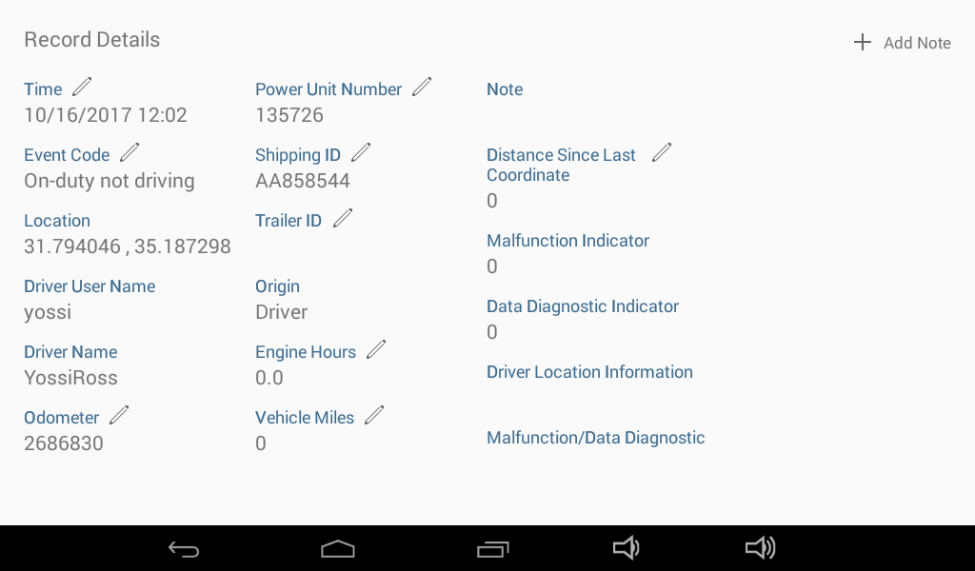

User can add a note to an existing record. The note next is saved along with the record.

* Click on **Add Note** at the top right corner of the **Record Details** page.
* The flashing cursor enables you to type in your text using the displayed keyboard. If the cursor is not flashing, click on the word **Comment** to activate the cursor.
* Click on **Done** to complete the action.  
    
  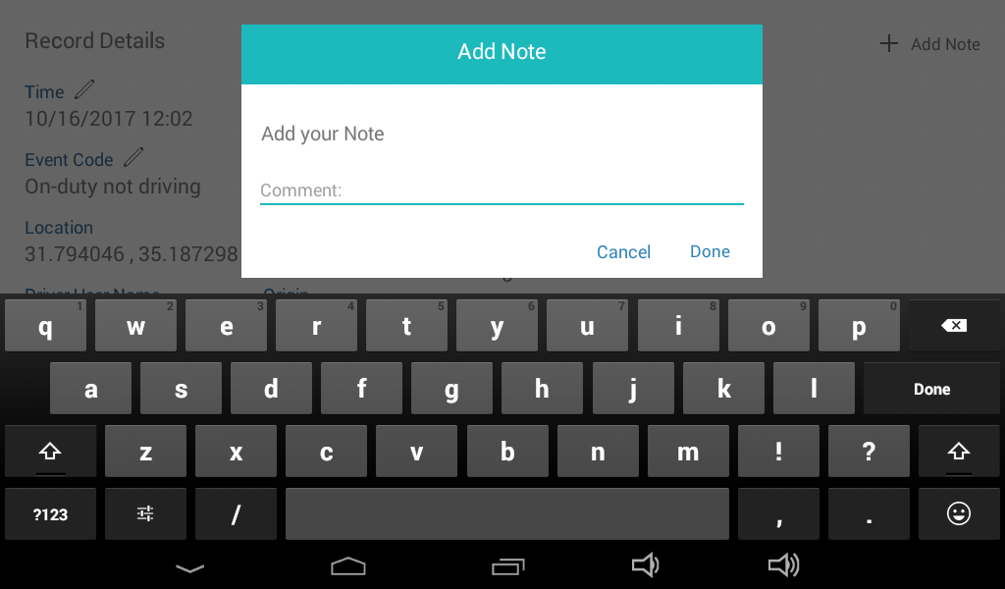

## New Manual Record

When driver enters data for a new event or edits an existing event, all editable fields appear with a pencil icon adjacent the name of the field. All other fields, where available, are automatically filled in by ELD.

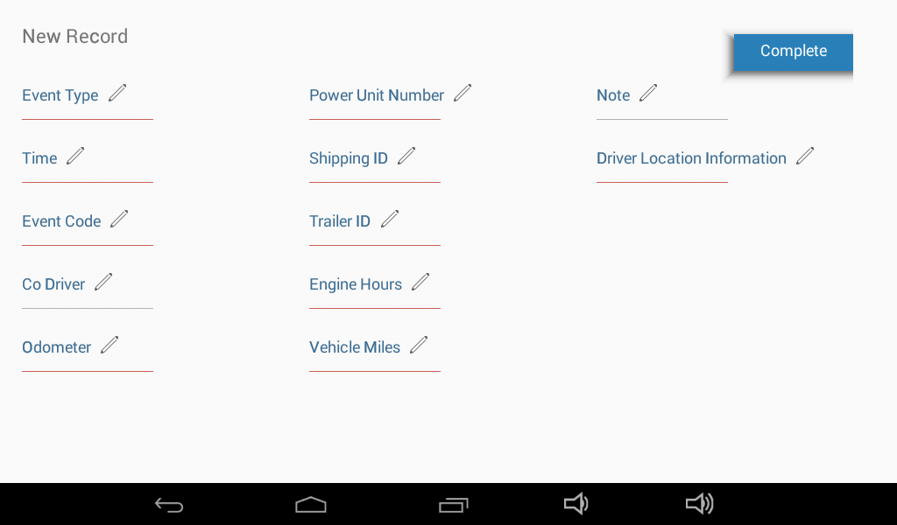

# Editing Existing Record

The following section describes how the user can edit any one of the editable fields.

* On the Record Details page, click on **Time**; the calendar display appears, defaulting to the current date.   
    
  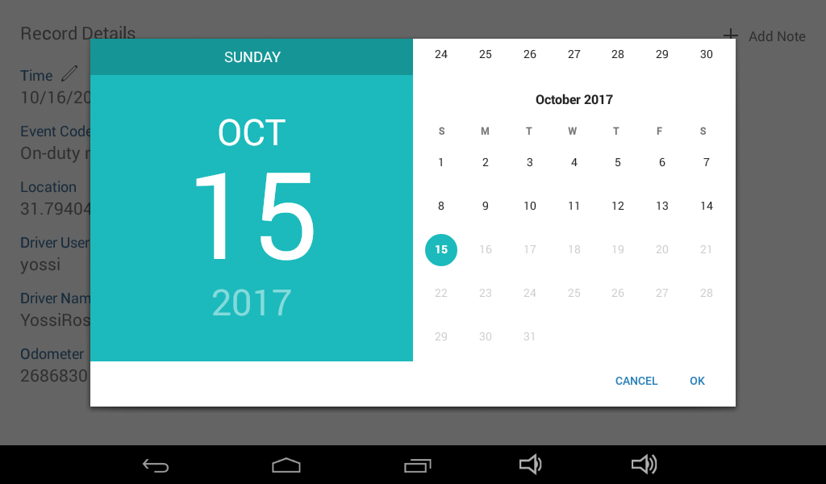
* On the right side of the display, scroll down to display previous months.
* Click on a day of the month; the selected date appears on the left side of the display.
* Click on **OK**; a clock display appears, allowing you to enter a precise time of the day. The display defaults to the current time.
* Click on an hour on the clock's face to change the hour; the hour you selected is displayed and the seconds display appears.
* Click on the desired seconds value and then click on **OK.**
* User is prompted to enter a comment. Enter a comment then **Done** or choose **Cancel**.
* The new timestamp appears on the record details page.

## Edit Event Code

* Click on **Event Code**; the Event Code options appear.
* Click on an option to select it; you are prompted to enter a comment.
* Enter a comment then **Done**, or choose **Cancel**.

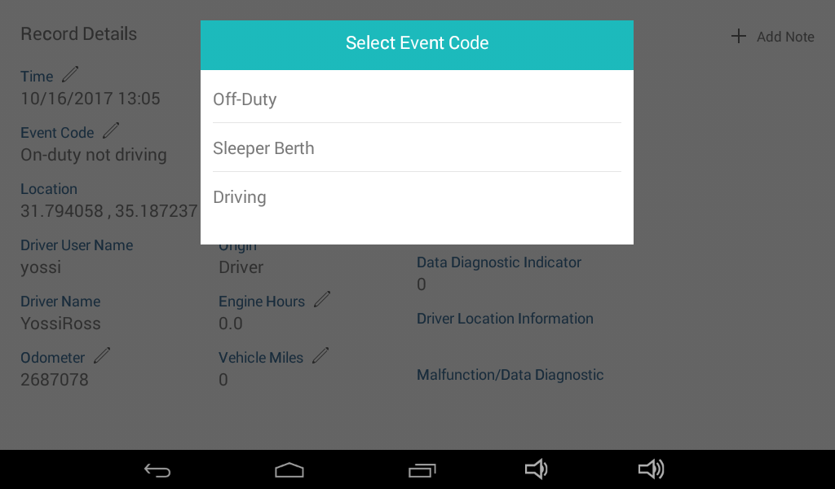

## Edit Odometer

* Click on **Odometer**; the current odometer reading appears.
* At the flashing odometer, use the number pad to enter the desired value. The entered value must exceed the current value. Click on **Done**.
* Enter a comment then **Done**, or choose **Cancel**; the odometer value is replaced.

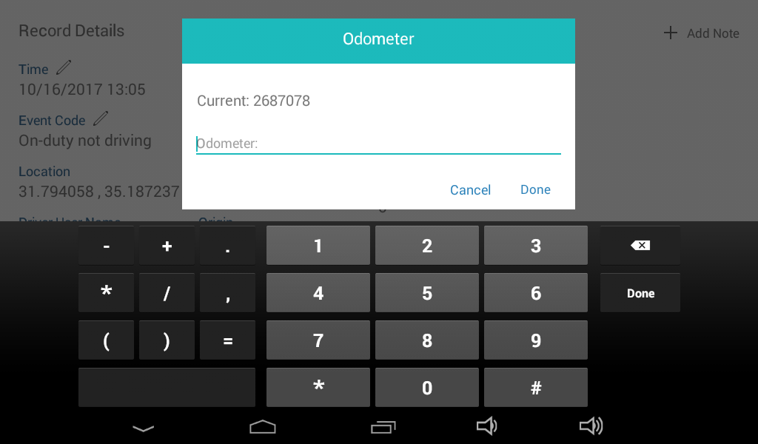

## Edit Power Unit Number

The power unit is the ISR processing unit that is connected to the tablet in the vehicle. This value is obtained automatically and typically will not be edited. In cases where it is necessary to edit a historical record, this option is available.

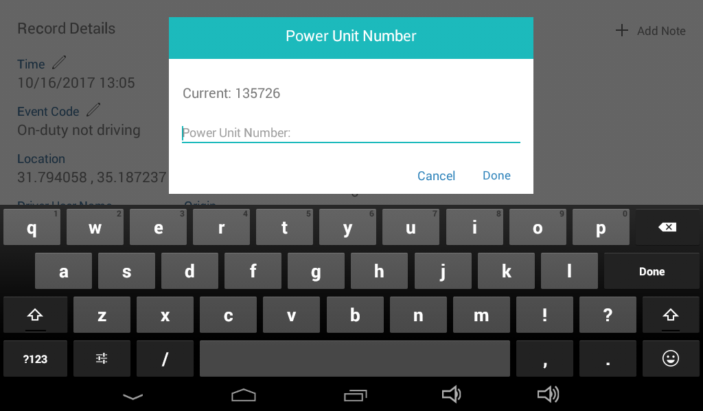

## Edit Shipping Document Number

This option is available to a driver who wishes to correct an error in Shipping Document number or to correct an historical record.

* Click on **Shipping ID**; the current value is displayed.
* At the flashing prompt enter the new value using the displayed keyboard. Click on the **?123** key to display the number pad.
* Click on **Done**, then add a comment if necessary.

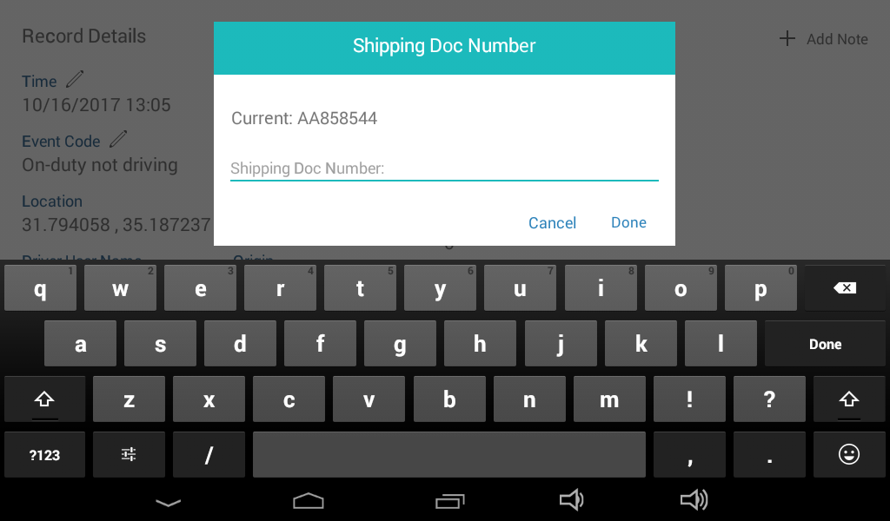

## Edit Trailers

This option is available to a driver needs to correct an existing record and edit the Trailer ID.

* Click on **Trailer ID**; the Manage Trailers dialog box is displayed showing the current value.
* At the flashing prompt enter the new value using the displayed keyboard. Click on the **?123** key to display the number pad. Up to three trailers can be added. To add more than one trailer, use the **Add** option to extend the list.
* Click on **Done**, then add a comment if necessary.

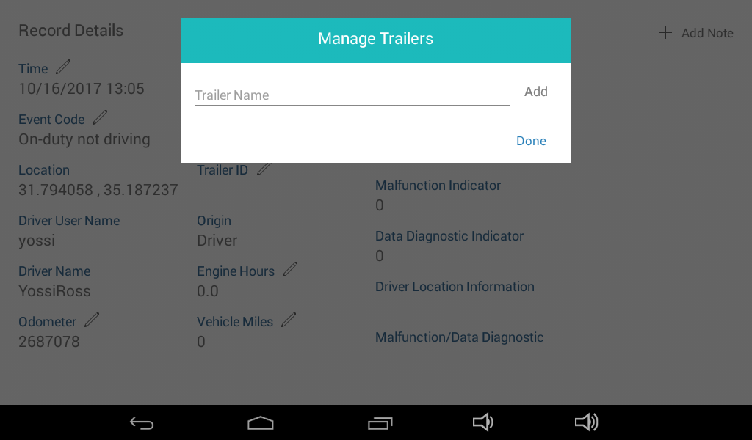

## Edit Engine Hours

In cases where the ELD was not connected or not functioning for a period of driving time, the driver will need to edit the following fields manually: **Engine Hours**, **Vehicle Miles**, **Distance since last coordinate**.

In the manner described above, click on the desired field to edit its content. For each edited field, driver must enter a comment to explain the circumstances that created the need to edit.

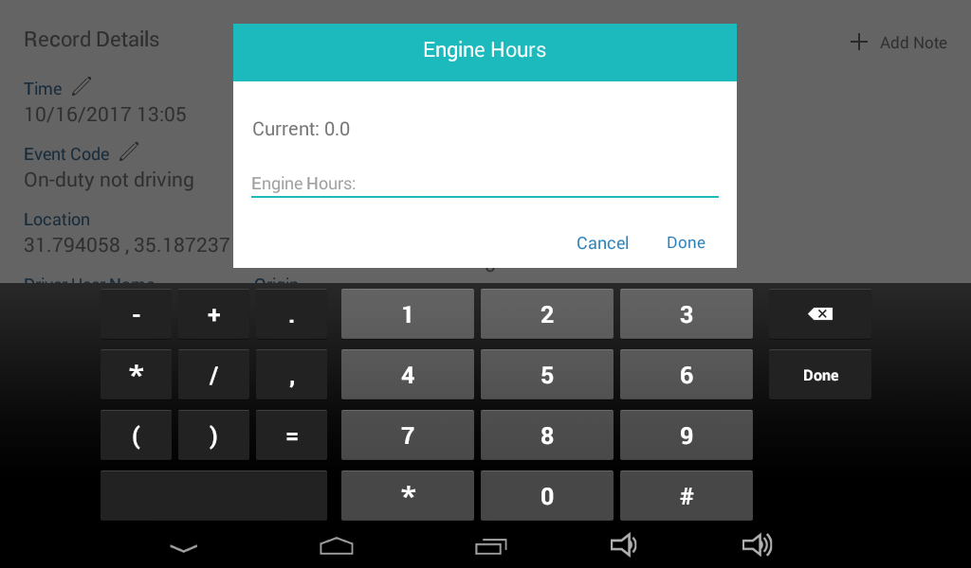

## Edit Vehicle Miles

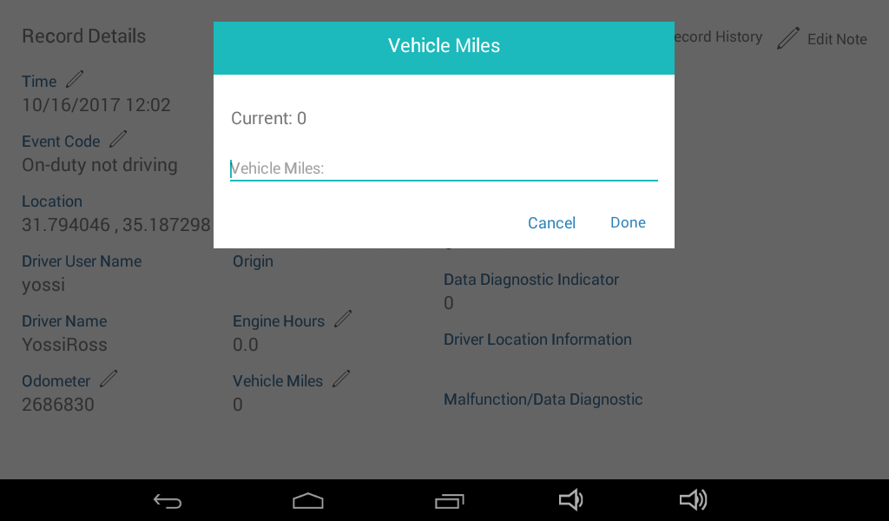

## Edit Distance Since Last Coordinate

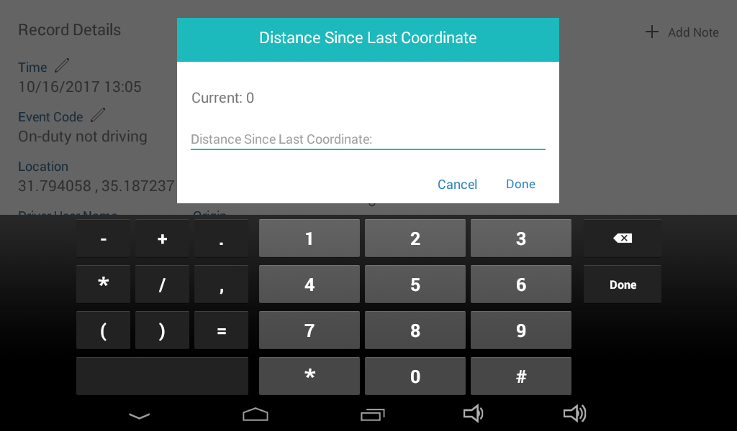

## Edit Note

Notes in general are mandatory to enable driver to explain why this particular field required editing.

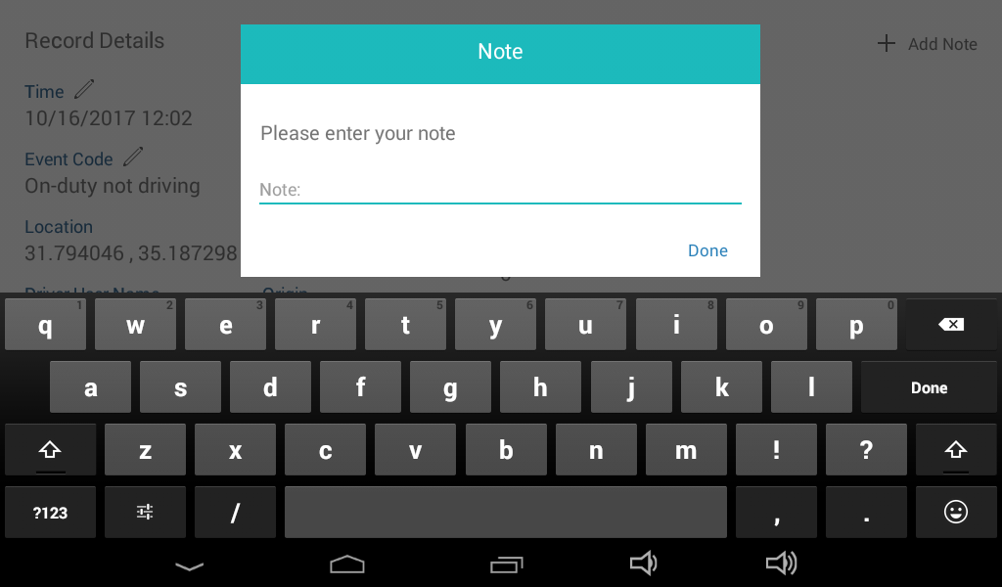

## Save Changes

After record has been edited, click on **Save Changes** at the top of the Record Details screen. Changes are saved to the ELD memory and the ELD database. The original record is also retained and can be accessed by displaying **Record History**.

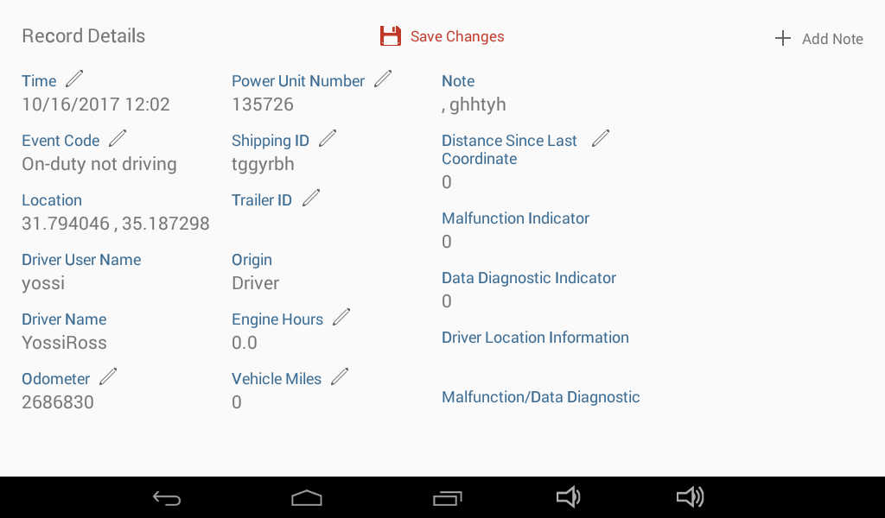

# Duty Status Chart

* Click on **Chart** on the Records page to display a graphic representation of the current 24-hour period.

The chart allows a user or law enforcement person to track the driver’s activity over the course of 24 hours, using a line that crosses from one status to another, showing how many hours (left-right axis) were spent at each status. The top-bottom axis show the four different status options.

The Chart display shown below is a sample of a printed ELD chart:

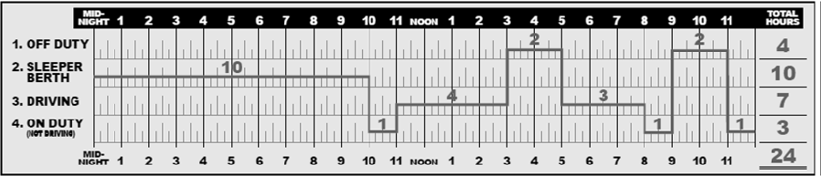

# Support Personnel Screens

When a user who has been assigned Support Personnel status logs in to the ELD, he will see the Support Personnel screen.

This screen allows him /her to configure device settings or create new drivers. Drivers that are created by Support Personnel are automatically added to the Drivers List on the database, enabling the new driver to login to the ELD, as described at the beginning of the current document.

Adding a driver is equivalent to adding an Account.

* Fill in new driver details on the New Driver page and then choose **Create**; the new driver can now log in to the ELD using the password that was assigned to him/her.

## Main Support Personnel Menu

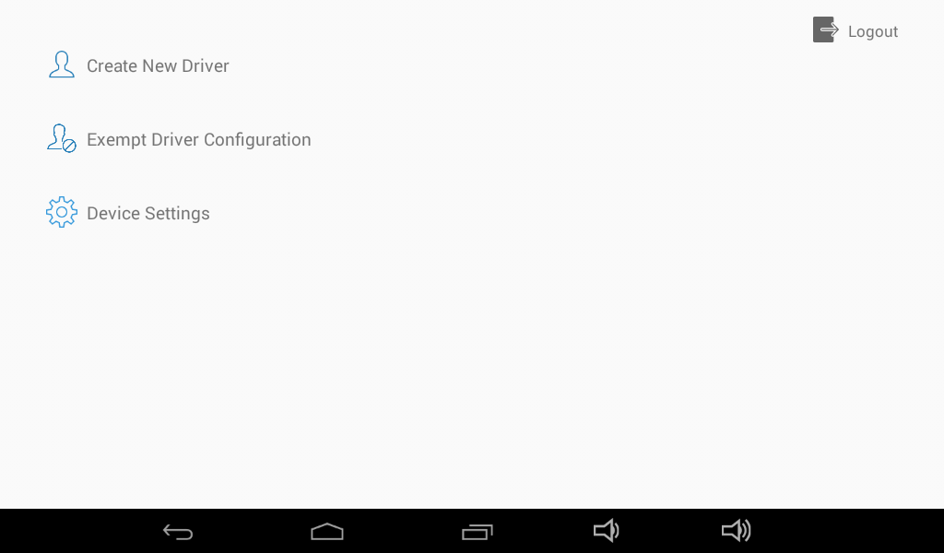

## Create New Driver

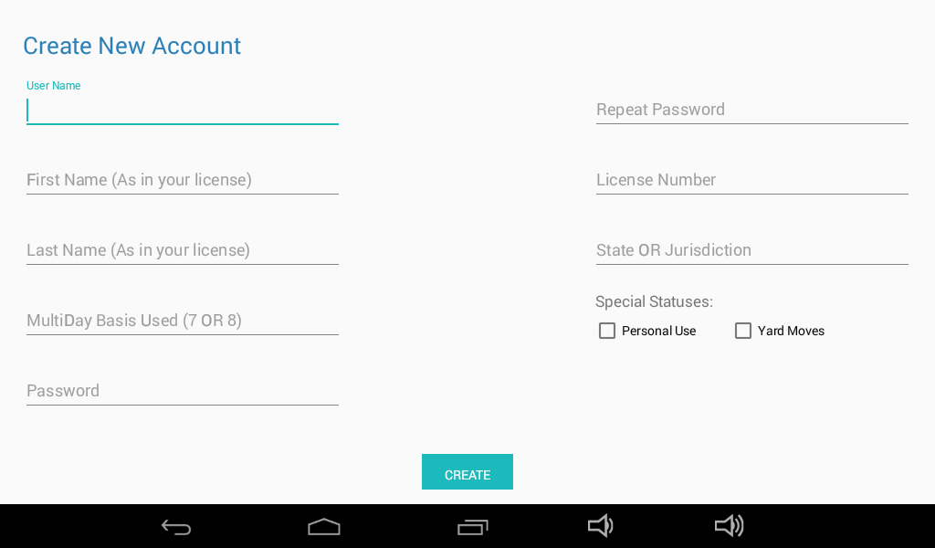

## Exempt Driver Configuration

Exempt drivers are those who are not obligated to record and store ELD data. A driver is designated exempt by the authorized Support Personnel who logs in to the ELD as such.

* Choose **Exempt Driver** from the Main Support Personnel screen; the Exempt Driver Configuration display appears.
* Enter **User Name** and then annotation text to explain the reason for exemption.
* Choose **Exempt Driver**, then **Done**. To cancel exempt status, follow above steps and then choose **Normal Driver**.

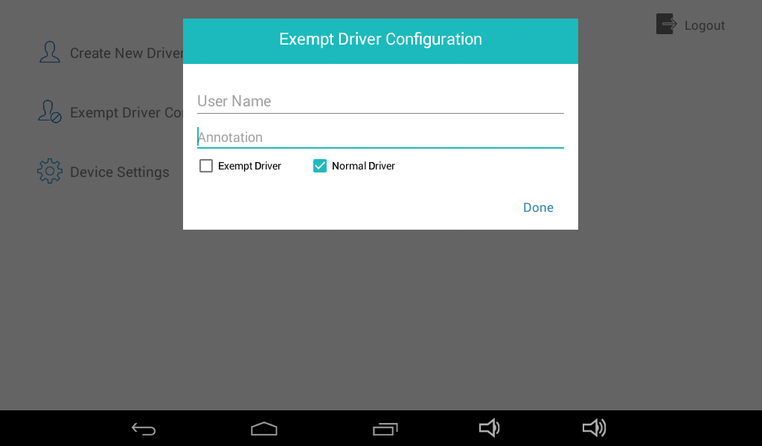

## Device Settings

Only Support Personnel can configure the device settings.

* From the Support Personnel screen, click on **Device Settings**; the following display appears:

