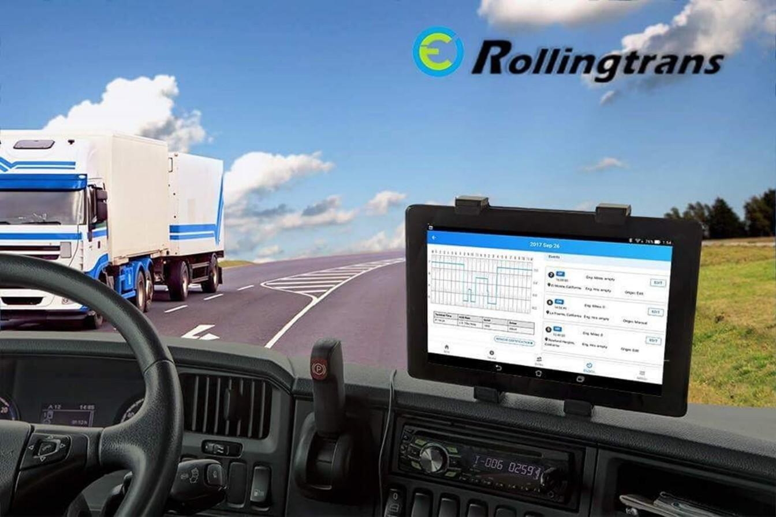


Rollingtrans RT ELD Plus- Accurate Halo ELD

User Guide

Copyright

Copyright © RollingTrans 2017
Contents subject to revision without prior notice. The information in this manual is subject to change without notice.

Disclaimer
RollingTrans does not warrant that the hardware will work properly in all environments and applications, and makes no warranty and representation, either implied or expressed, with respect to the quality, performance, merchantability, or fitness for a particular purpose. RollingTrans has made every effort to ensure that this User’s Manual is accurate; RollingTrans disclaims liability for any inaccuracies or omissions that may have occurred. Information in this User’s Manual is subject to change without notice and does not represent a commitment on the part of RollingTrans. RollingTrans assumes no responsibility for any inaccuracies that may be contained in this User’s Manual. RollingTrans makes no commitment to update or keep current the information in this User’s Manual and reserves the right to make improvements to this User’s Manual and/or to the products described in this User’s Manual, at any time without notice. If you find information in this manual that is incorrect, misleading, or incomplete, we would appreciate your comments and suggestions.

Table of contents

Copyright 1
Disclaimer 1
Table of contents 2
- Installation 4
  - Important Safety and Product Information 4
  - System requirement 4
    - Hardware requirement 4
    - Android and iOS system setting 4
  - ELD interpreter 6
  - ECM to ELD Interpreter connection 6
  - Bluetooth Connection 7
Main Menu 7
  - Bottom Tabs 7
  - HOS (Home) 7
    - HOS main screen 7
    - Bluetooth connection 8
  - DVIR 9
    - DVIR Summary 9
    - DVIR Checklist 10
  - ELOGs 10
    - E Logbook Event 10
  - Menu 11
Account Setting 12
  - Driver 12
  - ORG OWNER 12
  - Account 13
  - Modify an Account 15
  - Add a Vehicle 16
  - Modify a Vehicle 17
E Logbook 18
  - DVIR 18
    - DVIR Item Checklist 18
  - ELogs 20
    - System Automatic Judgment 20
    - System Manual Status Change 20
    - Edit a Log 21
    - E Logbook ADD Event or Remark 21
    - Certify a Log 22
    - Reactivate a Log 24
  - Edit and Modify the Log Record 24
    - Driver and Carrier’s Authority 24
    - Edit a Log Record 24
DOT Roadside Inspection Guide 25
  - Roadside inspection guide 25
    - HOS record Inspection options 25
    - Submit to FMCSA Web Service 26
    - Mail Option 26
    - Display HOS Record on device screen 27
  - Back-up Driver Log Data 27

Appendix 26
  - Contacting Rollingtrans 26

Installation

Important Safety and Product Information
Failure to heed the followings could result in an accident or collision resulting in death or serious injury.

Distraction Warning
This device and system is intended to enhance the situational awareness when used properly. If used improperly, you could become distracted by the display, which could lead to an accident serious personal injury or death. Only access the information displayed on the device with a glance. Always maintain awareness of your surroundings and do not stare at the display or become distracted by the display. Focusing on the display could cause you to miss obstacles or hazards. You assume sole responsibility and risk for using this system.

Vehicle Installation Warnings
- When installing the device in a vehicle, do not place the device where it obstructs the driver’s view of the road or interferes with vehicle operating controls, such as the steering wheel, foot pedals or transmission levers…etc. Do not place unsecured on the vehicle dashboard. Do not place the device in front or above airbag

- If user use windshield mount to mount wireless device please be aware the windshield mount may not stay attached to the windshield in all circumstances. Please check the installation instruction of your windshield mount before installing it into your vehicle. Do not place the mount where it will become a distraction if it should become detached. Keep your windshield clean to help ensure the mount stays on the windshield.

System requirement

Hardware requirement
The following components are required for FMCSA compliant ELD rule
      - ACCURATE HALO ELD Interpreter hardware
      - Vehicle ECM (Engine Control Module) using SAE J1939, J1708 Protocol
      - Connection Cable of 1939 9Pin, 1708 6Pin, and Custom OBD-II Cable for Volvo and Mack 2013+ model
      - Android 5.0+ or iOS 9.0+ Smartphone or Tablet with 2G/3G/4G GSM data, Bluetooth, and GPS function
      - Access to Rollingtrans ELD APP from Android Play Store© or iOS App Store©
      - An activate Rollingtrans user account

Android and iOS system setting
For Android or iOS phone and Tablet, please always turn on following wireless function

- Mobile Data
- Bluetooth
- GPS Location
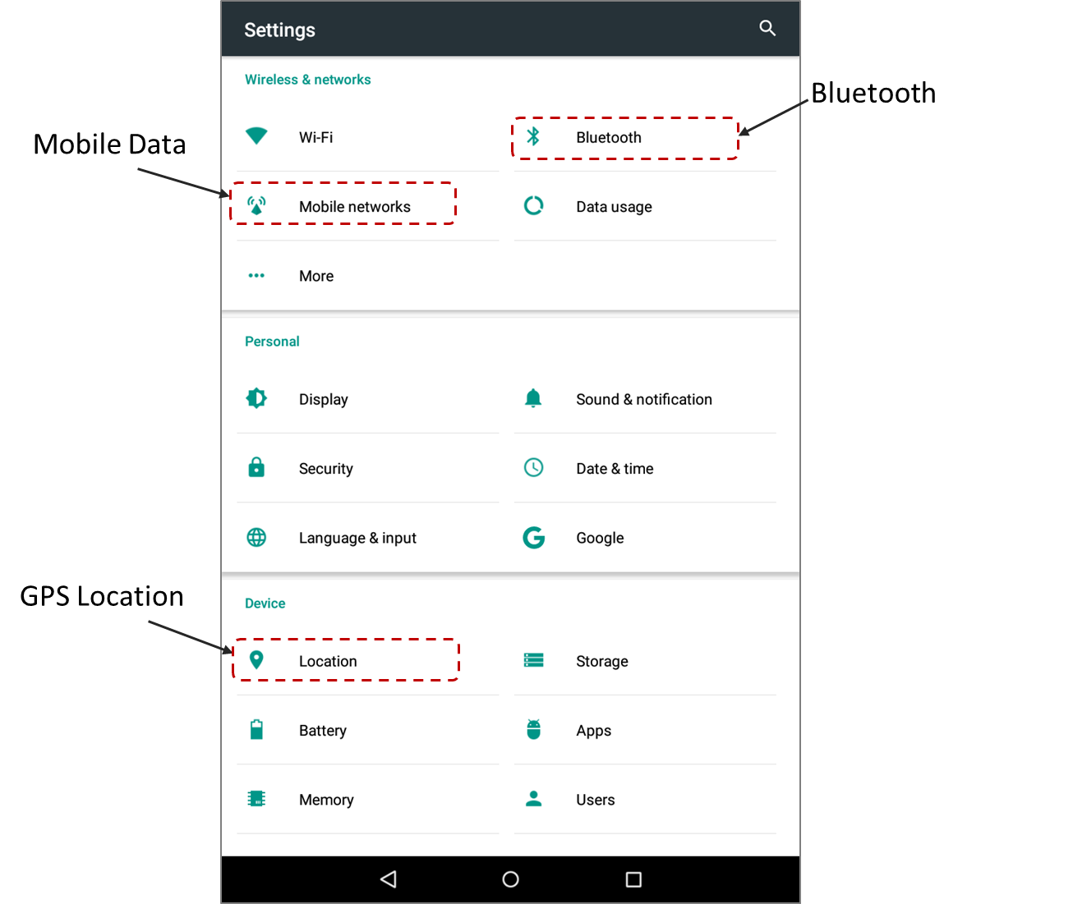

ELD interpreter
ELD interpreter is the ELD hardware device connect to your commercial vehicle’s ECM. The interpreter captures your ECM J1939 or J1708 protocol and transfer ECM information to Wireless device on board. The functionality of each indicator LED as following.

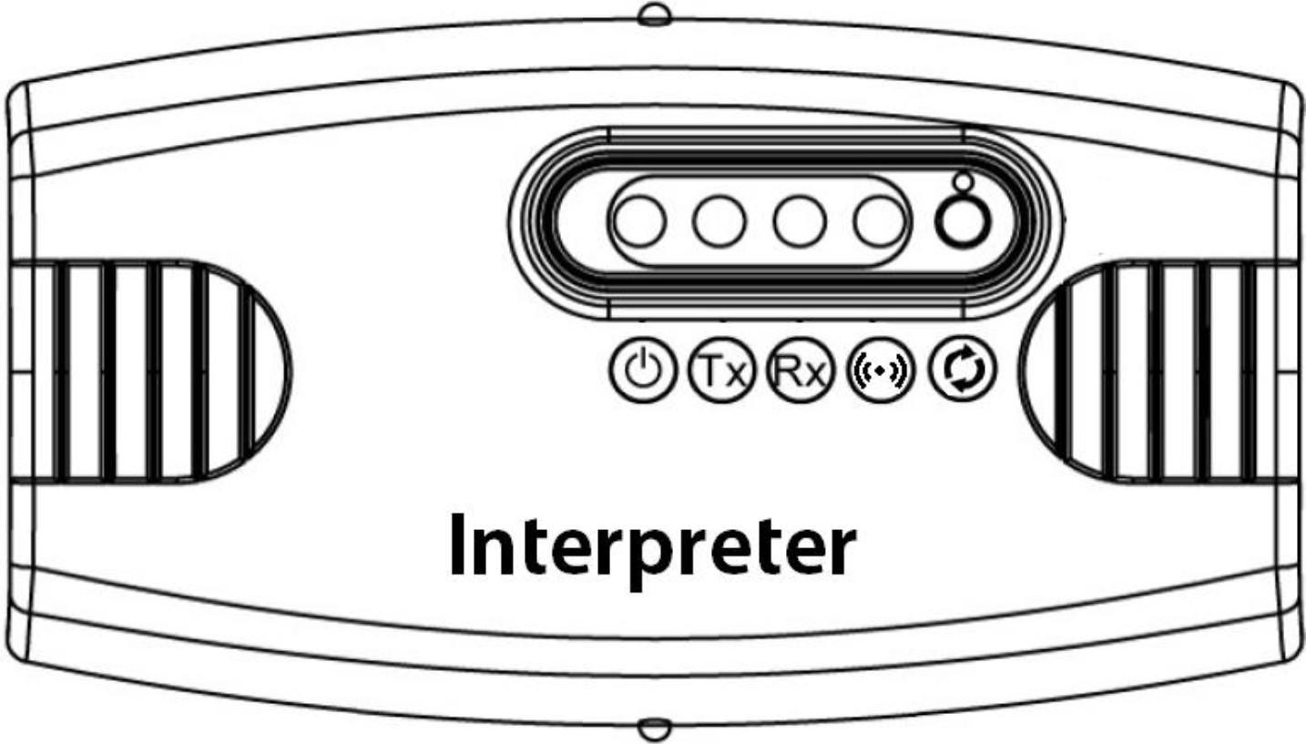

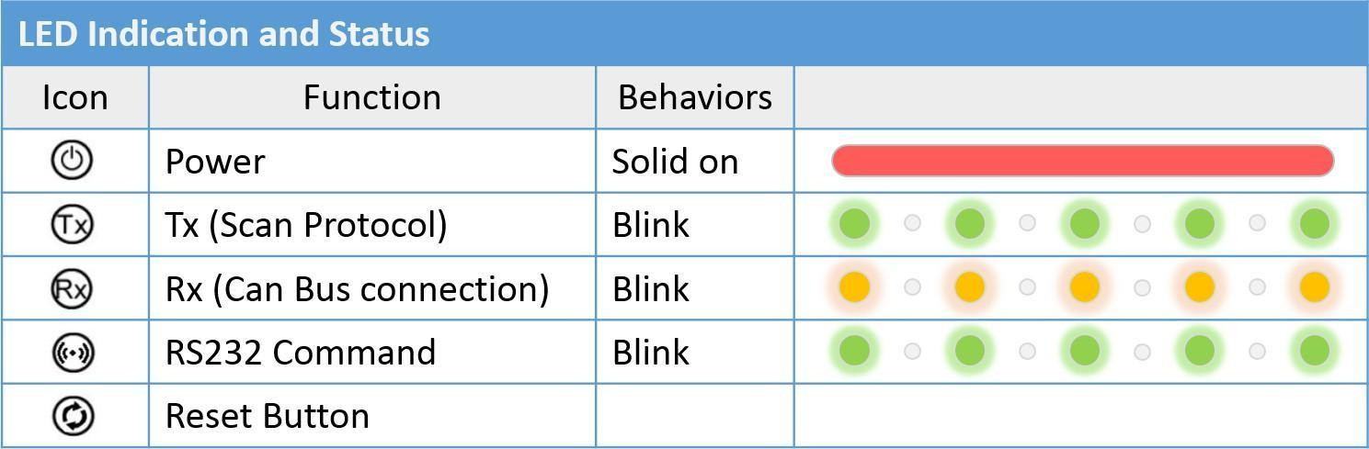

ECM to ELD Interpreter connection
The ELD Hardware interpreter use RS232 DB9 connector. User needs to use SAE J1939 9 pin, SAE J1708 6 Pin, and our customized OBD-II cable to connect to your vehicle’s ECM.
ELD interpreter RS232 DB9 connector
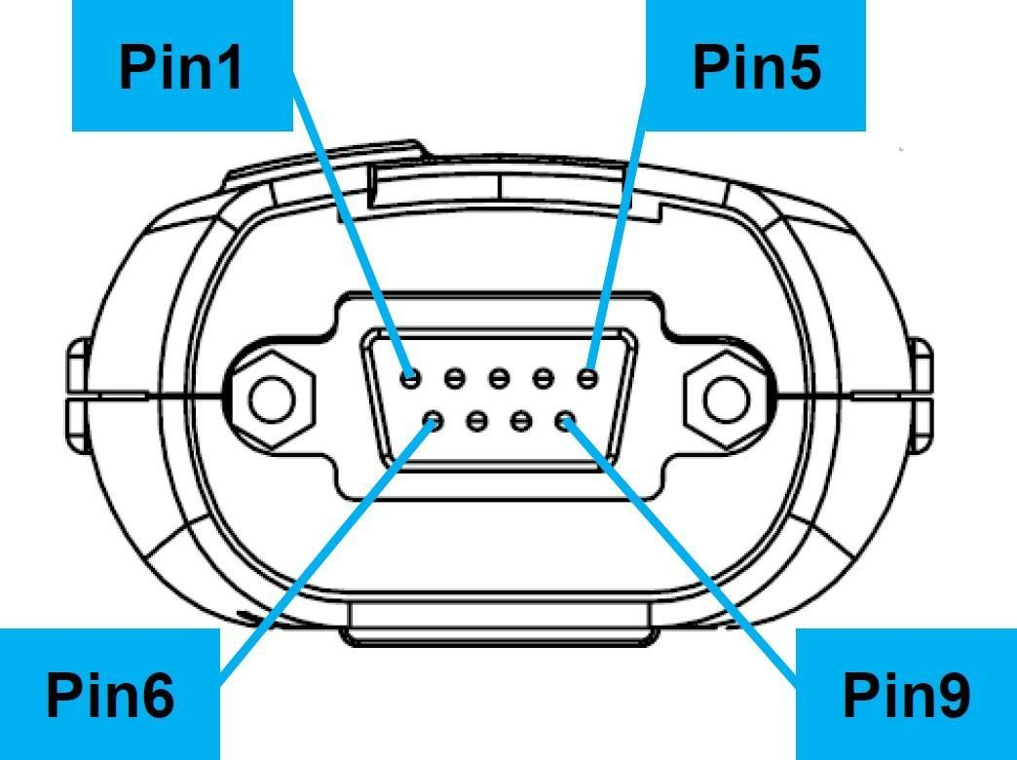

Bluetooth Connection
The ELD Hardware interpreter use Bluetooth wireless connection to your Smartphone or Tablet. From your Smartphone or Tablet go to Bluetooth and choose the correct ELD. Make sure you pair with correct ELD interpreter. You can find Bluetooth Device Serial Number on device label.

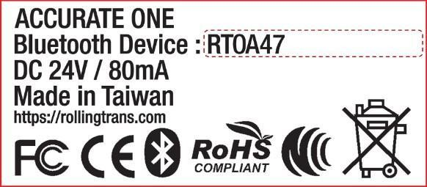
 Main Menu

Bottom Tabs
In the Home Screen, there are four different main bottom tabs for HOS, DVIRs, eLogs, and Menu four main functions.
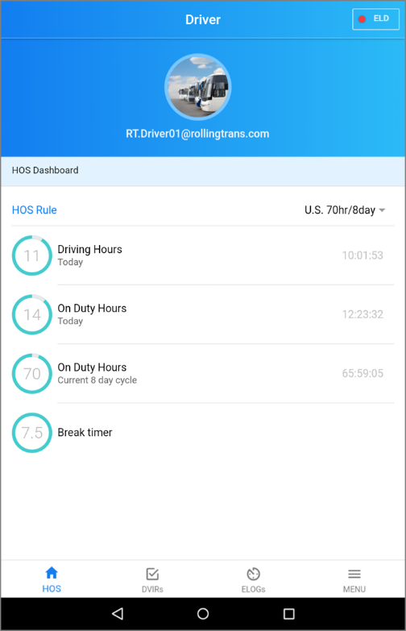

HOS (Home)

HOS main screen
HOS Dashboard shows you current driver ID, HOS rule, and your current Driving Hours, On Duty Hours, and current HOS Cycle remaining hours.

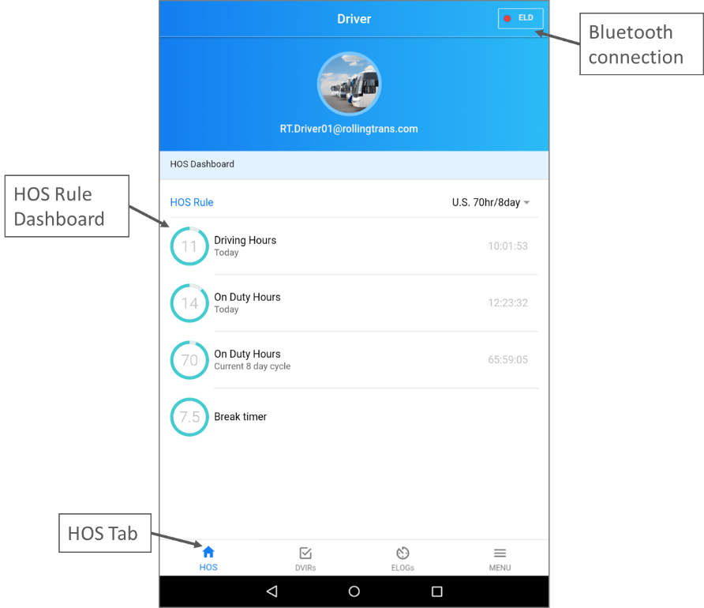

Bluetooth connection
      - To pair ELD interpreter to your Phone or Tablet, please go to your iOS or Android SETTING →
Bluetooth → Pair with your ACCURATE HALO ELD device.

Apple iOS Bluetooth Pair Android Bluetooth Pair
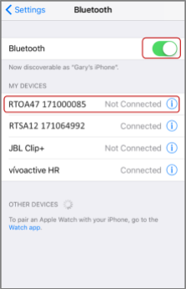
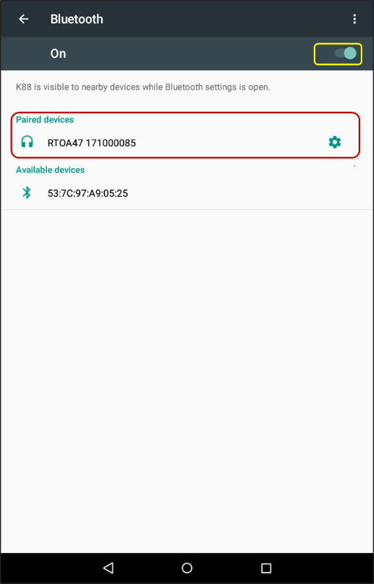

      - After pair ELD interpreter with your Phone or Tablet please go to Rollingtrans ELD App. Then click top right corner Bluetooth connection button to connect ELD Bluetooth device
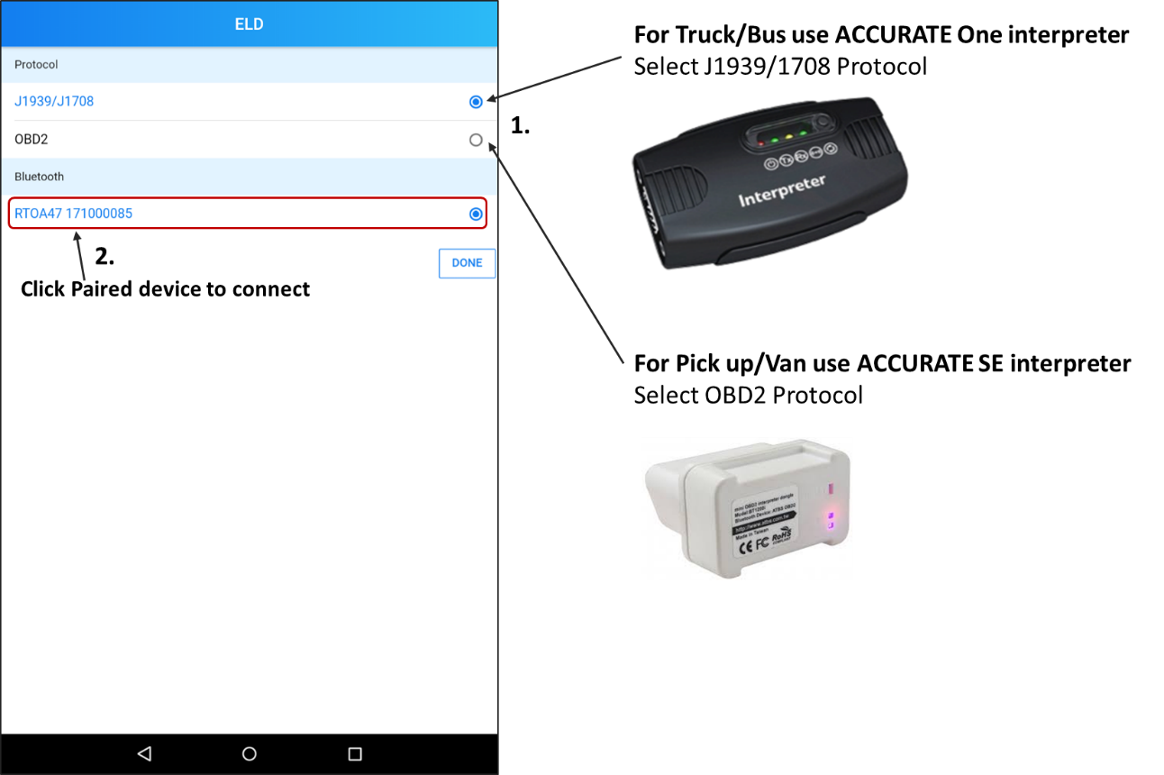

DVIR

DVIR Summary
DVIR summary list can shows you daily vehicle condition and notify you poor condition and defect items.
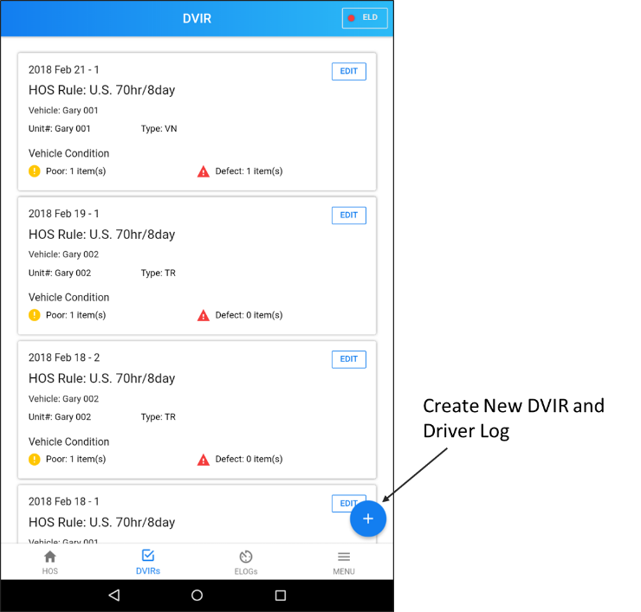

DVIR Checklist
Check all your vehicle items and change the condition according to driver’s daily vehicle inspection. Press Finish to finish then your inspection report and inspection result will automatically upload to cloud database.
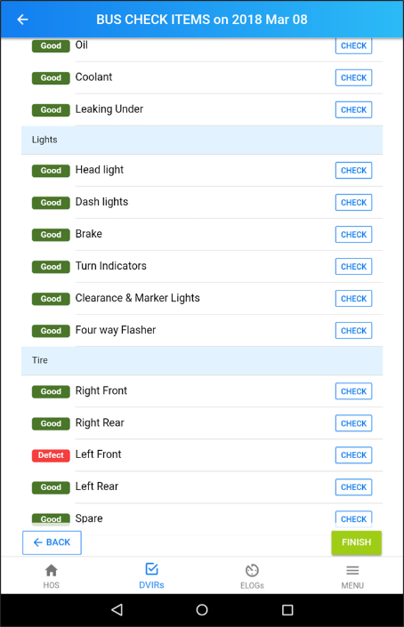

ELOGs

E Logbook Event
To Create a new log please start from DVIRs and create a new DVIR. Your new log for today will automatically create after you finish your DVIR.
To Operate your driver log just go to ELOGs Tab and select today’s log
- Change Status: Click “CHANGE STATUS” and select your current status
- Add Remark: Click “+” button and Click “Remark”
- Add Event: Click “+” button and Click “EVENT”
- EDIT Event: Click “EDIT” and modify event contents.
- Certify the Log: At the end of the day, please don’t forget to certify this log and verify your daily driving information.

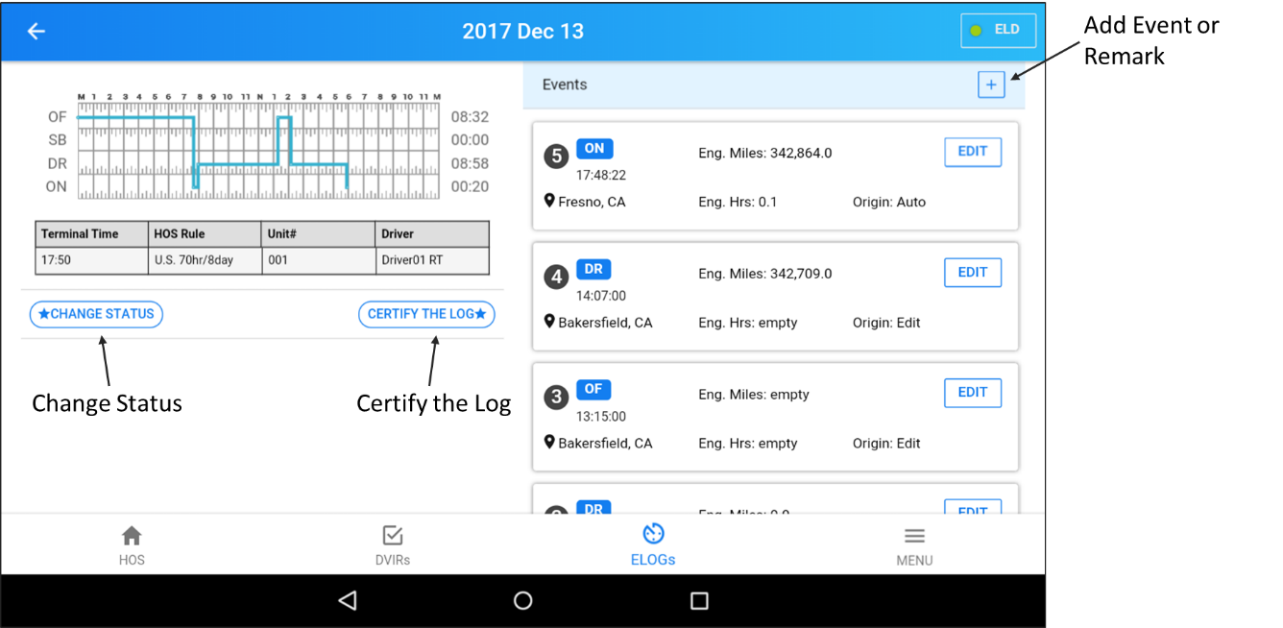

Menu
In Menu Tab you can Add/Edit your account information. If you are owner you can modify Company, Driver, and Vehicle account. If you are using driver account, you can only View/Edit your own driver account information.
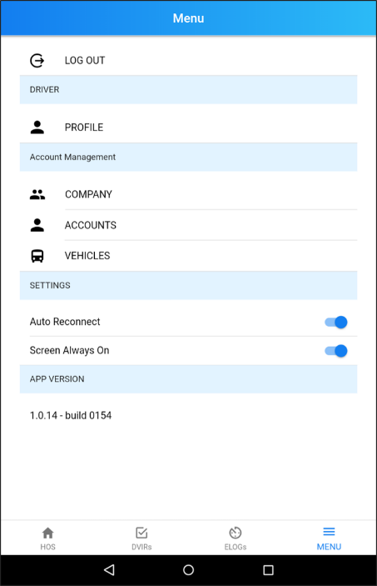

 Account Setting

Driver
Driver must acquire the username and password from the fleet manager. Each driver will have unique username and password.
    - Enter your user id
    - Enter the password. The entered password will not be displayed
    - Click on Login button to login into RollingTrans app.
    - If the ELD app does not connect automatically, go to Home Screen, and check the Bluetooth icon if it is connected to appropriate ELD. Select the right ELD.
    - After your log in the App, please go to Menu → DRIVER → Profile to view driver’s profile
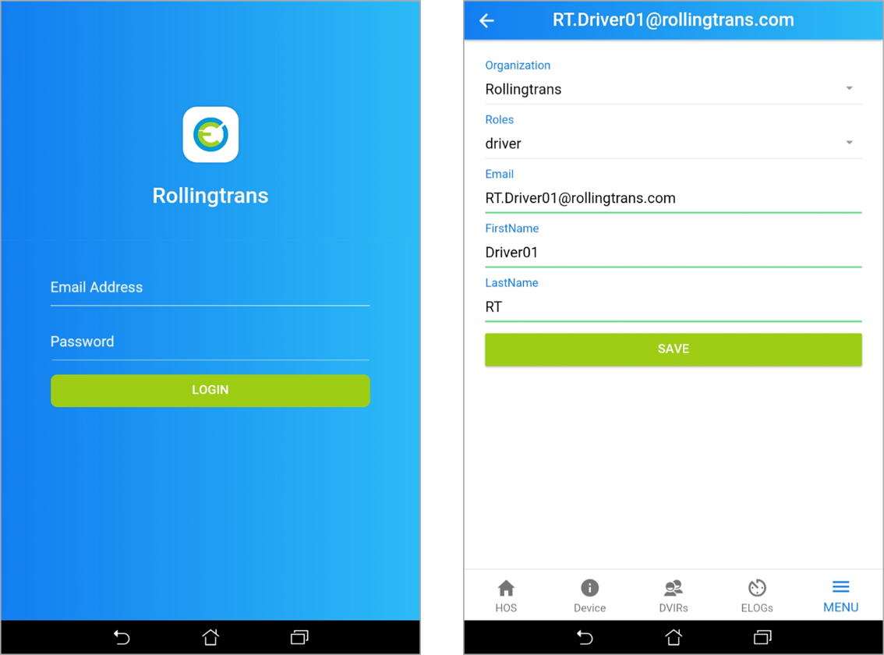

ORG OWNER
    - Click MENU→ ORG OWNER
    - Enter the following information

      - Company Name
      - DOT Number
      - Company Address

- After entering the information, click SAVE

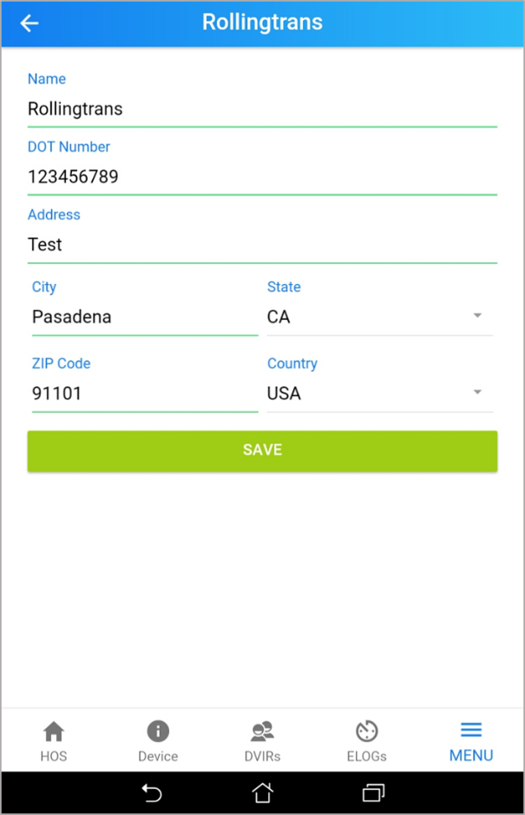

Account
    - Click MENU→ ORG ORGANIZATION→ ACCOUNT
    - Click “ +” to add a new driver

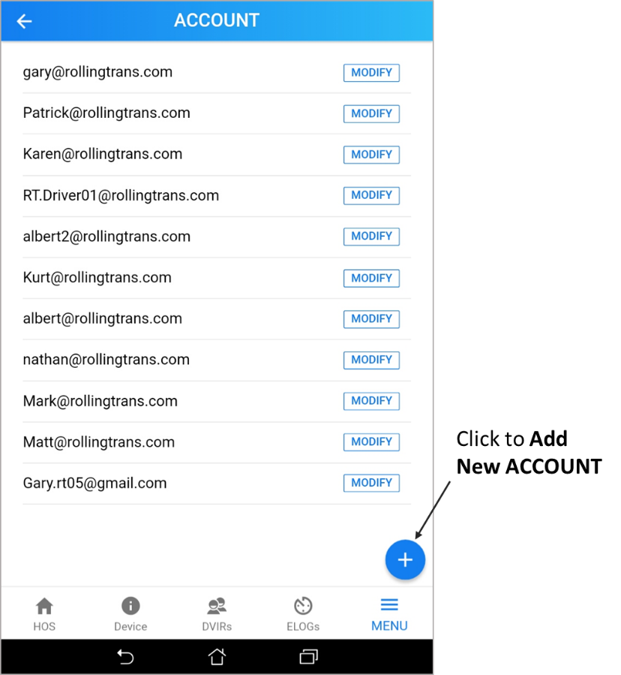

    - Enter the following information

      - Organization (Default)
      - Roles (driver or orgOwner)
      - Email
      - Password
      - Confirm Password
      - FirstName
      - LastName

- After entering information, click SAVE

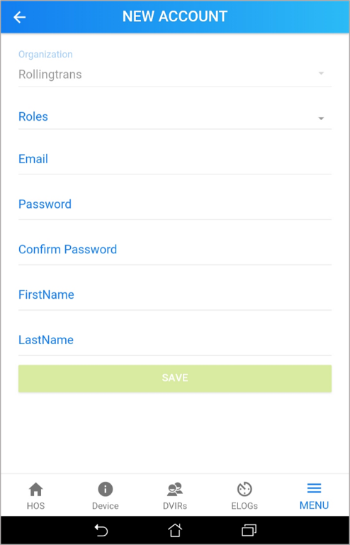

Modify an Account
    - Next to the Driver’s email, Click OPTIONS
    - Under Option: What do you want to do?
    - You can choose “Delete Account”, “Update Account”, or “Cancel”
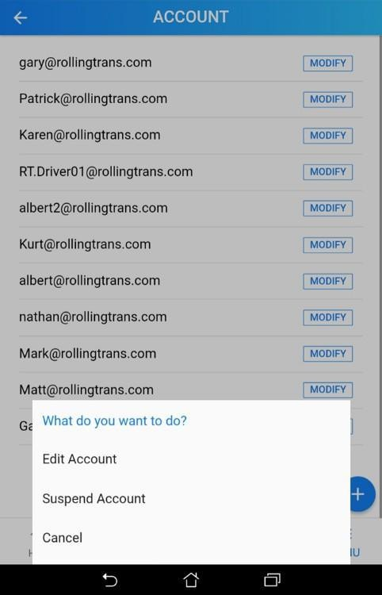

Add a Vehicle
Click “+” to add a vehicle
- Enter the following information
- Organization (Default)
- Title
- Odometer
- Unit #
- Body Type
- Year
- Address
- Timezone
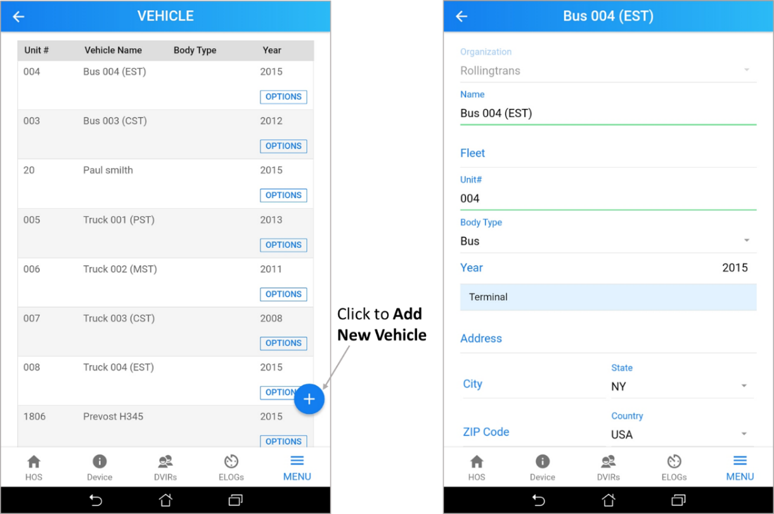

Here below is iOS and Android City time zone reference chart for you to choose your terminal timezone.
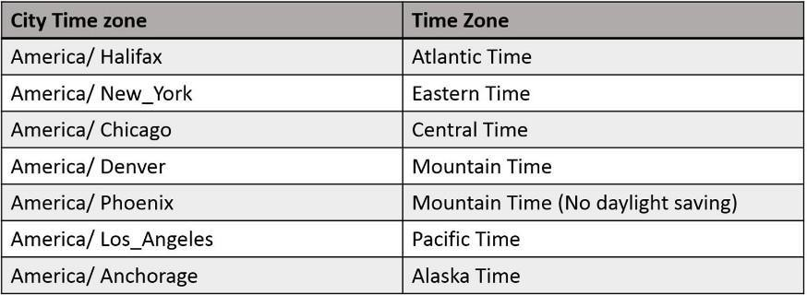

Modify a Vehicle
Choose your vehicle and click OPTIONS
Under What do you want to do? You can click “Delete vehicle”, “Update vehicle”, or “cancel”.
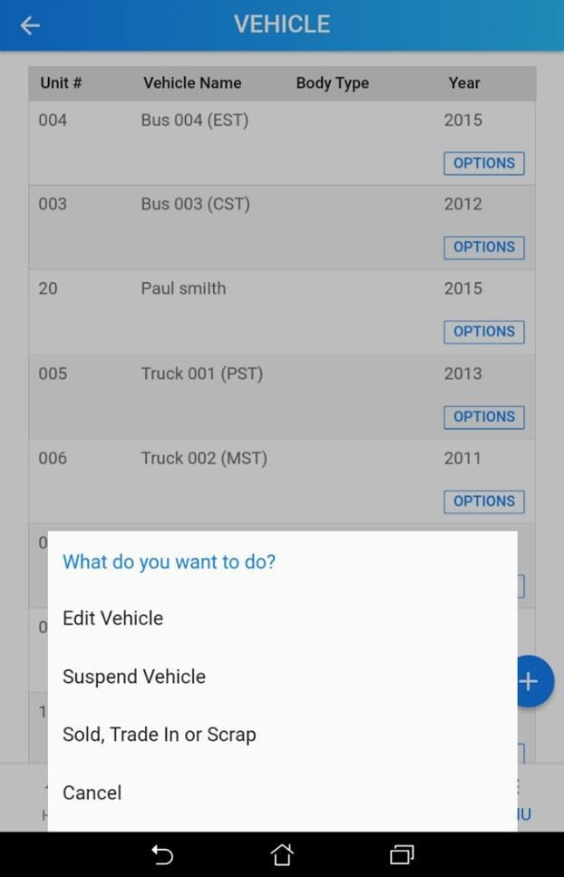

 E Logbook

DVIR

DVIR Item Checklist
The driver can View, Edit, or Delete, the signed DVIR
      - Click DVIR Tab → “+”
      - Check and choose the appropriate action

        - Company
        - Driver
        - Co-Driver (if required)
        - HOS Rule
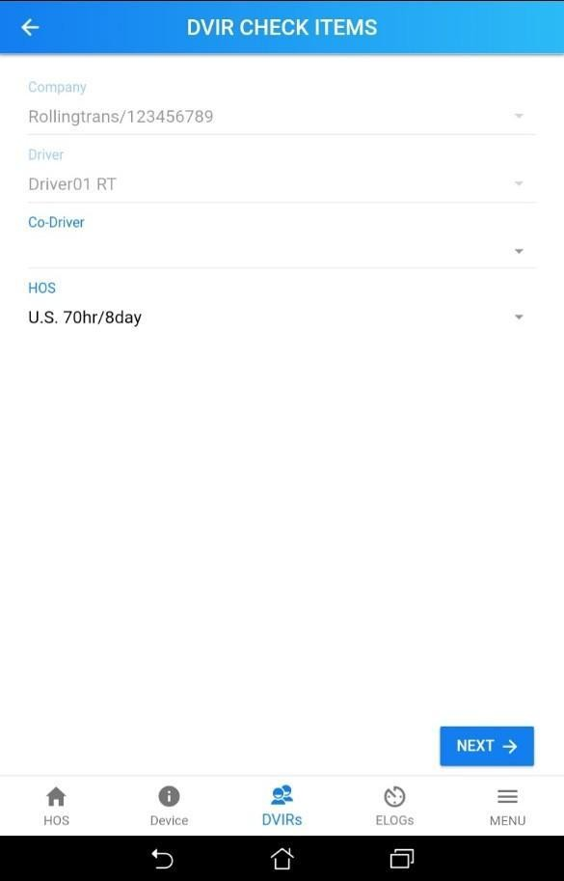
      - Click Next

      - Choose your Unit #, body type and vehicle name. Then, verify the Timezone
      - Scroll the bar to the right next to Trailer. Select your trailer type and enter unit #
      - Verify the current position. Click Next
      - Screen will shows Continue to create DVIR/E-log records. Do you want to continue?
Click Continue. By click continue, the system will generate today’s log and automatically create a
On Duty event at this time

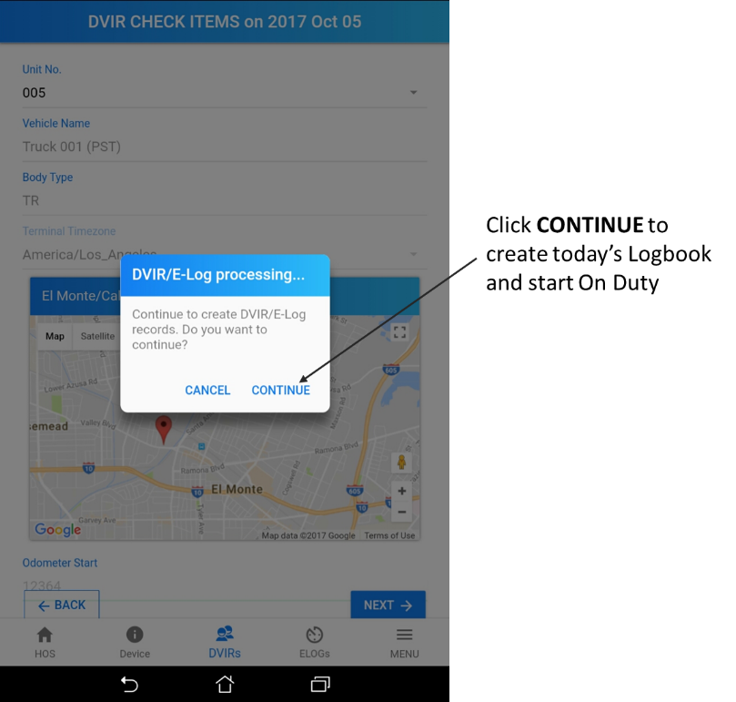
      - At the BUS Check items, system will identify the condition of previous selection on the item. Define the rating → Click Confirm* If there is an issue on the item, enter the notes at Notes section
        - Good
        - Fair
        - Poor
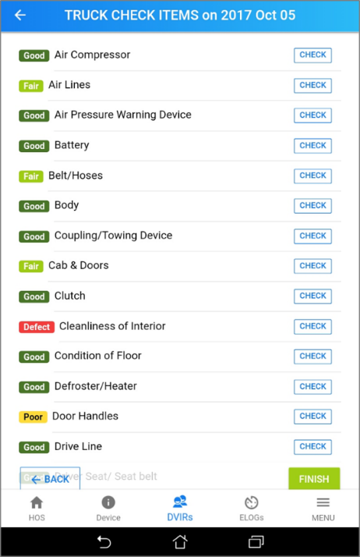
        - Defect

      - After checking all items, click FINISH
      - Options: Save DVIR to Finish today’s DVIR and the inspection result will upload to cloud database. If not, Click Cancel

ELogs

System Automatic Judgment
According to FMCSA ELD final rule, when ELD connect to the system, there will be four different status.
On Duty
- When engine is on, the status will be changed to ON or ON Duty Driving
- When the driving speed is over 5 mph at least 30 seconds, the status will be changed to DR or
Driving
- When the driving speed is below 5mph at least 5 minutes, system will show a reminder” Are you still driving?” You can press the Yes bottom to keep the status or press No or ignore for 1 minute to change the status to On or On Duty.
Off Duty
- When you are in the driving or on duty status and turn off the engine, the status will be changed to
Off or Off Duty.

System Manual Status Change
If drivers need to manually change the status, Click Change Status
You can select the status on your own
- Off Duty
- Sleeper Berth
- Driving
- On
Duty Or
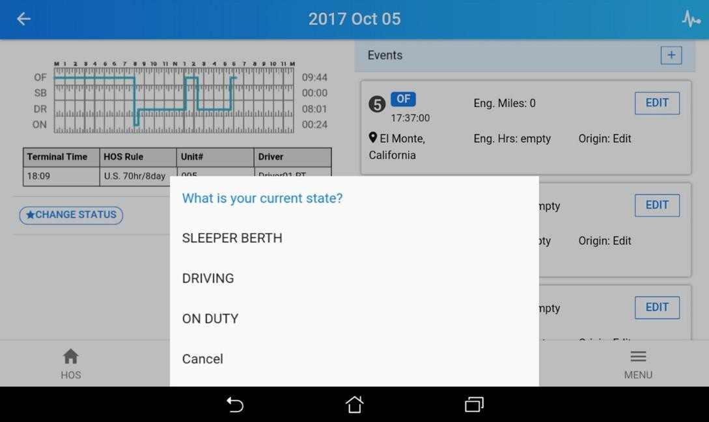
Cancel

Edit a Log
Drivers can edit the event by click the log that they want to edit
- On the Event Type, you can select

  - OFF DUTY
  - SLEEPER BERTH
  - DRIVING
  - ON DUTY

- After you select, click OK to save or Cancel to Return.
- In the Notes Section, you can enter the information during the event.
- Click Save
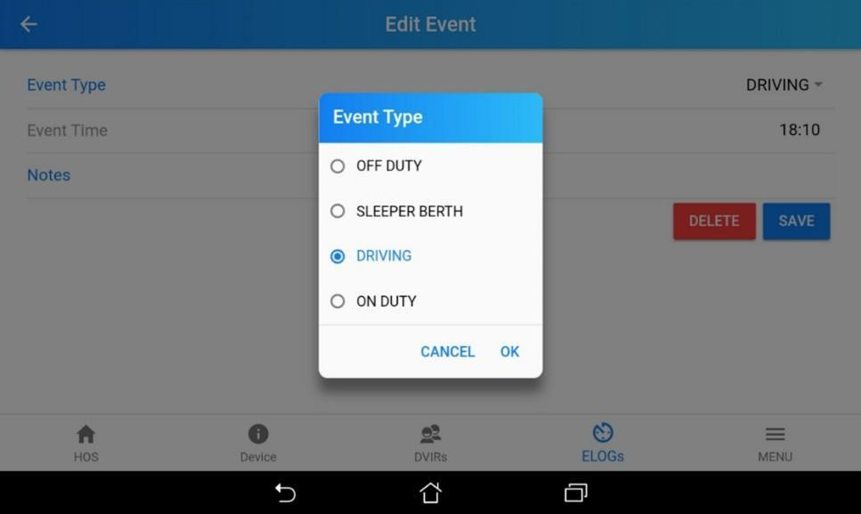

E Logbook ADD Event or Remark
Click “+” to add an Event or Remark
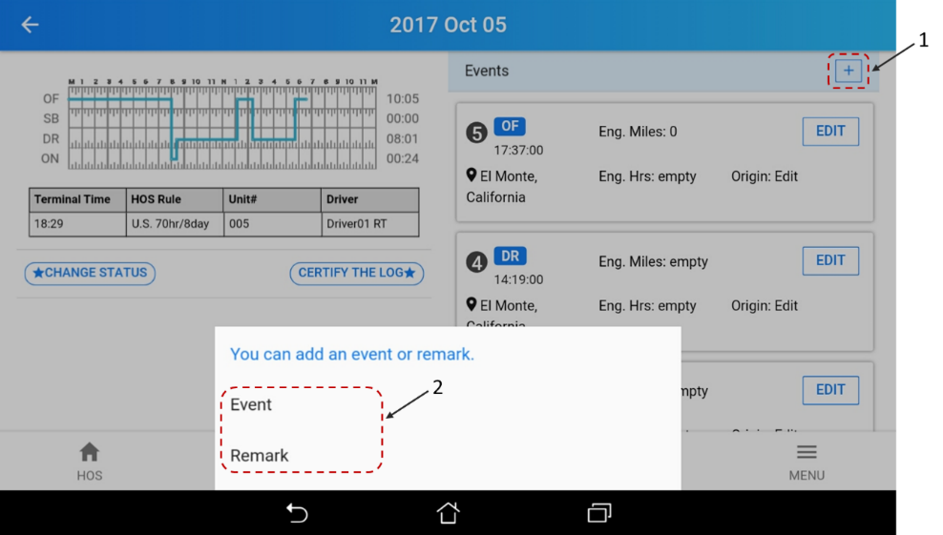

- Add Event
Select and input following information to add event.
  - Event Type
  - Event Time
  - Click SAVE to finish

- Add Remark
To record your fuel fill-up for IFTA report, please click “+” → Remark and then input following information
  - Time: Input remark time
  - Slide Fuel fill-ups toggle switch
  - State: Your current State will be captured by GPS Location
  - Fuel Type: Select your fuel type
  - Unit Price $/Gal
  - Gallons
  - Total
  - Click SAVE to finish
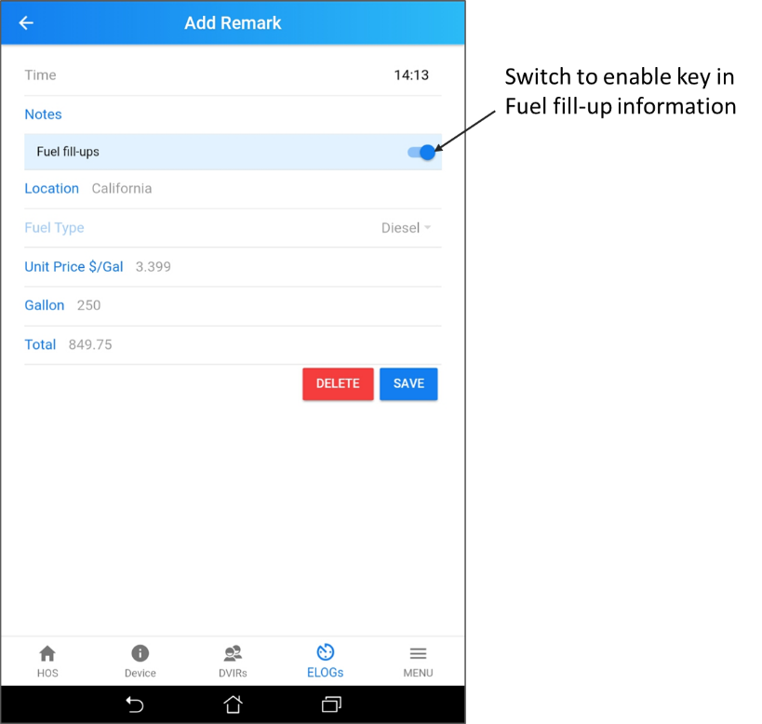

Certify a Log
After you finish the day, you can click CERTIFY THE LOG.
- First, you need to verify your driving log today. View/Edit to correct your log today and click “VERIFY”

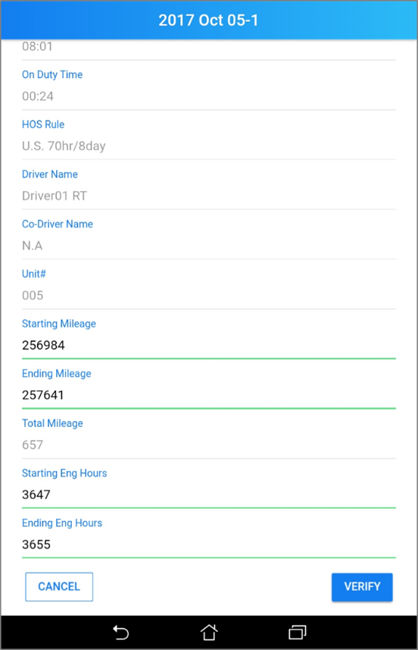

- Then, System will need you confirm, “ I hereby certify that my data entries and my record of duty status for this 24-hour period are true and correct”. Click Agree to certify or Cancel to return.
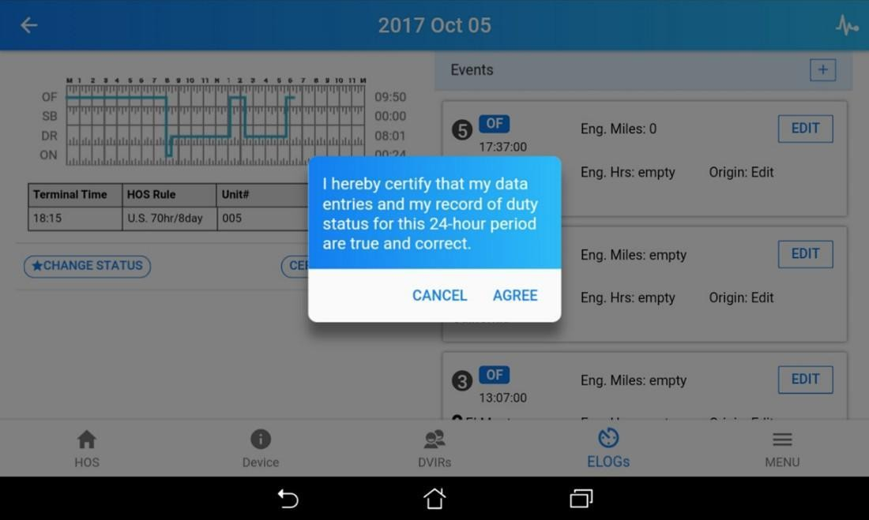

- After you certify the log, if you want to edit your driver log again, please click “REACTIVATE LOG” to remove certification and edit your log.

Reactivate a Log
Click REACTIVATE LOG if
- You want to continue to record your driving log today.
- You want to edit the log
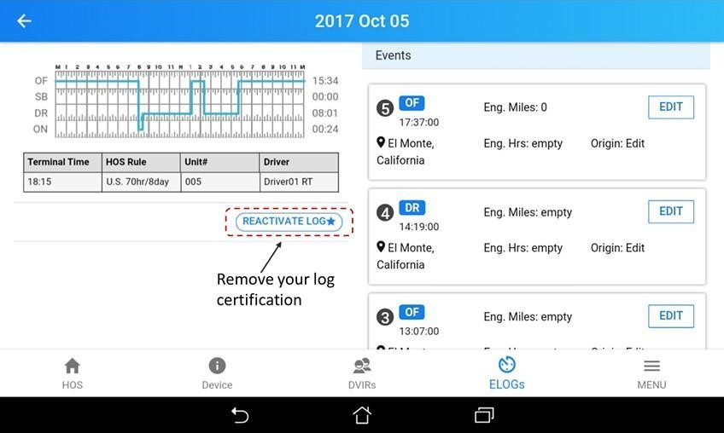

Edit and Modify the Log Record
Only assigned driver can edit the log and certify the log. Once you edited or modified the log, it will show the original log and modify version.

Driver and Carrier’s Authority
Drivers have authorities to modify their own log during the current trip. Carrier also can modify the log after receiving permission from the driver. It will show the original and modified version for both drivers and carriers.

Edit a Log Record
Go to the log record need to modify, click edit to edit existing log and click add to add an log record in driver’s log.
Please note, driver and owner have different authority to modify log record. The default setting, driver can only modify current day’s log record.

 DOT Roadside Inspection Guide

Roadside inspection guide
When in contact with safety authorized officers or any other DOT roadside inspection, please follow the following procedures to provide your HOS record to safety authorized officer. There are three different option to provide your driver log record for inspection.

HOS record Inspection options
      - Submit to FMCSA Web Service
      - Mail HOS records to safety authorized officer’s email
      - Display on the device
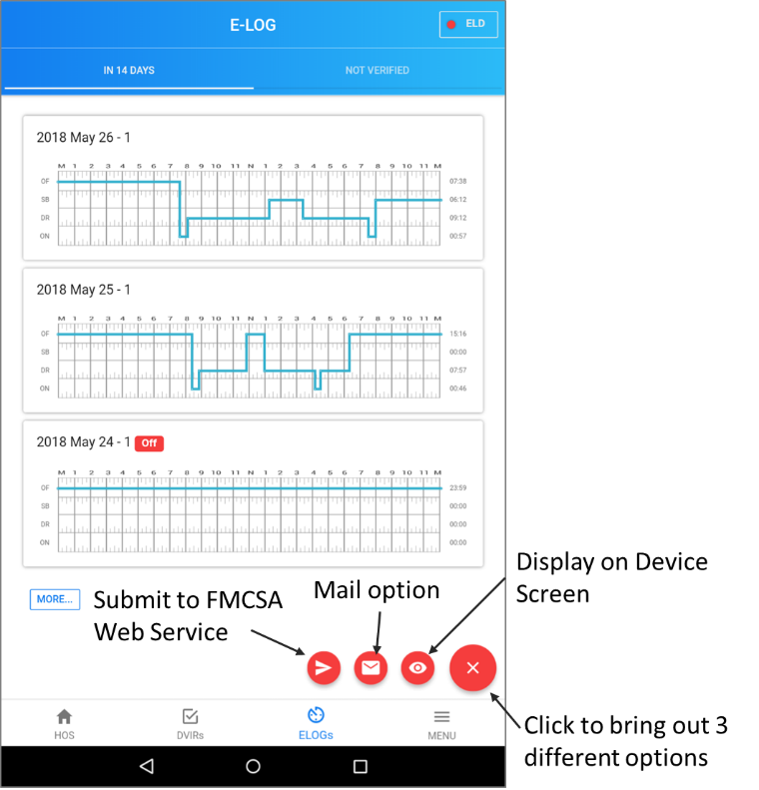

Submit to FMCSA Web Service
Click Submit to FMCSA Web Service button to submit your HOS record to FMCSA Web Service. Your Safety authorized officer might ask you to key in his/her inspection code in submit comments.
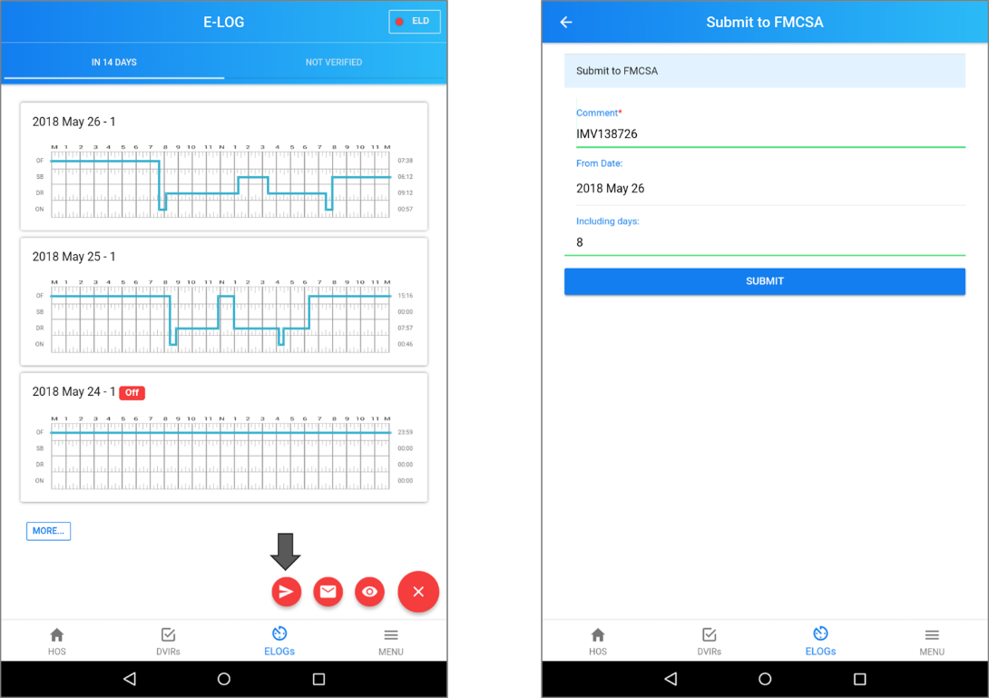

Mail Option
Click Mail option button and select date and including days to send your HOS record to Safety authorized officer’s designated email address.
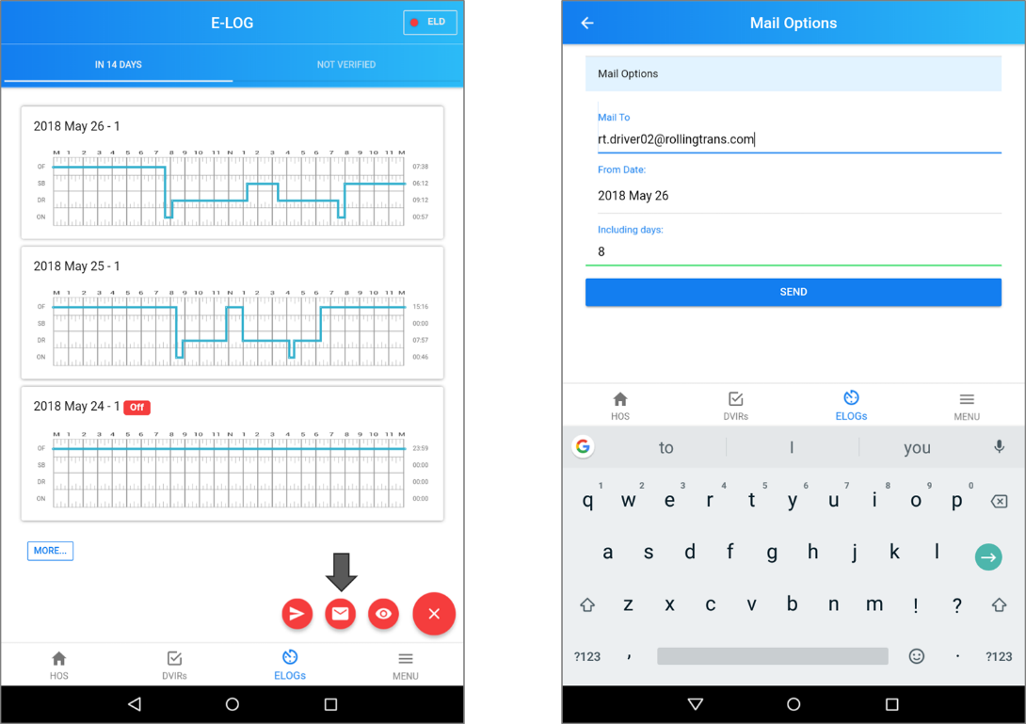

Display HOS Record on device screen
Click Display HOS record button, then you can display your past 8 days HOS record on your device screen for Safety authorized officer’s inspection

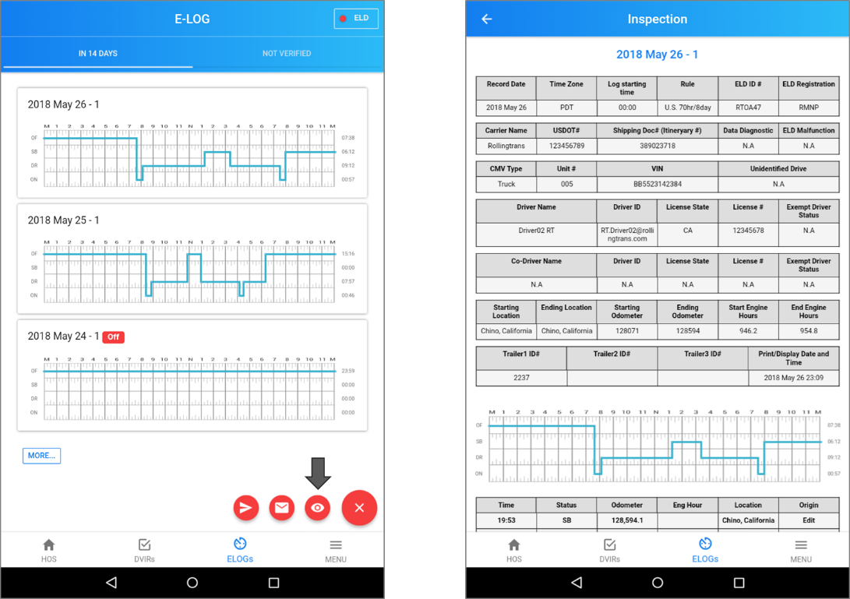

Back-up Driver Log Data
Owner account of motor carrier has responsibility to export each driver’s log record and store in your local storage location or any other place to back-up your drivers date. According to FMCSA ELD final rule ELD system provider will only back-up your driver’s HOS Record for 6 months.

 Appendix
  - Contacting Rollingtrans
Drivers should first contact their fleet manager in their motor carrier who owns ELD System App Owner account with any questions. Fleet manager may contact their Rollingtrans representative, when needed.



Add: 155 N Lake Ave Pasadena, CA 91101
Tel: 626-993-6655
Email: Service@rollingtrans.com
Https://Rollingtrans.com

