

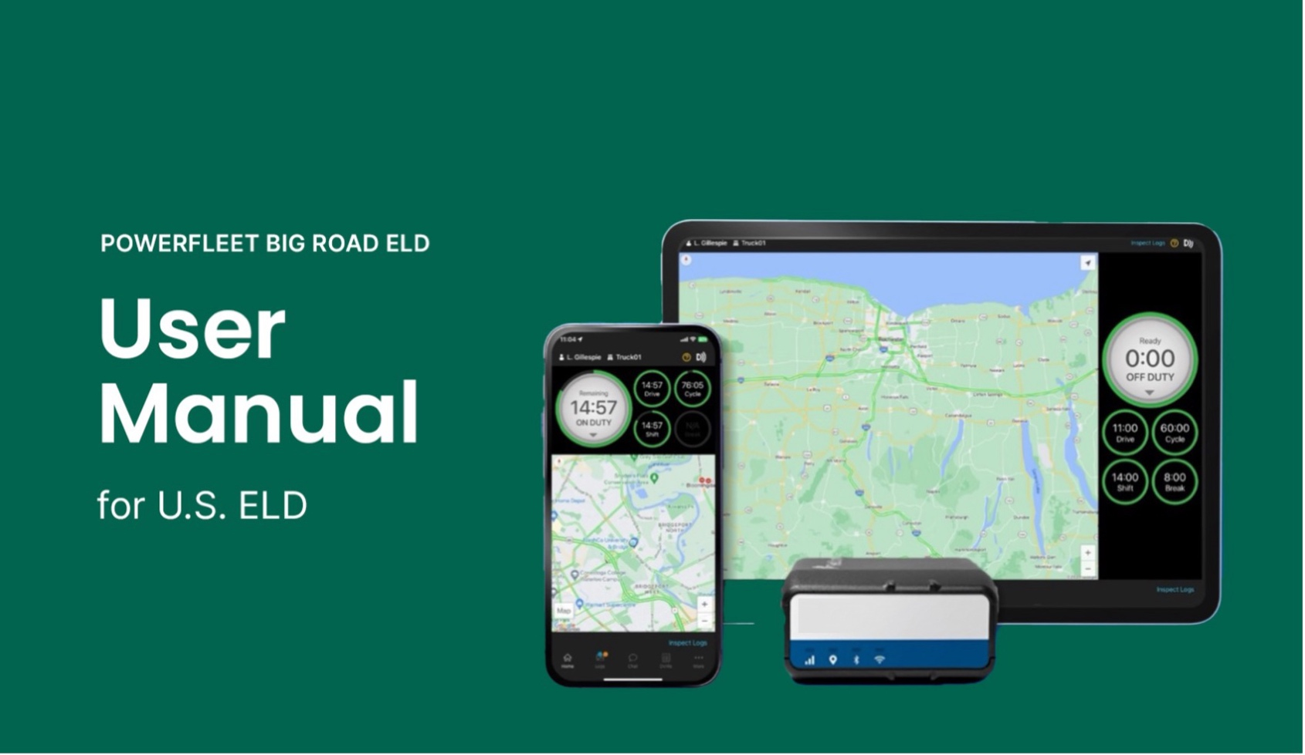

Contact Support

(P): 1-800-220-0779
(E): support@fleetcomplete.com
Contents
Getting Started 02
Using BigRoad 06
Roadside Inspection 24
Malfunctions 27
ELD Driver Card 29

Getting Started

Install Powerfleet BigRoad ELD
Before reading this manual, you must install your device. See the Install Guides for full instructions.

Click here to download the Install Guides.

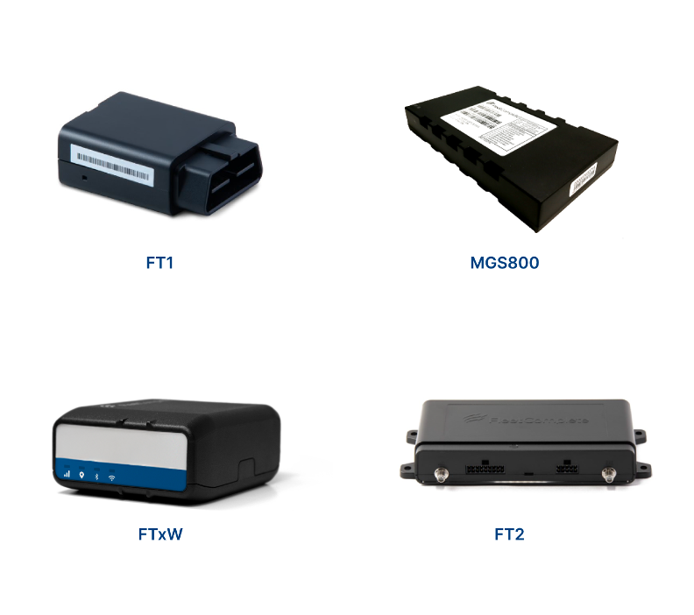
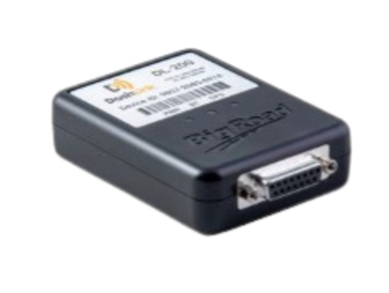
DL-200

Getting Started

Download the BigRoad Mobile App
If you've already received an email to join a fleet on BigRoad, follow the instructions in that email.

If you're a new user, begin by downloading the BigRoad Mobile App for iOS (Apple) or Android (Google).

HOW TO DOWNLOAD BIGROAD FOR IOS (APPLE)

- Tap on the App Store icon from your device.
- Enter BigRoad in the search bar
- Tap on Get and then Install.

HOW TO DOWNLOAD BIGROAD FOR ANDROID

- Tap on the App Store icon from your device.
- Enter BigRoad in the search bar and tap on the listing.
- Tap on Install.

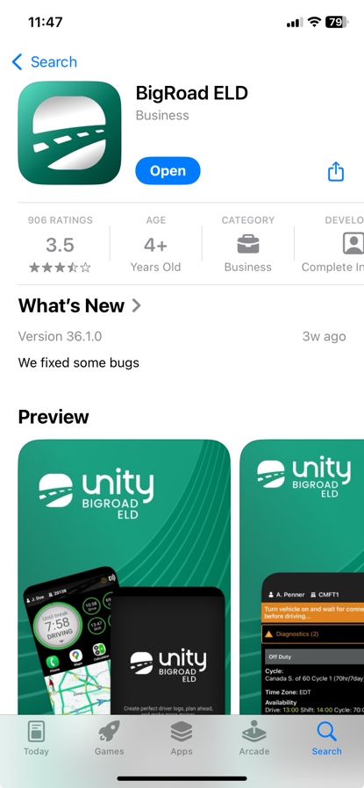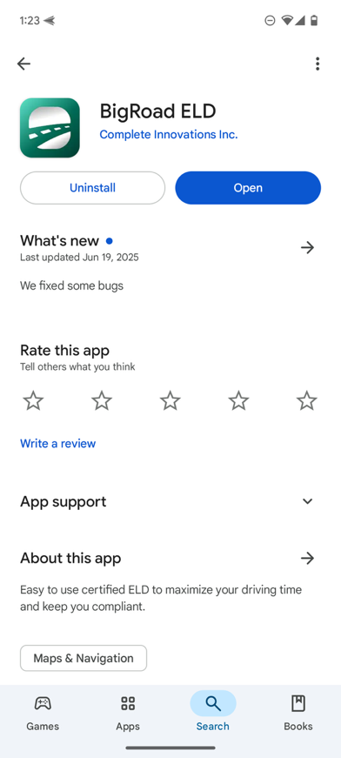

Getting Started

Sign Into Your Fleet

LOG IN TO THE BIGROAD MOBILE APP

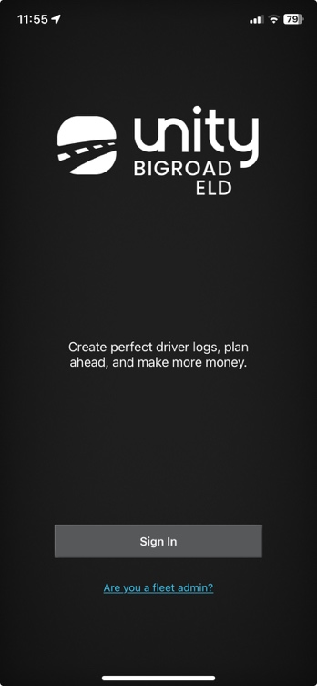
1
1
Launch the BigRoad Mobile App by tapping the BigRoad icon on your device's home screen.

2
2
Tap the Sign In button.

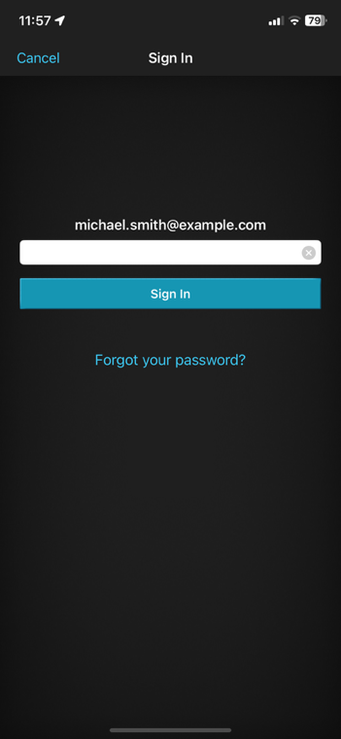

3
Enter your email address and password for the account that your carrier has set up for you.
3

4
Tap Sign In.
4

Getting Started

Log In to a Truck

CONNECTING TO A POWERFLEET BIGROAD ELD-ENABLED VEHICLE:

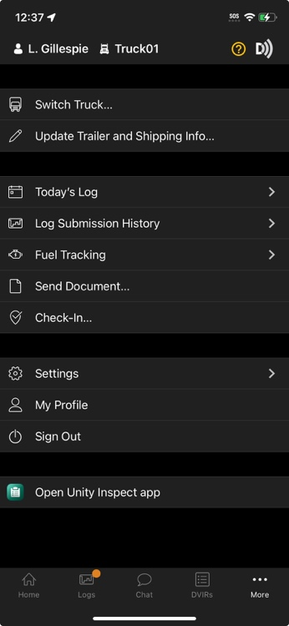

1
Ensure that the vehicle is running before you attempt to connect. If you are signed in to the app…
1
2
2
Tap the More menu.
2
3

3
Select Switch Truck.

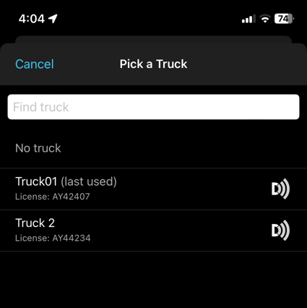


4
Select the truck you want to connect to BigRoad ELD. Note that BigRoad ELD-equipped vehicles will show a DashLink icon beside them.
4


5
BigRoad ELD should now be connected to your vehicle. Look for the DashLink icon in the top-right corner of the BigRoad Mobile App to confirm status.
5

NOTE: If your ELD-equipped vehicle has not been added to the BigRoad Mobile App, ask your carrier to add your truck. An Administrator must do this from the Fleet tab in the BigRoad Web App. ELD-equipped vehicles cannot be added or modified using the BigRoad Mobile App.

Using BigRoad

Duty Status Selector

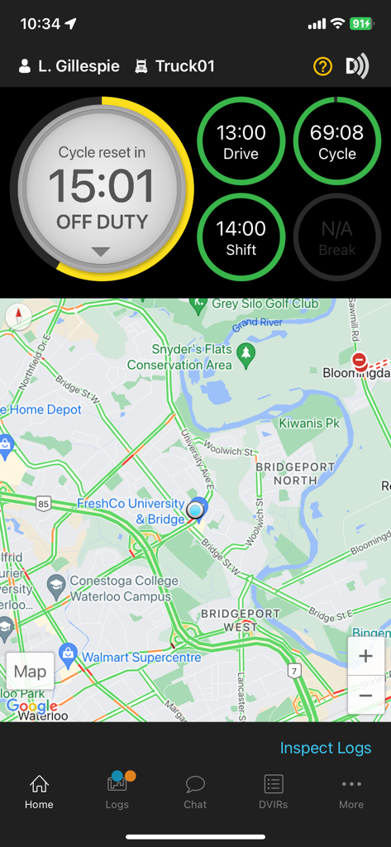
Easily change your current duty status and provide a visual indication of how much driving time, on-duty time, and break time is remaining.

Using BigRoad

Tracking Your Duty Status

AUTOMATIC DUTY STATUS SELECTION

- When connected to a Powerfleet BigRoad ELD-enabled vehicle, driving status will be automatically recorded once the vehicle begins moving at greater than 5 mph.
- After being stopped for 5 minutes or turning off your vehicle, your duty status will automatically be changed to On Duty (not driving).

AUTOMATIC DUTY STATUS SELECTION

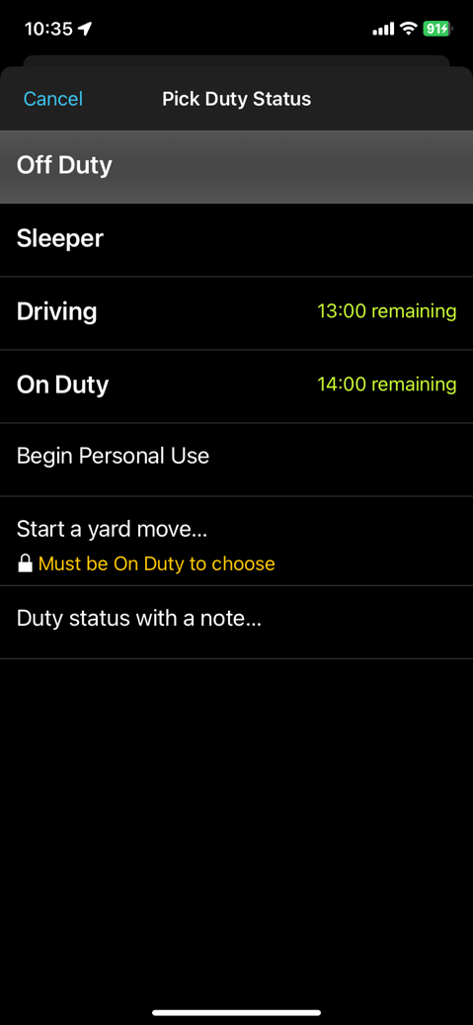
            - By tapping the duty status circle from the BigRoad Mobile App home screen, you can easily change your duty status. Driving is automatically recorded, however if it becomes necessary, you can manually set your duty status to driving.

            - The duty status circle will also show you how much drive and on duty time you have remaining.

Using BigRoad

Using The Daily Log List

The Daily Log List allows you to quickly find the daily log you want to review.

TO GET TO THE DAILY LOG LIST:

1
Tap the 'Logs' menu tab from the home screen.
1

Tap Daily Logs on from the home screen.

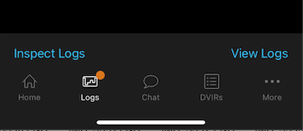
2
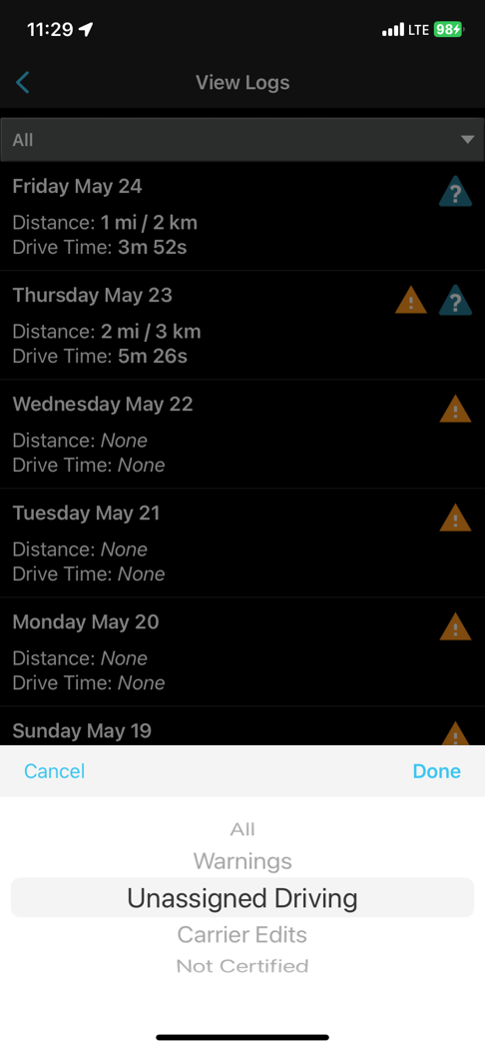
Tap on View Logs.
2

3
You will see a list of your logs for the past 14 days.
3
4
4
4
You can filter this list by Unidentified Driving, Carrier Edits, Warnings, or All.

This will help you to quickly find the log day you are looking for.

Using BigRoad

Editing Your Logs

TO ENTER EDIT MODE:

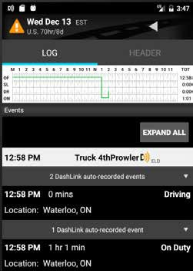
1
Continuing from the previous page, tap on the log day you want to edit to see details for that day.
1
2
2
You can choose to edit the Log or the Header tabs.

3
The Log tab contains all the event, DVIR, and certification information.

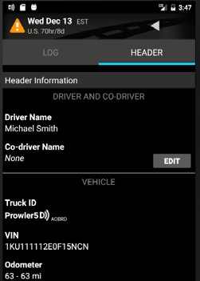
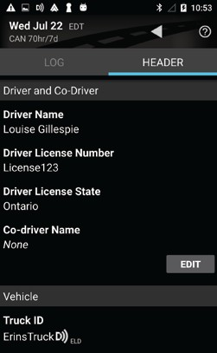

4
The Header tab contains driver(s), carrier and vehicle information.

Using BigRoad

Editing Your Logs

TO EDIT DUTY EVENTS:

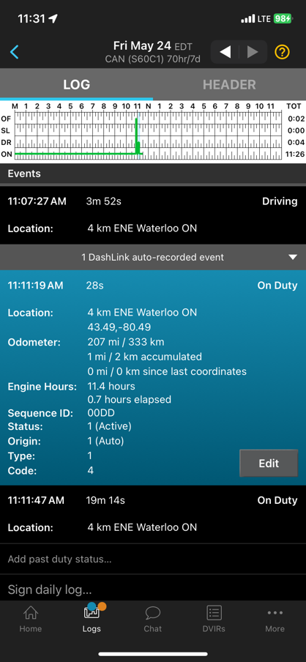
1
While in the Log tab, select the event you wish to edit. It will expand and display an Edit button.
1

2
Tap Edit.
2

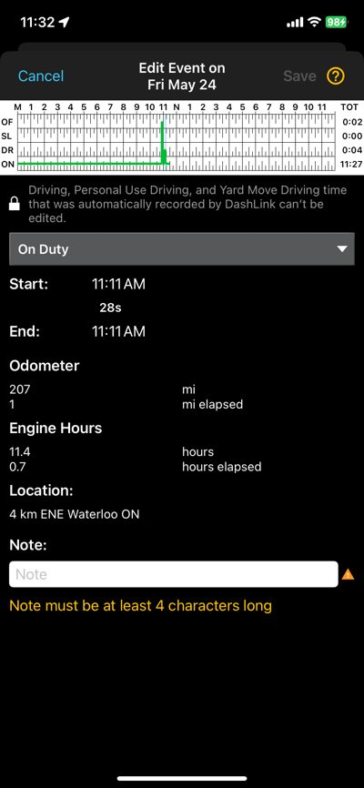
3

3
Add any changes or notes required to the duty status event.
4
Tap Save.
4

NOTE: Automatically recorded drive time, including PC or Yard Move, cannot be edited, only annotated. Drivers can edit the following event types:
    - Off Duty
    - On Duty, Not Driving
    - Sleeper

Using BigRoad

Editing Your Logs

TO EDIT THE HEADER:
While on the Header tab you can edit an event, select the event you wish to edit, and tap the Edit button.

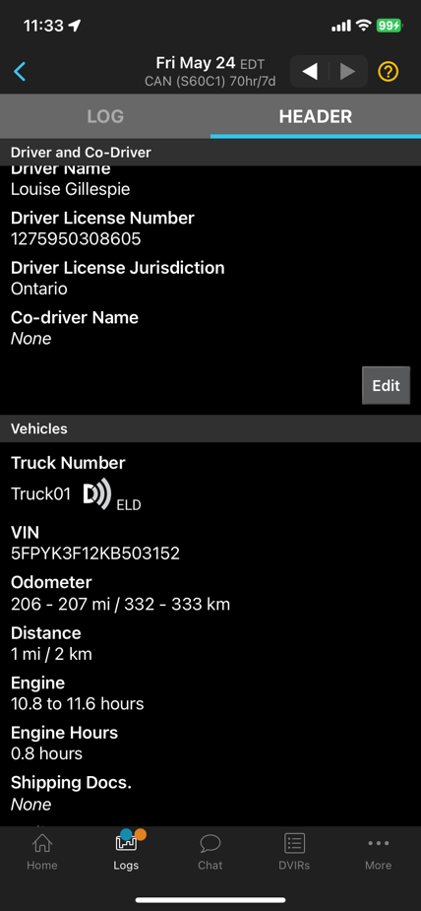
1
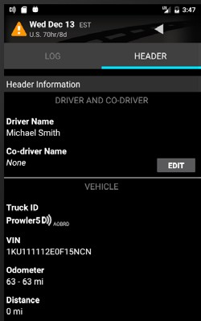
While in the Header tab, navigate to the section of the header that you want to edit.
1

2
2
Tap Edit.

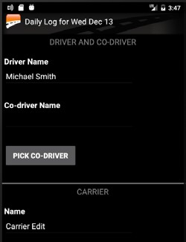
3
Add any changes you wish to enter
3

4
Tap Save.
4

Using BigRoad

Editing Your Logs

TO ADD A PAST DUTY STATUS:
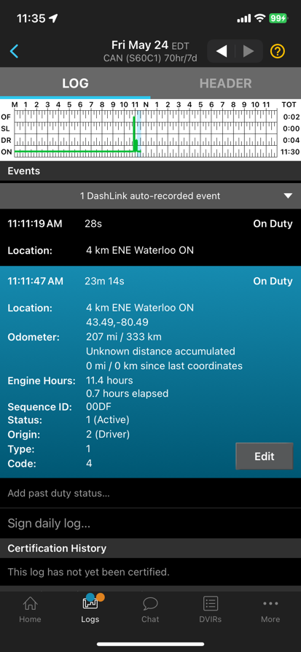
1
Tap Add past duty status to add a new duty status event to your log.
1

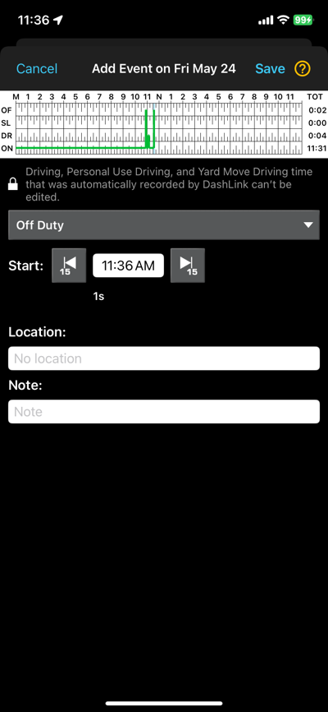

2
2
Select the Duty Status and Start Time.
4
3
3
4
Enter the Location.
Enter a Note.
5
Tap Save. The new duty status event will be reflected in your logs and your hours-of-service.
5

Using BigRoad

Log Warnings

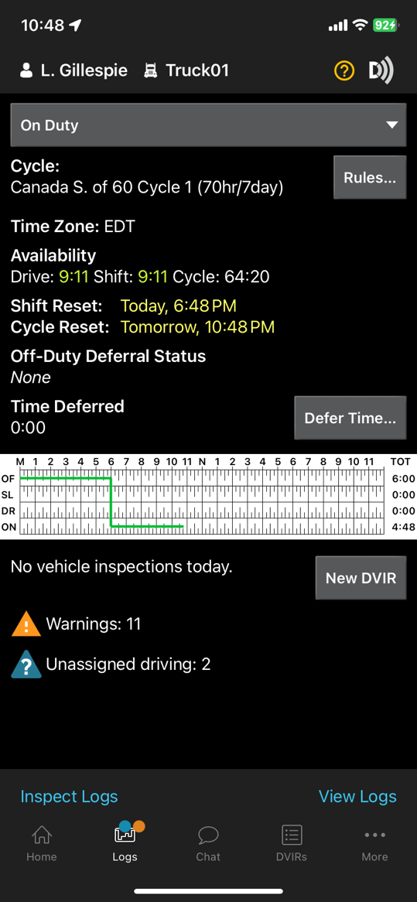

HOW TO IDENTIFY ERRORS OR OMISSIONS IN YOUR LOG:


The BigRoad Mobile App will identify any errors or omissions in your log and notify you using an alert icon. This will look like the small orange triangle with an exclamation mark shown here.

FIXING ERRORS USING EDIT:

To fix errors in your log, use the same process outlined in the Editing Your Logs section of this manual. Specific errors will be highlighted with the orange alert icon shown above.

Using BigRoad

Certifying Your Logs

WHEN YOU COMPLETE YOUR DAY, YOU’RE REQUIRED TO CERTIFY YOUR DAILY LOGS. TO DO THIS:

In the Daily Logs list, select the log day and open the Log tab.
- Tap Sign Daily Log or Sign All at the bottom, to sign Log and DVIR at the same time.

IF THERE ARE ANY ERRORS IN YOUR LOG, YOU WILL BE PROMPTED TO EITHER FIX THE PROBLEMS OR TO SIGN THE LOG NOW.

Follow the wizard to review any problems.

Once the problems have been addressed, tap Sign Daily Log again.

IF YOU HAVEN’T ALREADY ADDED YOUR SIGNATURE TO THE BIGROAD MOBILE APP, YOU WILL BE PROMPTED TO DO SO.

Using your touchscreen, draw the signature that you would like to use with your finger.

Tap Save.

Tap Sign Log.
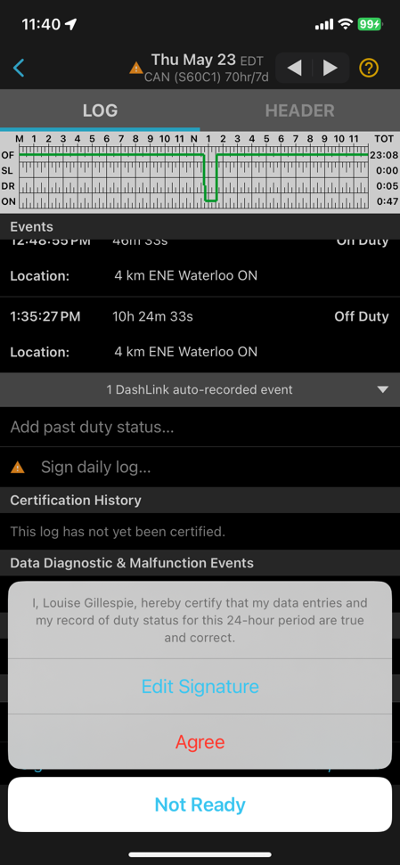

NOTE: Your Safety Manager can only make suggested changes to your log up to the time that you certified it.

Using BigRoad

Certifying Your Logs

POPUPS ON LOGIN AND LOGOUT FOR EMPTY & UNSIGNED LOGS
The BigRoad mobile app shows a popup on login and logout if there are log days that have not been signed.

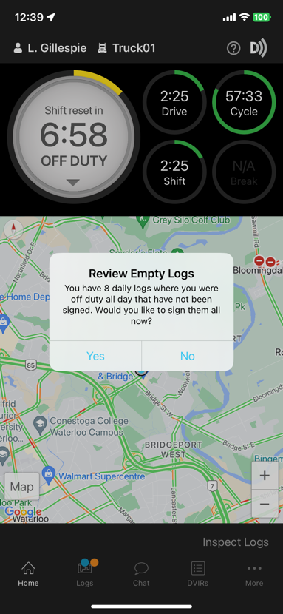
1
The first one on login asks drivers to sign all unsigned logs for the days they didn’t log in and there was no activity. This allows them to certify all logs at once when they return from time off.
1

2
2
The second pop-up at login asks drivers to sign the remaining unsigned log days that have activity. They need to sign these one at a time to ensure they review the activity before certifying it.

3

At logout, another pop-up asks drivers to sign all unsigned
Logs.

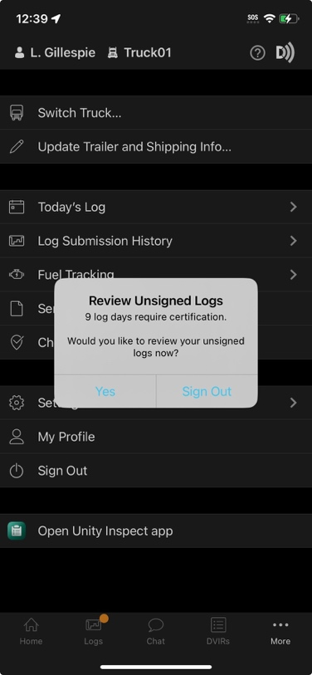
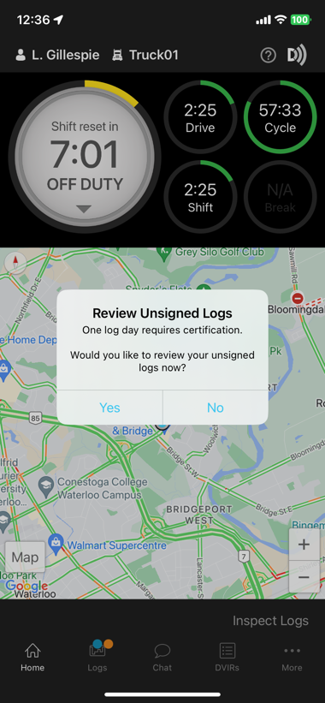

Using BigRoad

Unidentified Driving
Unidentified driving is recorded when a vehicle with a BigRoad ELD installed begins moving but there isn’t a driver signed in and connected to that truck. Drivers who subsequently sign in to the app and select that truck will be notified that there is unidentified driving to review. This is also called unassigned driving within BigRoad until it is assigned to a driver.

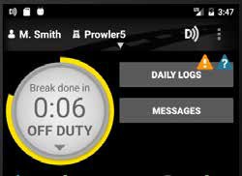
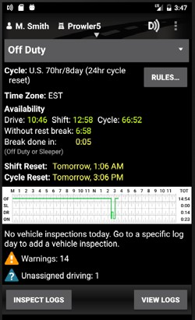
1

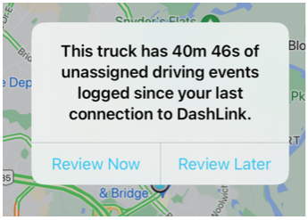
TO REVIEW UNIDENTIFIED DRIVING EVENTS:
Tap Review Now from the pop-up notification or from the Home screen of the BigRoad Mobile App, tap the
1
Logs Menu tab.


The Logs screen in the app will indicate if there are 1 or more days with unidentified driving events that have not yet been reviewed. This will be called Unassigned driving.

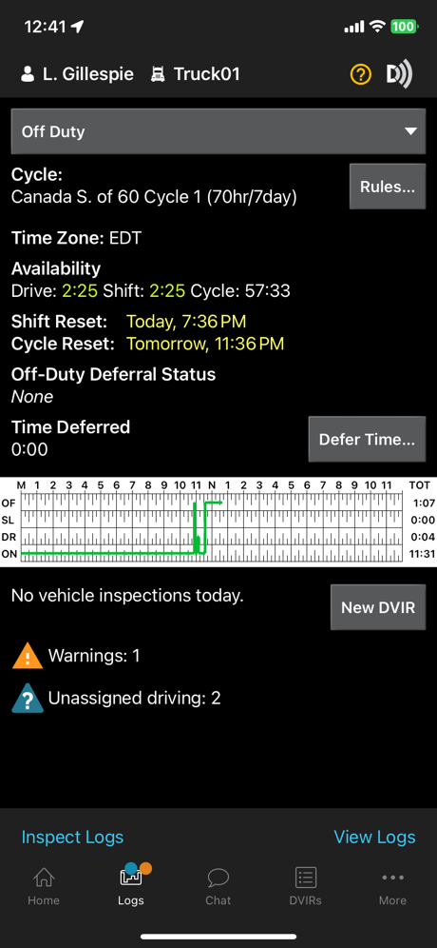

There will also be an indicator that unidentified driving exists above the Logs menu icon.
2

2

Tap the Unassigned driving text at the bottom of the screen. This will take you to the list of days with unassigned driving events that have not been reviewed yet.
3
3
4
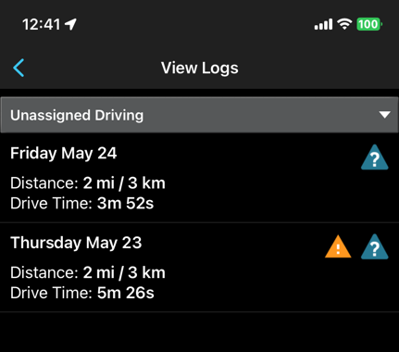
When you open a log day with unassigned driving events, you will see a box indicating there is at least one unassigned driving event to review. Tap this box to review the list of events in a drop-down menu.
4

Using BigRoad

Unidentified Driving

1
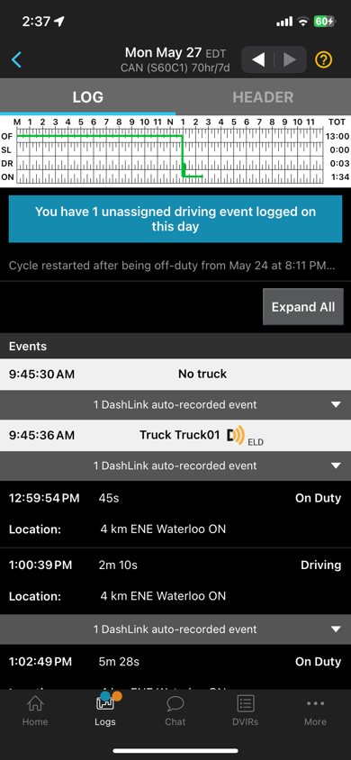
Review each unassigned driving event that was tracked and has not been assigned to yourself or to another driver.
5

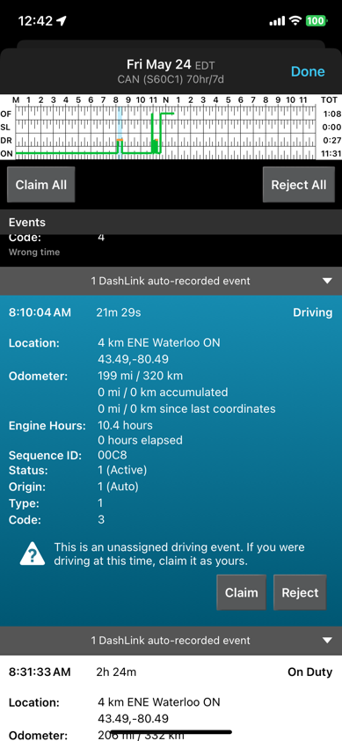

6
2
For each event that belongs to you, tap the Claim button.

3
If an event does not belong to you, tap Reject.
7

- You will not be prompted again for events you have rejected. These events will be listed in a report available on the BigRoad Web App for review by Fleet Administrators.

For convenience, you may also claim or reject all events that have occurred on a particular day.

Using BigRoad

Unidentified Driving

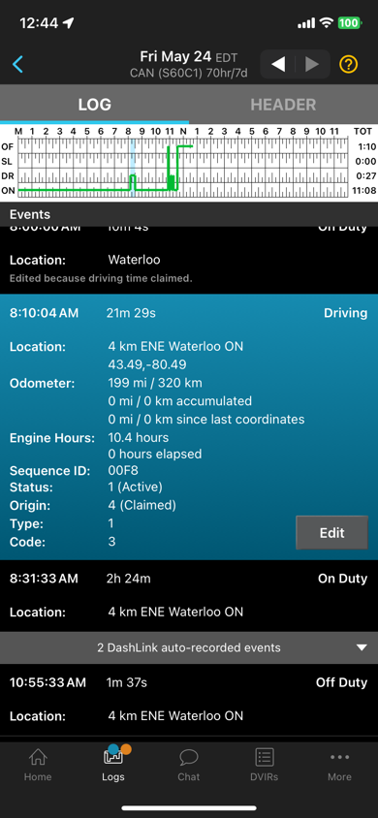
TO UNDO UNIDENTIFIED DRIVING EVENTS
CLAIMED IN ERROR:
If an Unidentified Driving (UD) event was claimed in error, the driver or support person can UNDO the claim and re-assign it back to Unidentified driving. This ability is available on both the Mobile and Web apps.
5
1

To UNDO a UD event claimed in error, start by tapping EDIT on the event.

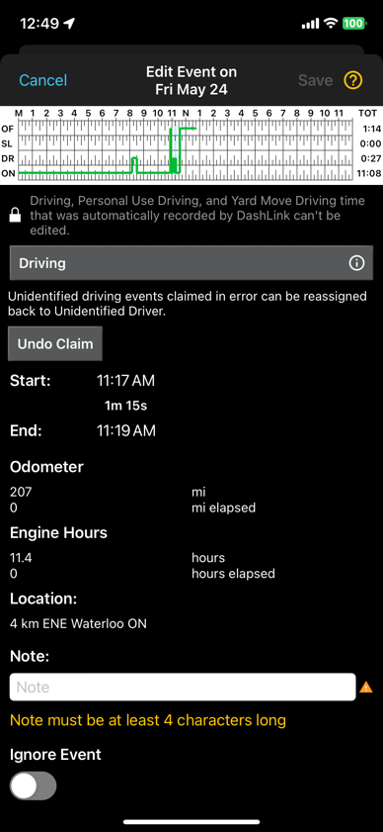

6
2
Tap the Undo Claim button.

3
After confirming, the UD event will no longer appear under their logs and it will be re-assigned as an unassigned event which can be claimed by any other driver in that fleet or annotated by the fleet safety manager on the web app.
7

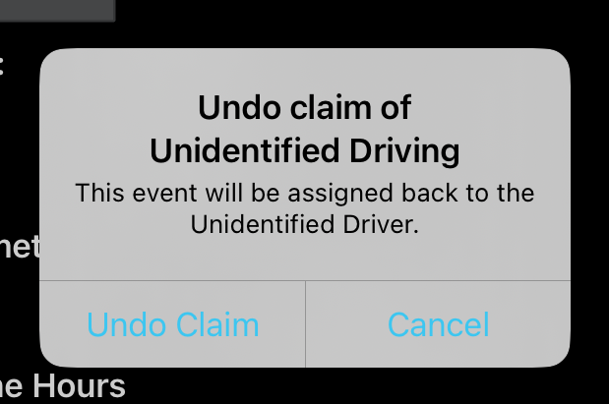

Using BigRoad

Approving Carrier Log Edits
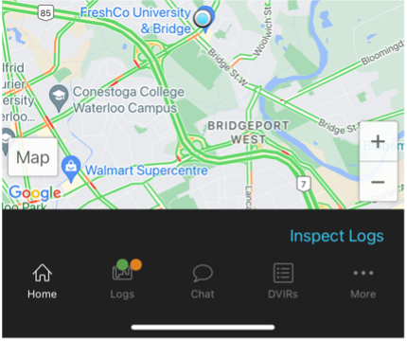

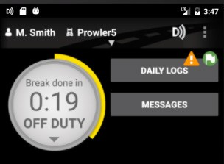
If your carrier has made suggested edits to your daily logs, there will be a green indicator above the Logs menu tab on the BigRoad mobile app Home screen.

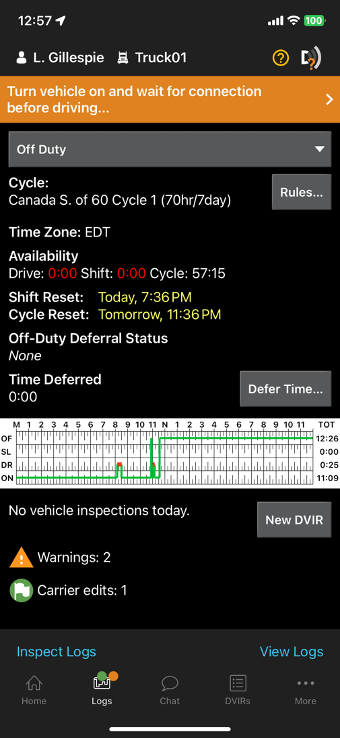
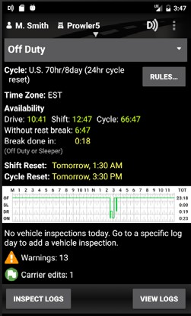

TO REVIEW THESE SUGGESTED EDITS:
1
From the home screen of the BigRoad Mobile App, tap the
1
Logs menu tab.

2
The app will indicate that there are any days with carrier edits that have not yet been reviewed.
2

3
3
Tap the Carrier edits text at the bottom of the screen. This will take you to the list of days with carrier edits that you have not yet approved or rejected.

4
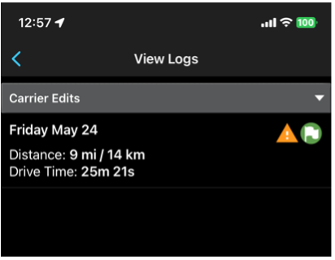
Select a day you want to review the carrier edits for.
4

Using BigRoad

Approving Carrier Log Edits

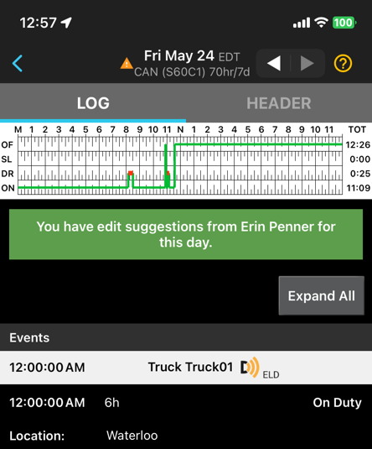
1

In the daily log, tap the green banner outlining the changes to review them.
5

2
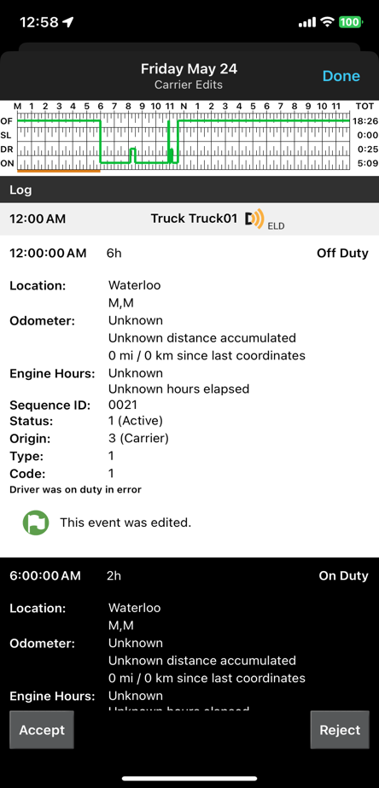
You will see all suggested edits indicated by a green circle with a white flag and a note from the Safety Manager explaining why the changes were made.
6

                - In the list, any newly created or edited events will appear in white with a green flag icon.

                - Any inactive events will be hidden by default but can be expanded for review by the driver.

3
You will have the ability to accept or reject these edits.
7

                - If you accept the edits, they will be added to your log and you will be prompted to recertify the log.

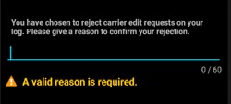
                - If you reject these edits, you will be required to provide a reason and your log will remain unchanged.

Using BigRoad

Hours of Service (HOS) Rule Limit Notifications

When a driver is approaching the last 30 minutes of an HoS rule limit, or they have already run out of time when they sign in, the BigRoad ELD app notifies them.

It’s important to have app notifications enabled on the driver’s mobile device for BigRoad ELD to be warned of upcoming time limits.
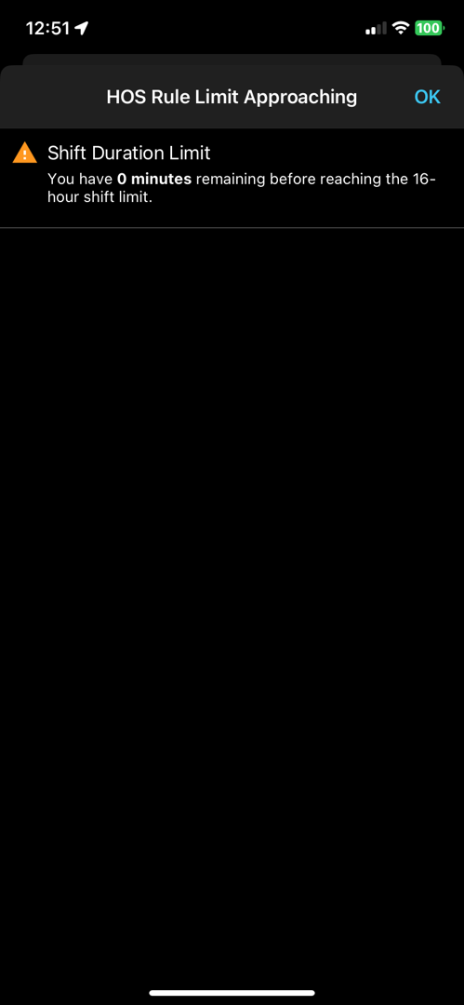
- The driver will receive a notification in the form of an in-app full screen alert
- When the HOS rule limits for duty-/driving hours have been reached, the warning for that specific limit will disappear from the logs screen

Using BigRoad

Team Driving

Some drivers work together and drive as a team to cover more ground and deliver loads in a timely manner. BigRoad accommodates team driving with a few easy steps. For illustration, let us assume Driver A is the person Driving, and Driver B is the co-driver.

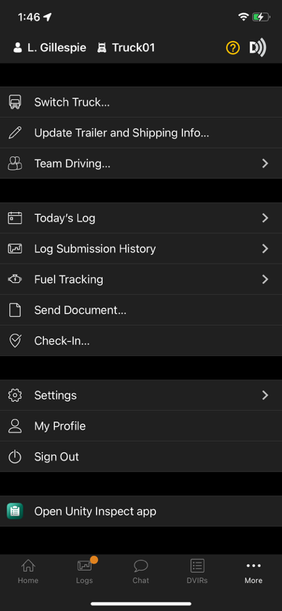
To start Team Driving:
Complete the following steps:
              - Select the Same Truck
1
              - Driver A signs in to the BigRoad Mobile App
              - Select the truck from the Pick a Truck Screen
              - Tap ‘More’ from the main screen & Tap ‘Team Driving’
2
• Tap the button, ‘Start Team Driving’
  - The Driver (Driver A) is now taken to a list of drivers on their fleet that they can choose as co-driver (Driver B).
• Confirm the co-driver selection prompt.
3
  - Driver B will now receive a pop up to accept/reject the team driving request.
  - Once Driver B Confirms, team driving has started.
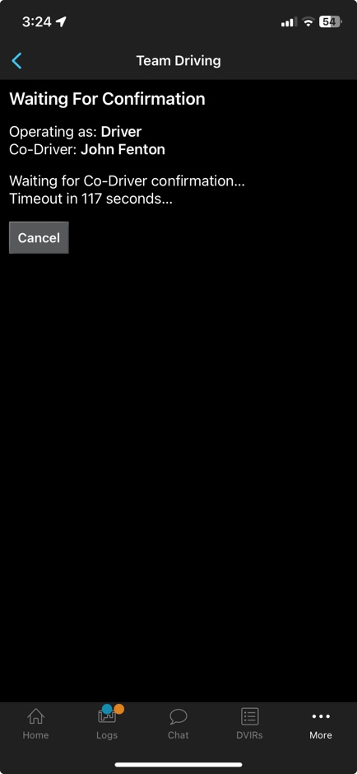
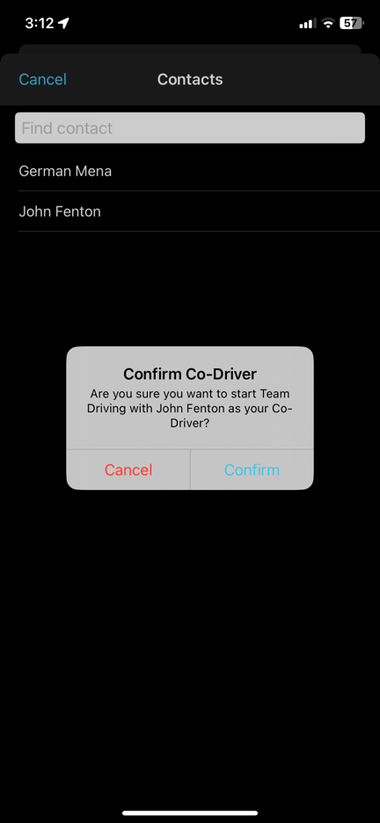
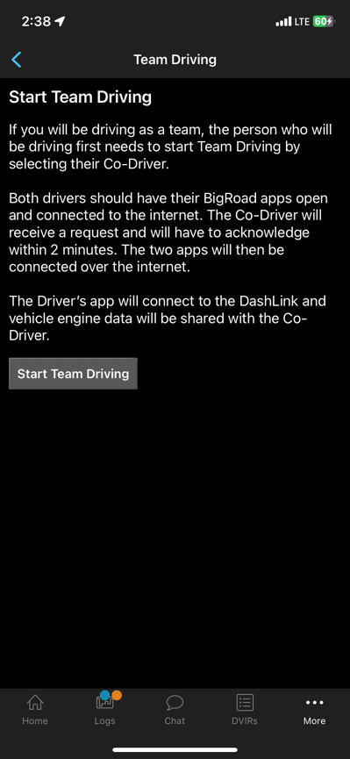
Note: It may take a few seconds to display the team driving request in-app. The drivers’ names will appear on each other’s daily logs as a co-driver. Once movement is detected Driver A’s app will be locked however driver B will be able to make changes.

Using BigRoad

Team Driving

TO SEE TEAM DRIVING STATUS:
On the home screen, tap the Team Driving icon next to the driver’s name. The Team Driving status will be displayed.

TO END TEAM DRIVING:

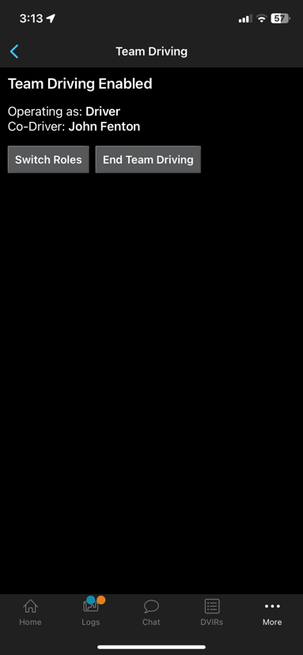
When the vehicle is not moving and team driving is complete for the shift, navigate to More and select Team Driving to end the Team Driving connection.
1

2
Upon confirming, one driver receives a notification that Team Driving has been ended by the other driver.
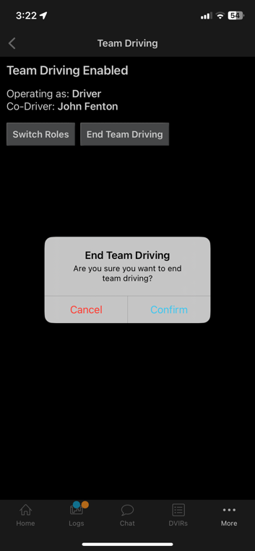
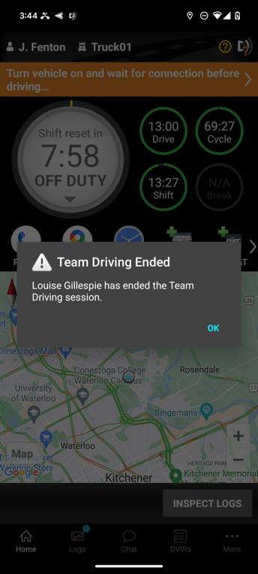

3
Drivers can now operate as single drivers.

Roadside Inspection

Using Inspection Mode and Sending Your Electronic Records of Duty Status (eRODS) To The FMCSA

HOW YOU WILL BE INSPECTED:
You'll be inspected based on the configuration of the truck you're currently driving. If you're driving a truck that's configured for ELD, you'll be inspected against ELD Regulations.
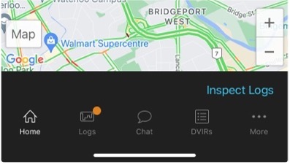

INSPECTION MODE OPTIONS FOR ELD USERS:

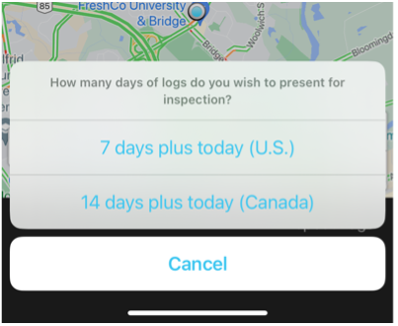
This option allows you to send your logs to the FMCSA via web services or email. To send your logs to the FMCSA:

1
1

2

3

4

5

6
Tap on Inspect Logs from the Home screen.
2
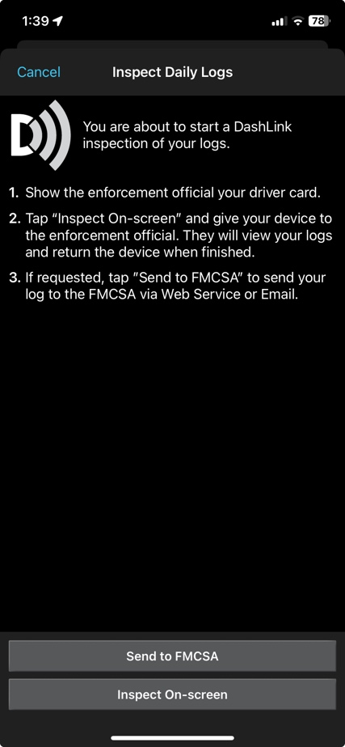
Choose ‘7 days plus today (U.S.)

3
Tap Send to FMCSA.

4
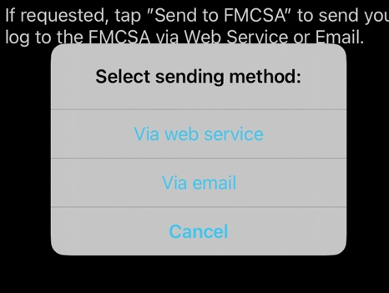
Select Via web services (preferred) or Via email.

Roadside Inspection

Using Inspection Mode And Sending Your Electronic Records of Duty Status (eRODS) To The FMCSA
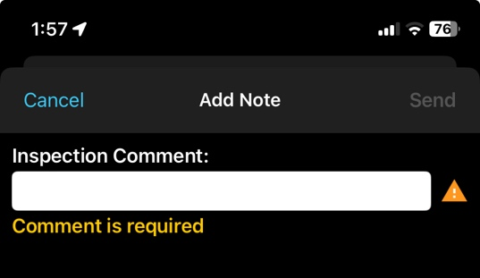
1
Enter the inspection comment provided to you by the safety official (required) then tap Send.
NOTE: After hitting Send, you will see a message indicating that you were successful or unsuccessful. If you were unsuccessful in transferring the logs to the FMCSA, you can show your logs on-screen instead.

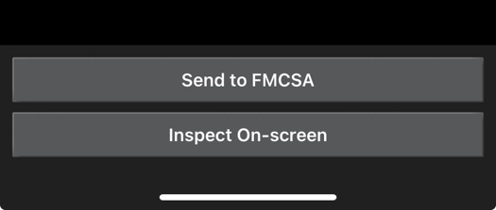

INSPECT ON-SCREEN
2
This option allows the officer to view your logs on screen. Follow steps 1 through 4 on previous page.
1

2
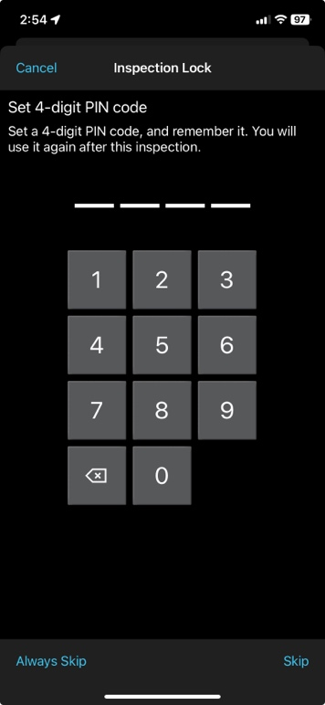
3
Select Inspect On-Screen.

4
The driver will be prompted to setup a pin so the safety official can only see the Inspection Mode data. There is an option to skip this step.

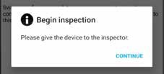

3
5
BigRoad will advise you to hand over your device to the inspector.

Roadside Inspection

Using Inspection Mode And Sending Your Electronic Records of Duty Status (eRODS) To The FMCSA
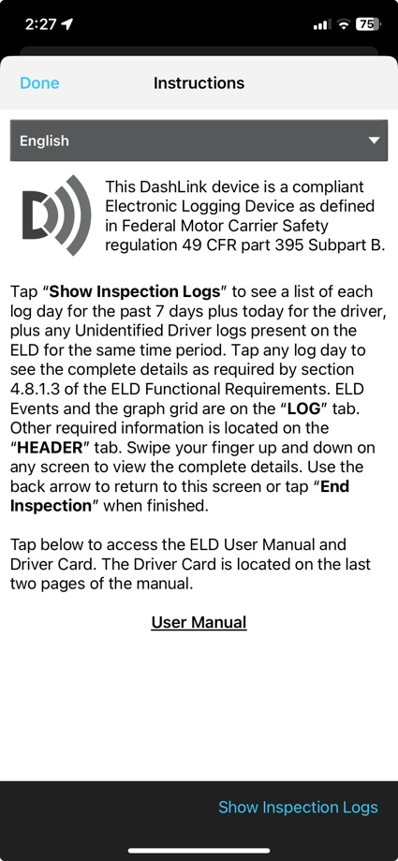

Upon tapping Continue, more information about the regulation is shown to the safety official.
They can choose which language to view the logs in.
They can access the ELD User Manual (this document) using this link for detailed information.

Then they will select ‘Show Inspection Logs’

From the list of logs, tap on any log day to explore details on the below tabs:
- Log – containing all events
- Header – information about the log day
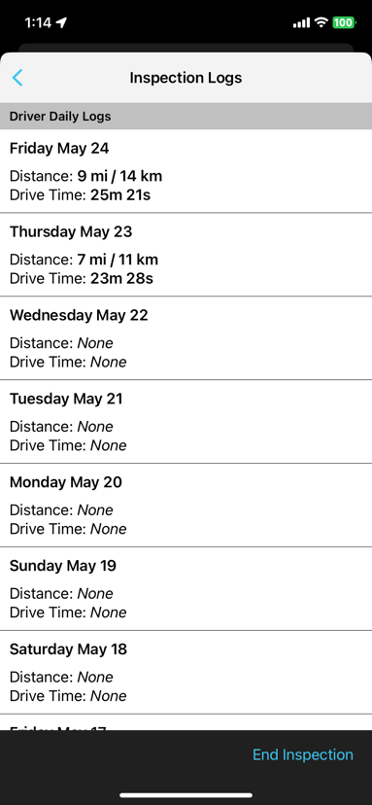
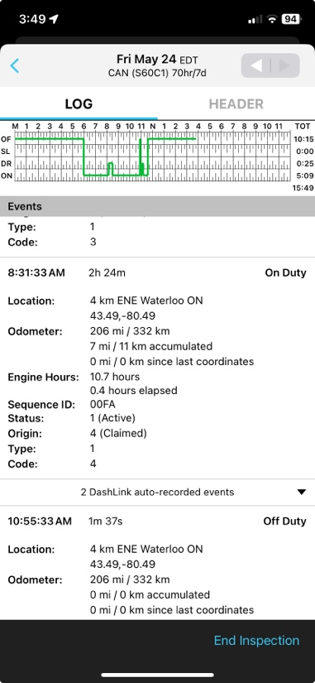
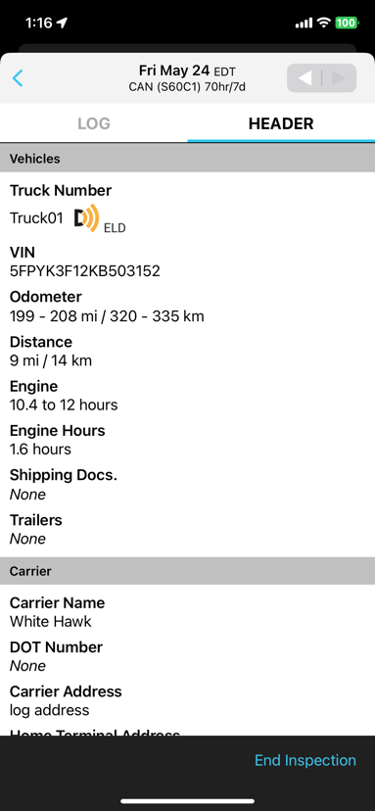
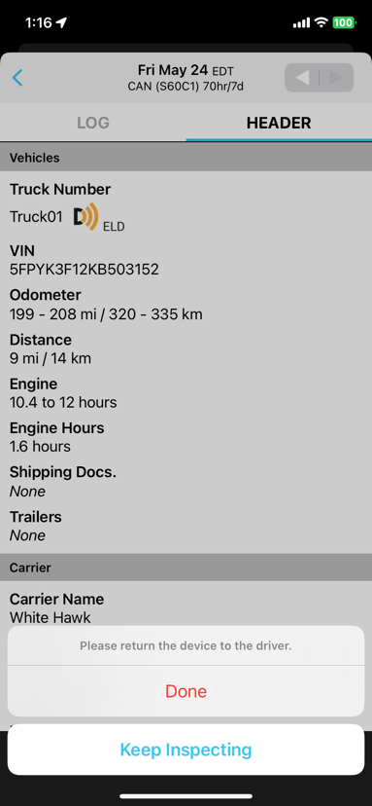
After reviewing, tap End Inspection and tap Done.

BigRoad

Instruction Sheet for Diagnostics & Malfunctions

Powerfleet BigRoad ELD self-monitors for issues that prevent it from logging in a compliant manner and creates diagnostic & malfunction events in your logs when certain data is not present.

This is an instruction sheet for the driver describing the measures to take when the ELD malfunctions.

When there is a diagnostic/malfunction issue, the BigRoad Mobile App will notify on-screen in red or orange banner on top. Usually, these diagnostic issues will resolve themselves quickly. However, if they persist, a malfunction/diagnostic code will be set. Below is a list of Malfunction/diagnostics codes which may show up in case of any issues.

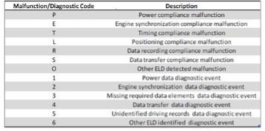

For persistent diagnostic issues, some basic troubleshooting may resolve the problem (see next page).

Please contact Powerfleet Support if you need further assistance. Powerfleet can be reached at 1-800-220-0779 or support@fleetcomplete.com.

If a malfunction occurs that cannot be resolved by yourself or Powerfleet BigRoad Support, please refer to the ELD Driver Card / Quick Instruction Sheet.

You must switch to paper logs when the Powerfleet BigRoad ELD is malfunctioning and immediately notify your carrier.

Your carrier must arrange for the unit to be fixed within 8 days, or they must request an extension from FMCSA.

When your BigRoad ELD is malfunctioning, you can continue to use the BigRoad Mobile App to show any past logs that remain accessible, correct, and certified. Any days where the log is incomplete or cannot be certified must be reconstructed on paper. You must always carry blank paper logs with you in case they are required.
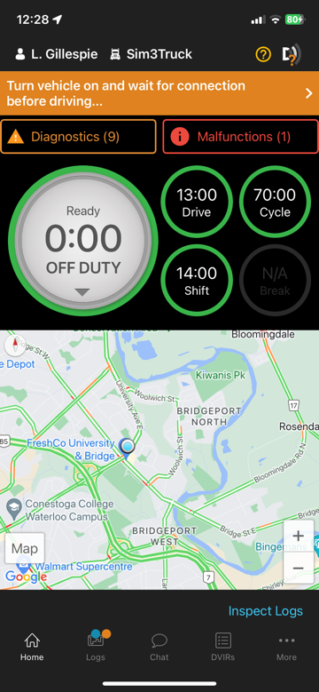
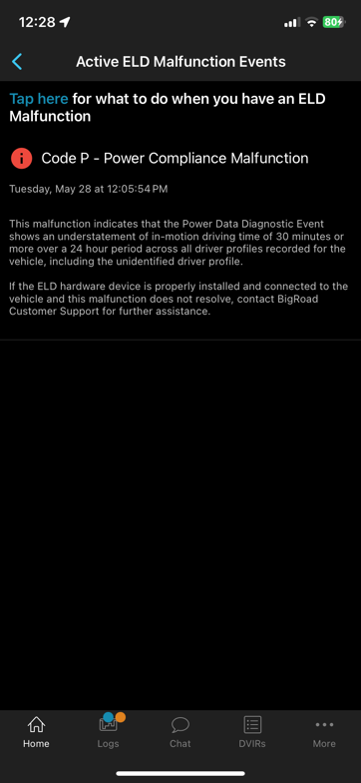

BigRoad mobile app showing diagnostic & malfunction notifications and a sample of malfunction details.

BigRoad

Basic Troubleshooting for ELD Device Hardware

DIAGNOSTIC | ISSUE | RESOLUTION
Lost ECM connectivity | Loose BigRoad ELD cable  Loose diagnostic port cable | Check that the cable is firmly attached to vehicle's diagnostic port and to the BigRoad ELD unit.  Check that the diagnostic port housing remains solidly in place and that no wires have become detached from the back of the port.
Lost GPS connectivity / Lost timing compliance | BigRoad ELD not receiving strong enough GPS signal:  Red LED blinks 3-1 or 3-4 pattern on MGS800 & MGS700  GPS LED flash count (x3 times) on FT1  On DL-200 the GPS LED is not lit | Reposition BigRoad ELD so that the top of the unit is facing up and no metal panels are obstructing the view of the sky.
Cannot connect to BigRoad ELD | Bluetooth not enabled  Wrong truck selected.  Vehicle not equipped for ELD.  Wrong Device ID set for vehicle  Bluetooth not connecting | Turn on Bluetooth on your mobile device.  Select the correct truck via Switch Truck.  Contact your fleet manager to enable DashLink logging (ELD) for your vehicle.  Contact your fleet manager to ensure the Device ID set on the truck matches the ID or serial number on the BigRoad ELD unit.  Restart the mobile device and re-select the truck in the BigRoad Mobile App.


ELD DRIVER CARD/QUICK INSTRUCTION SHEET
BIGROAD ELD


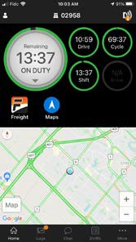
BigRoad mobile app with
dashlink connection
DASHLINK STATUS
DRIVER & TRUCK
COUNT-DOWN CLOCK & DUTY STATUS

QUICK LINKS TO USEFUL APPS
DVIRS (CREATE, MAINTAIN, SEND, INSPECT)
BigRoad ELD certification

The BigRoad Mobile App used with a Powerfleet BigRoad ELD device (FT1, FT2, FTxW, MGS800, MGS700, DL-200) complies with ELD mandate requirements defined by FMCSA in 49 CFR part 395.15 for ELD devices in the U.S.A. when used as instructed in the ELD User Guide.

CURRENT TRAFFIC CONDITIONS

LOGS

SETTINGS & TRUCK SELECTION & DOCUMENT CAPTURE

INSTANT MESSAGE

Addressing ELD malfunctions
How do I know I have a malfunction?
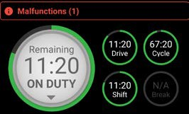
When a red banner appears
at the top of the app. It says ‘Malfunctions’ and indicates the number of active malfunctions.

What do I do during an ELD Malfunction?
In the event of an ELD malfunction, a driver must:
- Call BigRoad Support at 1-888-305-8777 ext. 1 to troubleshoot the issue.
- Note the malfunction of the ELD and provide written notice of the malfunction to your motor carrier within 24 hours.
- Reconstruct paper records of the duty status (RODS) for the current 24-hour period and the previous 7 consecutive days.
- Continue to manually prepare RODS in accordance with 49 CFR 395.8 until the ELD is serviced and back in compliance.
What does my motor carrier need to
do during an ELD malfunction?
If an ELD malfunctions, a motor carrier must:
- Correct, repair, replace, or service the malfunctioning ELD within 8 days of being informed of the condition.
- Require the driver to maintain paper records of duty status (RODS) until the ELD is back in service.
- Require the driver to maintain paper record of duty status (RODS) until the ELD is back in service
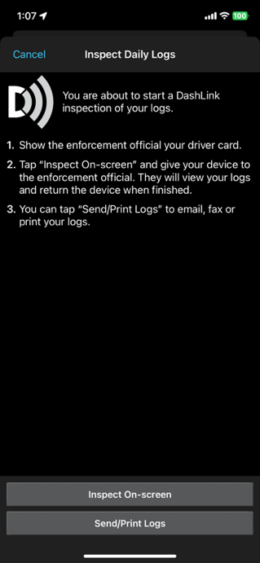
- If more time is required to resolve the issue, the carrier must notify their state FMCSA Division Administrator as part of 395.34 (2). For non-US operators, this can be the nearest state.
Driver inspection instructions
- Select Inspect Logs from the home screen and pick ‘7 days plus today (U.S.)’
- To submit logs electronically, ensure you are connected to your running vehicle.
  - Select ‘Send to FMCSA’ then ‘Via web service’ (preferred) or ‘Via email’.
  - The safety official will provide you with an ‘Output File Comment’ and an email address.
  - Tap Send and the safety official will receive the file.
- To show logs on-screen, tap ‘Inspect On-Screen’.
  - Set a pin code to prevent the safety official from navigating to other areas of your app or Skip
  - You should see a DashLink logo and instructions to start an ELD inspection.
  - Give the safety official your device and this instruction card.
- If a safety official requests your ELD Information Packet, follow step 3 above.
There is a link to the User Manual/ELD Information Packet on the Instructions screen

BigRoad ELD safety official’s guide to viewing logs on-screen

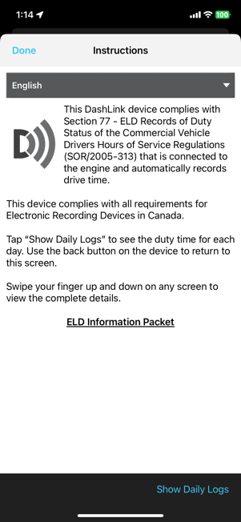
The DashLink logo verifies that the hardware is engine-connected and functioning correctly. If you do not see the logo, the driver is not using an ELD.

If you see this icon on the inspection screen, then the ELD device is malfunctioning. When malfunctioning, the driver will show paper logs for the drive time that transpired during the malfunction. Logs prior to the malfunction can be viewed on the phone or tablet.

*Tap Show Daily Logs to see log details.

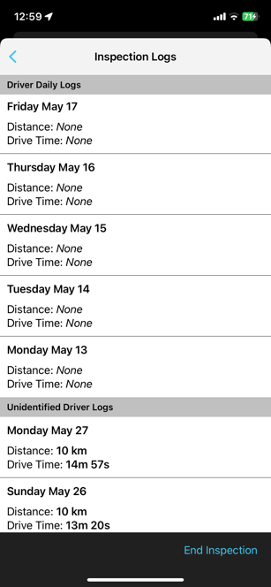

Tap any day to see detailed logs for that day.

Tap to review any unclaimed unidentified driving.

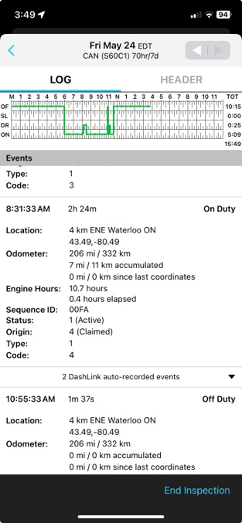

Tap the HEADER tab to view a list of vehicles, trailers, active Data Diagnostic and Malfunction Status, and other information for this log day.
The graph grid shows the driver’s drive, on-duty, off-duty, and sleeper berth time for the day.

Each duty status event is listed with required information, such as duration, location, and vehicle odometer/hours.
Need help?
Contact Support at
1-800-220-0779 or
support@bigroad.com

Tap the DashLink auto-recorded events sections to see details of non-duty status events recorded by the ELD.
