Document Information
Version History
Revision | Date | Author | Reviewer
V1.0.0 | 04/27/21 | V.Patel | M.Hupa
Change Log
Change | Page

Table of Contents
I. Introduction 2
II. Application Operation 2
III. Select Your Vehicle 3
IV. View Logs / Download Logs 3
V. HOS Features 5
VI. DVIR Features 6
• Setting up the DVIR for each vehicle 7
• Viewing the DVIR through the AAT System Portal 7
VII. Sharing Data & Reports 8
VIII. Additional Drivers 8
IX. Setting-up Drivers and Additional Options 9
X. Un-Identified Driving Events 9

Introduction
This manual is intended for Drivers and Users of the AAT HOS / DVIR application. This guide assumes that the application has already been downloaded by the Client and set-up for general usage by AAT for the Client.
This guide will go-over and show how to access certain application functions of the AAT Electronic-Logging-Device (ELD), Hours of Service (HOS), and Driver Vehicle Inspection Report (DVIR) solution.
These applications can be used on a fixed device that is already permanently fixed into a vehicle or its provide the option for multiple Users/Drivers to use in multiple vehicles.
The vehicles should already be equipped with AAT Diagnostic and GPS vehicle hardware that obtains vehicle data and then transmits this data to the AAT servers and to the AAT HOS Mobile application.

HOS APP DVIR APP
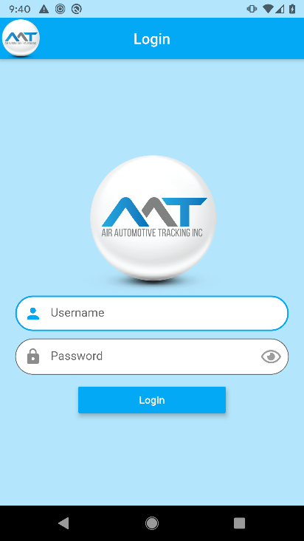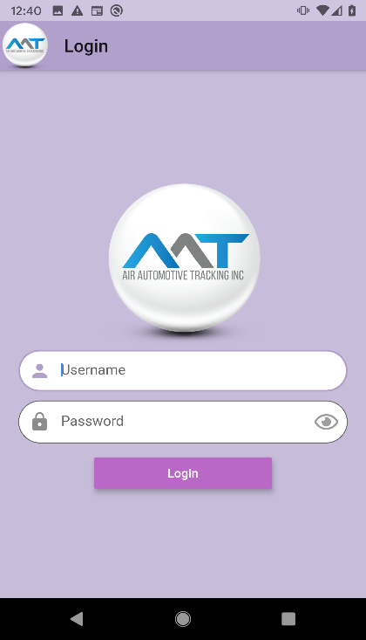
Application Operation
Login-Screen
The first step to access the AAT mobile applications is to enter your provided credentials. The login name and password are provided in the AAT email you should have received after completing your Online registration and set-up.
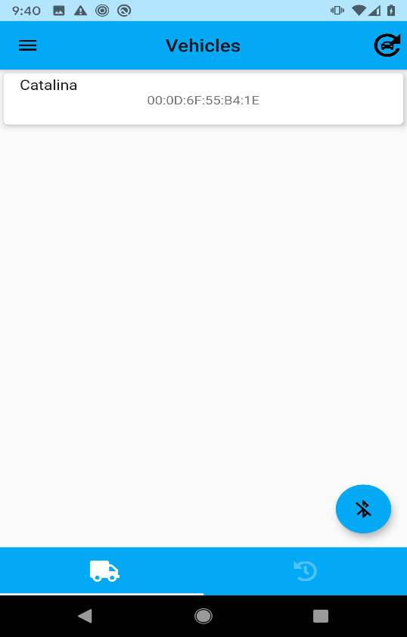
Alternatively, if your organization has already provided this information, and completed the set-up process for you, then AAT would have provided a list of drivers and their passwords. Please then contact or consult with your organization in order to obtain the correct login and password.
Select Your Vehicle

If the Driver’s mobile device is not already associated to a certain vehicle, then the driver will see the screen to the right upon login. If the driver only has permission to view/drive one vehicle, there will only be one vehicle option to choose from.
If the driver is in close proximity to the vehicle and has the appropriate permissions to drive the vehicles they are standing next to, then the vehicle name and VIN should appear in the screen provided.
Please just select the vehicle that you will be operating from the list.

View Logs/ Download Logs
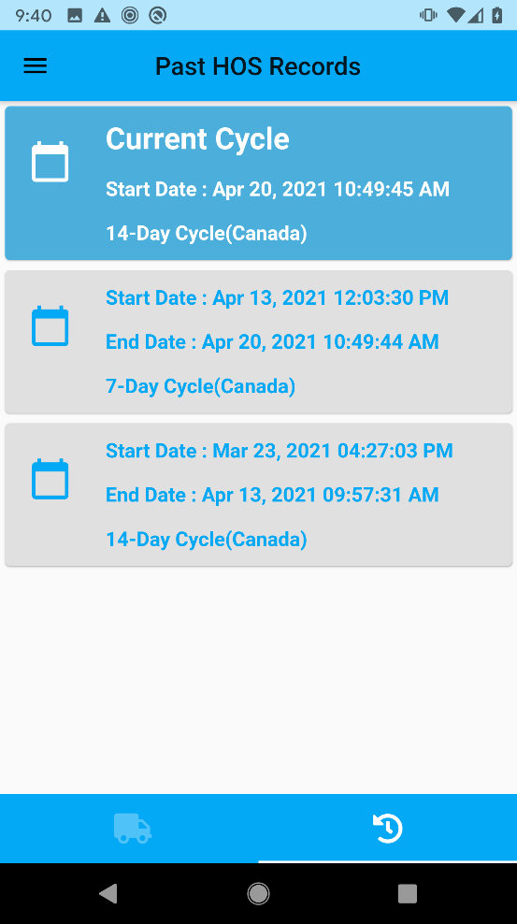
At the bottom right of the screen is the log history button .
These can be accessed and viewed before selecting vehicle and going On-Duty.
Toggling between the DVIR and HOS section will allow the driver to view the specific type of report for the specific day they are interested in.
The driver can select the log history button with the correct corresponding date to view his own driving logs.
No matter what vehicle was driven, selecting the buttons at the bottom of the screen will show the Driver’s logs for the present day and the last 6 months logs by each cycle.
By tapping on the any of the cycles, the driver will then be able to see each days history for the selected cycle on the screen. Drivers will be able to see the start time of every day of the cycle selected.
By tapping on each day, drivers will be able to see the second screen ( as shown on the next page) with the graph of their duty statuses for the day. By scrolling down, they will also be able to see their rule violations and remarks for that day. At the bottom ( as shown by the third image on the next page), drivers will be able to see the summary of the day and the optional buttons to download the log file and ELD Data file for the day.
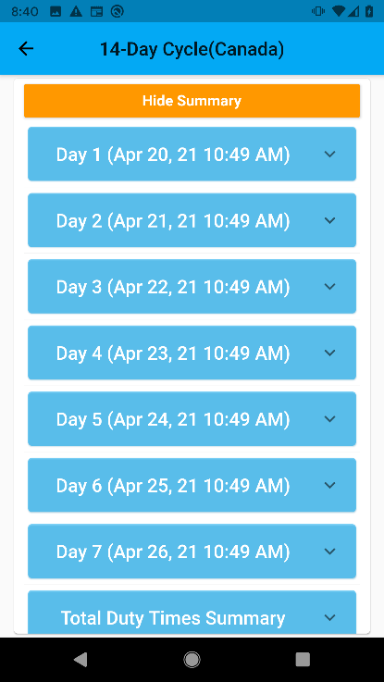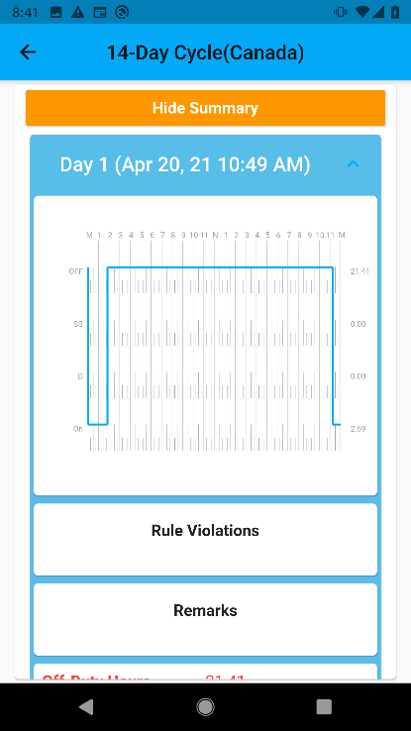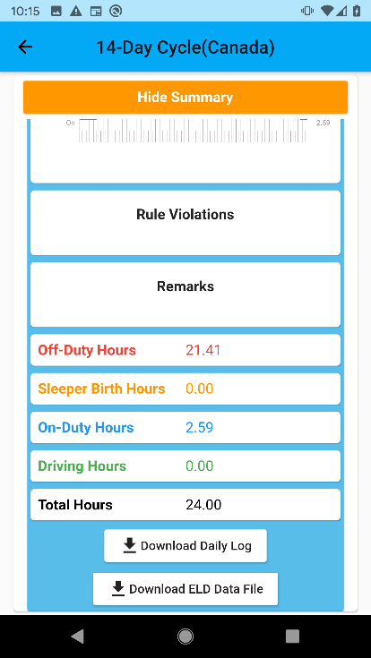
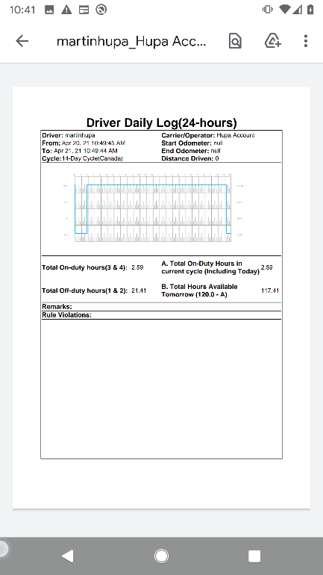
Pressing the button will download the daily log report in pdf format which will look like the screen as shown here to the right:
Pressing the button will download the ELD data file in csv file and redirect to the following screen ( as shown below) where drivers will be able to transfer the ELD file using the Wireless Web Services or Email to FMCSA.
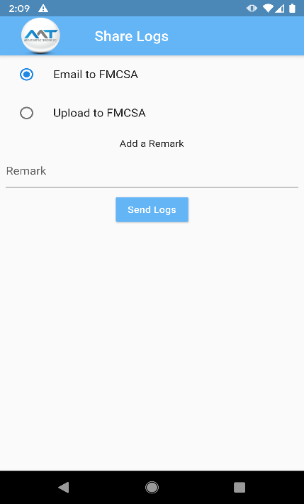
Choosing an email option will open an Interface for selecting an option that can email the file to the safely officials’ email address.
Choosing the upload to FMCSA option will upload file to the FMSCA using the provider certificate and registration ID.

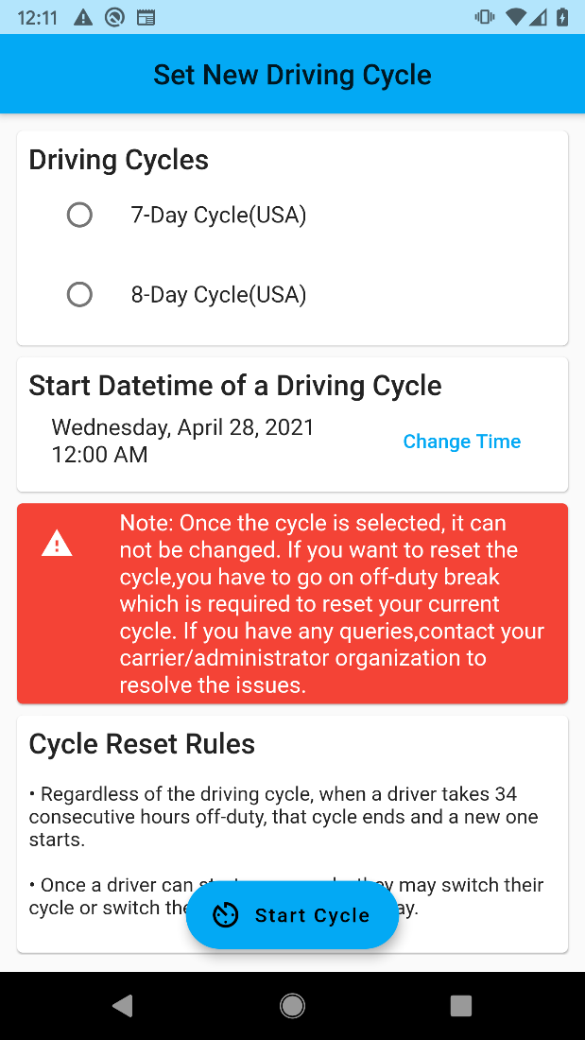
HOS Feature
Once the Driver has selected the vehicle they wish to use. They will be taken to the main HOS screen and will be automatically set to on-duty.
If the driver has not yet selected a cycle, or if a previous cycle has ended due to cycle reset rule (meaning staying off-duty after a consecutive 34 hours of off-duty status) a new select cycle page will appear asking the driver to select the new cycle they would like to use.
Set New Cycle Screen:
Whenever the driver begins a new cycle there will be a pop-up screen providing an option and letting the driver know they can change their cycle type.

HOS Screen
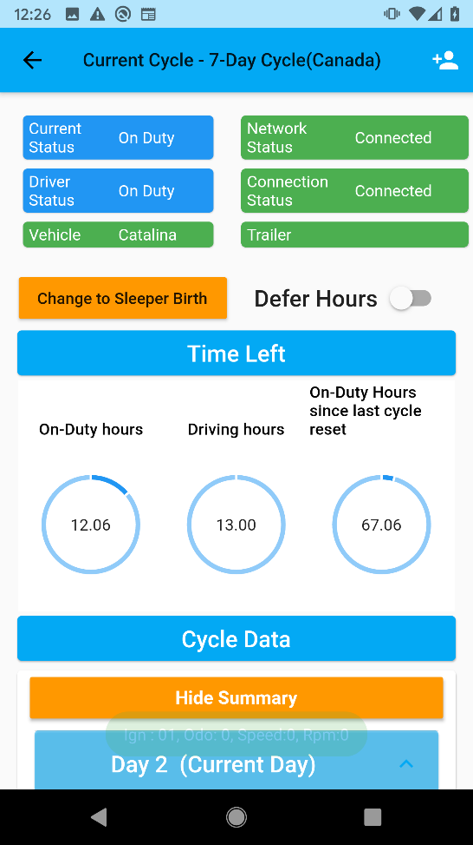
The AAT HOS screen will automatically be monitoring the driver duty status and hours to help stay in compliance with the selected Hours of Service Regulations.
The current cycle selected will be displayed at the very top. The cycle can be changed (if the driver is starting a new cycle) by the set new cycle screen that appears.
Current Status will show the driver’s current status.
Driver will display the Driver that is logged into the application
Vehicle will display the vehicle that the application is interacting with.
Connection Status represents the connection between the Driver’s application and the AAT hardware plugged into the vehicle.
Network Status represents internet status of the ELD device.
Trailer represents the trailer that is currently attached to the vehicle.
The Defer Hours option becomes active when it applies and can be applied by the driver when their present hours of usage makes this option available. It will not be available if the driver is currently not permitted to Defer Hours.
If the driver chooses to exercise this option when it becomes available, they just need to toggle it to the ON position. If the Driver later change’s their mind, they can just toggle it back to OFF if they do not need this feature implemented.
The driver’s current HOS status will be displayed on the time graph. With the total hours accumulated to the right of the time of the graph. This graph and page will automatically update based on the driver’s status.
Any violations that do occur will be displayed in the Violation Status Window and will stay there for the entire day. The Violation Status Window will be cleared on the next day.
Violations will also be recorded in the AAT System and can be viewed in Reports or set-up to alert the proper parties.
The three round graphs in the middle of the screen represents the On Duty, Drive, and Remaining Time in the entire Cycle. They are larger and more visible for the Driver to be able to gauge their time left as they drive. Alerts will also sound when the driver approaches the maximum threshold so as not to distract the driver from their regular duties.
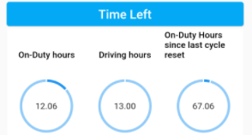
In order to exit the HOS section, the Driver must tap the back button in the top left corner. If the driver exits accidentally, they can easily just log back in through the same process and the app will pick-up where it left off.
Additional Drivers
Logging in as a Passenger or Additional Driver on one Device
Once one driver has logged in and is on-duty by entering the HOS screen, an additional driver can log-in if needed by selecting the add-driver button.
Once on the main HOS screen, all drivers will automatically be On-Duty until Logging off.
If the driver needs to complete a DVIR report, they just need to open the DVIR application and follow the following steps.

DVIR Feature
Vehicles Screen DVIR Report
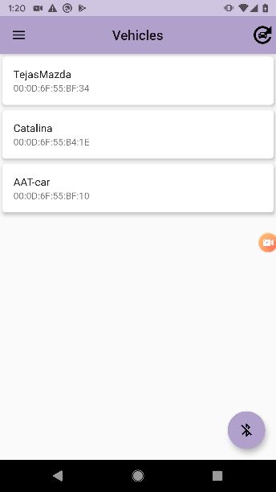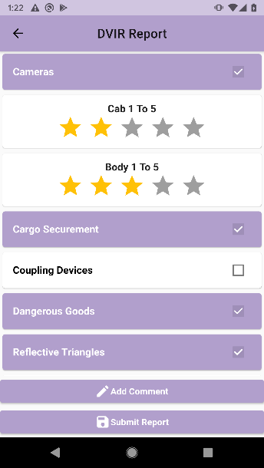
If driver wants to perform the DVIR then driver can login through login page as described above in login section through their Android or iOS device. Then drivers can tap on the vehicle they want to perform inspection for. After selecting the vehicle they want to perform the inspection on, they will be redirected to the DVIR report screen.
Once they are on the DVIR report screen, they can fill the inspection form and add any comments necessary.
By pressing Submit Report they will be prompted to provide their signature which will be used to sign the report digitally. The finalized report will be delivered to the respective officials which can be configured by the admin authorities through the AAT Website using their admin login.
Setting up the Driver Vehicle Inspection Report
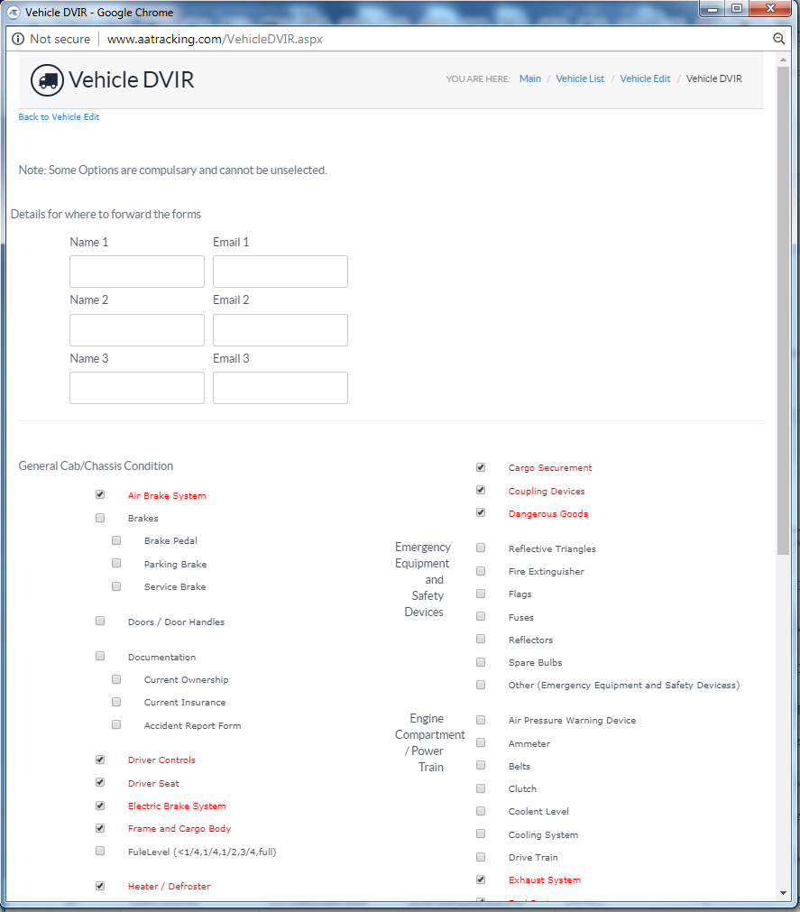
Drivers can view or setup what options each vehicle should have checked by accessing the AAT system.
After logging in, navigate to the Vehicle List, then select the vehicle that is to be edited by clicking the ‘edit’ link next to the vehicle. Then scroll to the bottom of the vehicle edit page and select Vehicle DVIR.
On the following page that opens, the User can now select what attributes the driver should check-off when they are inspecting their vehicle each day.
Viewing Driver Reports
To view past or Real-Time Driver reports from the AAT system login, the User must access the Driver List Page information screen. And select the View button under the Stats heading. This will bring up the Driver’s current driven hours. Different time frames can be searched for by changing the schedule/date field.

Internet Connection
If an internet connection is not available for the device running the HOS application, the Application will continue to work and communicate with the AAT in-vehicle device. Then, when connection is re-established, the saved data will be updated to the AAT Online System.

Setting up Drivers and Additional Options
All set-up and additional driver options are available by logging into the AAT System.
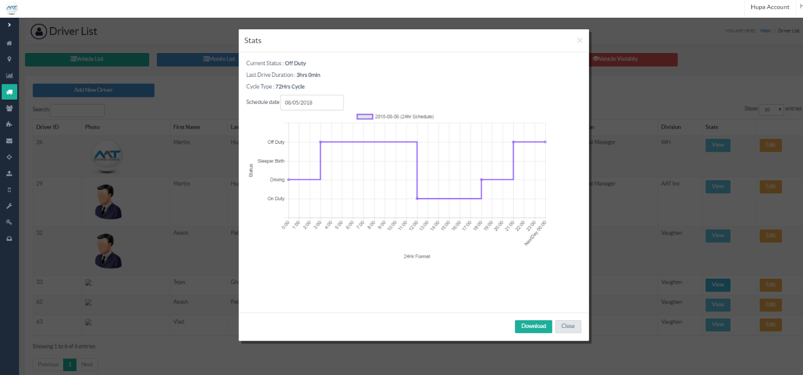
Anybody with the proper admin credentials, can log into the AAT system to edit the driver or vehicle settings.
The User must access the Driver List Page information screen, select the appropriate driver and see the additional options available:
Personal Use enabled – has to be set by admin and scheduled
Yard Moves enabled – has to be set by admin and scheduled
Users can edit and select where log files get sent for each driver as well.
Drivers have the ability to edit the Carrier information if permitted in their account settings. Under Driver List in the AAT system in the Driver Edit section, the following Carrier values and options can be changed.
Carrier name
Carrier DOT/MTO/Number
Main Office Address
Phone Number
Home Terminal Driver Details.
Home terminal time zone
Changing Units of Distance – can be changed per User login so that each User or driver see’s units in km or miles.
Unidentified Driving Events
If the Driver forgets to login and sets the vehicle in motion, the AAT system will know that a vehicle has been moved without proper procedure and will send Alerts to all interested parties that have been set-up through the AAT System.
The in-vehicle devices can also be set to alarm. The ELD device, when pre-set to the vehicle it is in, will notice there is movement without login and prompt a visual and audible warning to let the driver know to stop and login to the device.
In order to apply these accounted-for driving hours, someone will have to login to the AAT system and apply the hours from the ‘un-identified’ driver to the correct driver.

