CROMPTON
SYSTEMS

ELD Manual

Product: ELD24K
Model: HDV100A3

Table of Contents

Chapter 1: Shift Start Operations .......................................................................... 4
1.1 Powering on the Device ..................................................................................... 5
1.2 Login Screen ..................................................................................................... 6
1.3 Log in Process ................................................................................................... 7
Chapter 2: Daily Operations .................................................................................. 9
2.1 System Menu ..................................................................................................... 10
2.2 Operations .......................................................................................................... 11
2.3 Department of Transportation Data Requests ................................................... 12
Chapter 3: Making Data Changes .......................................................................... 13
Chapter 4: Shift End ................................................................................................ 14
4.1 Signing Out of Device ....................................................................................... 14
Chapter 5: Troubleshooting .................................................................................... 16
5.1 Hardware Issues ................................................................................................ 16
5.2 Software Issues ................................................................................................. 18

Chapter 1: Shift Start Operations

In this chapter, we will go over the steps necessary to start the device and log in to the ELD software.
  - Starting Software

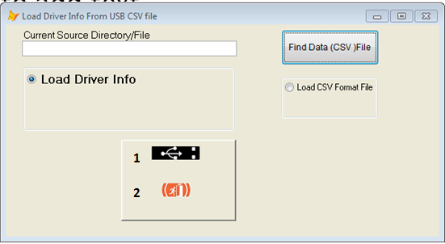
Figure 1.1 Load Driver Screen

- Load from USB
- Cancel

Steps to Start the Software

Before starting the software, insert your USB memory stick into the device. Upon starting the software, you will be taken to the Load Driver Screen. Select 1 to continue or 2 if you wish to cancel. The specific driver information will be loaded into the system. You will then be taken to the Login Screen.

1.2 Login Screen
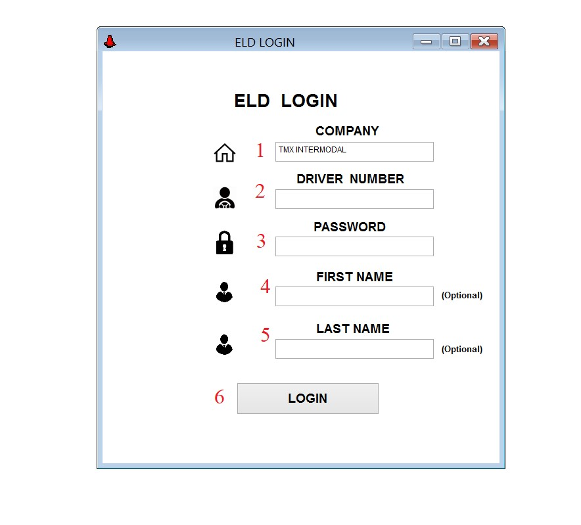
Figure 1.1 - Login Screen
- Company Name Field
- Driver Identification Number Field
- User Password Field
- User First Name Field
- User Last Name Field
- Login Button

1.3 Log in Process

Logging in is the first required action you must perform to access the variety of features in the ELD Software. You will need to provide your driver and truck information and perform a PreTrip Inspection before you are fully logged into the system.

Steps to Log into System
- Fill in the Company Name, Driver Number, and Password boxes with the appropriate information (Fields 1, 2, and 3 from Figure 1.1). If you do not have this information, or have forgotten it, refer to Chapter 5, Section 5.2 “Software Issues”.
- Fields 4 and 5 from Figure 1 are optional.
- Click the Login button (6 in Figure 1.1).
- You will be taken into the following Confirmation Screen:

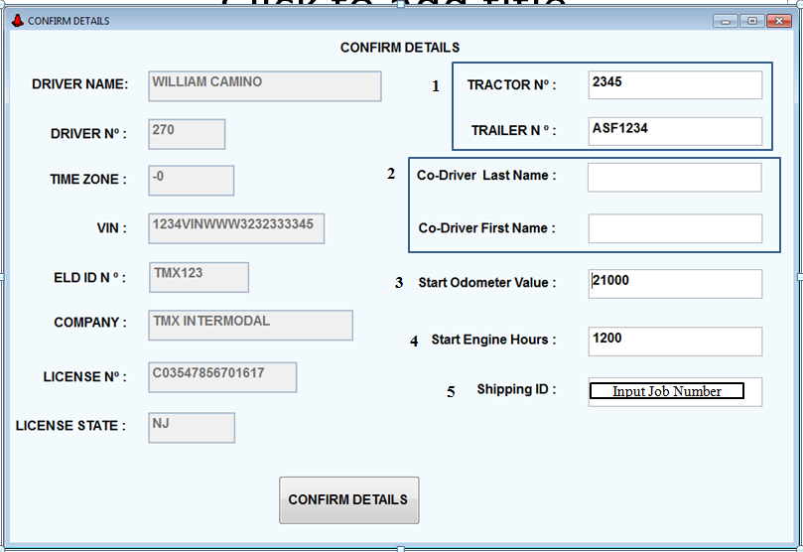
Figure 1.2 - Confirmation Screen
- Review details on this screen. Ensure all information is accurate and fill in the fields in the right column as follows:
Field 1 – Type in the Tractor and Trailer numbers
Field 2 – These are optional fields which can be left blank. However, they are required if you will be traveling with a second driver for long trips. Enter the first and last names of the co-driver.
Field 3 – Type in the truck’s odometer reading at your shift start.
Field 4 – Enter Start Engine Hours
Field 5 – Enter the Shipping ID for the receiver of this haul, which should be the job number.
- Click the Confirm Details button (bottom in Figure 1.2) if the information is accurate. If you do not have this information, or have forgotten it, refer to Chapter 5, Section 5.2 “Software Issues”.
- You will now enter the Pre-Trip inspection screen. If the software does not enter into the Pre-Trip inspection screen; refer to Chapter 5.2 “Software Issues.” You will use this screen to perform the mandatory inspections required before each trip, see figures 1.4a and 1.4b. Note, you must verify the conditions of the truck, chassis, and container are all satisfactory to proceed.
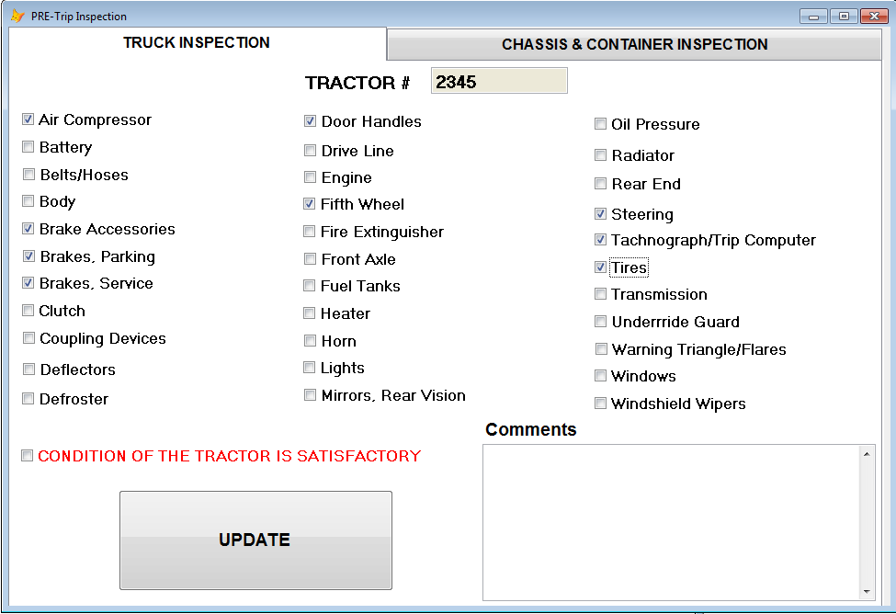
Figure 1.4a Pre-Trip Inspection Truck
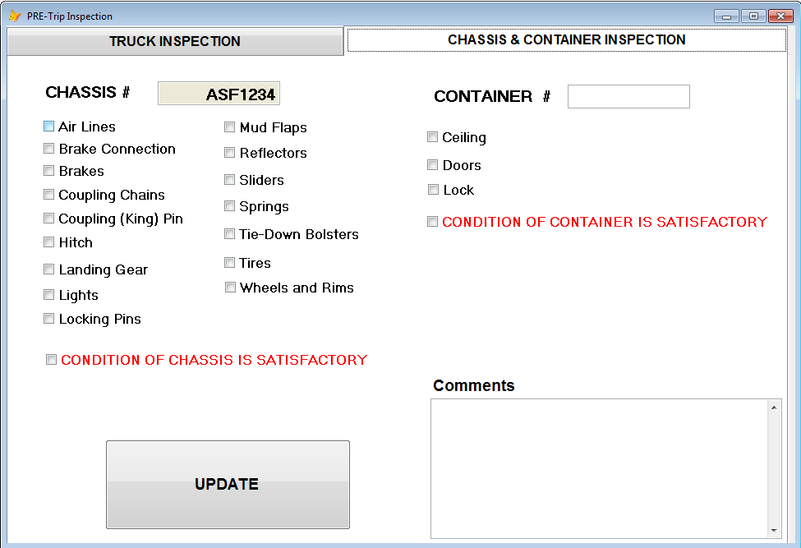
Figure 1.4b Pre-Trip Inspection Truck
- The first tab of the Pre-Trip Inspection, as shown in Figure 1.4a, is the Truck Inspection. You will need to press the empty box next to each component to check off that you have properly inspected that part. Once each component has been checked off, then also check off the “CONDITION OF THE TRACTOR IS SATISFACTORY” box. Enter any comments needed. Go to the second tab.
- The second tab of the Pre-Trip Inspection, as shown in Figure 1.4b, is the Chassis and Container Inspection. You will need to press the empty box next to each component to check off that you have properly inspected that part. Once each component has been checked off, then also check off the “CONDITION OF THE CHASSIS IS SATISFACTORY” box and the “CONDITION OF THE CONTAINER IS SATISFACTORY.” Enter any comments needed. Press the “Update” button
- You will be taken to the Main Menu Screen, see Chapter 2, Figure 2.1.

Chapter 2: Daily Operations

In this chapter, we will cover basic software functions required to perform your daily tasks and duties.

2.1 System Menu

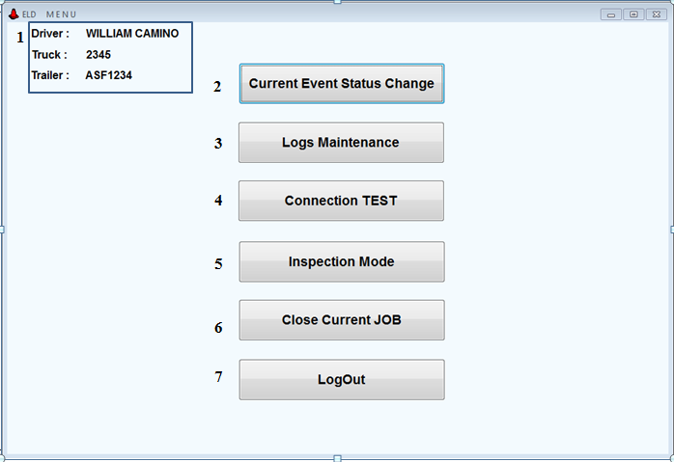
Figure 2.1 Main Menu Options
- User Information
- Current Event Status Change
- Logs Maintenance
- Connection Test
- Inspection Mode
- Close Current Job
- LogOut

Once the Pre-Trip Inspection is completed; you will enter the ELD Menu, Figure 2.1 Main Menu Options.
  - Current Event Status Change

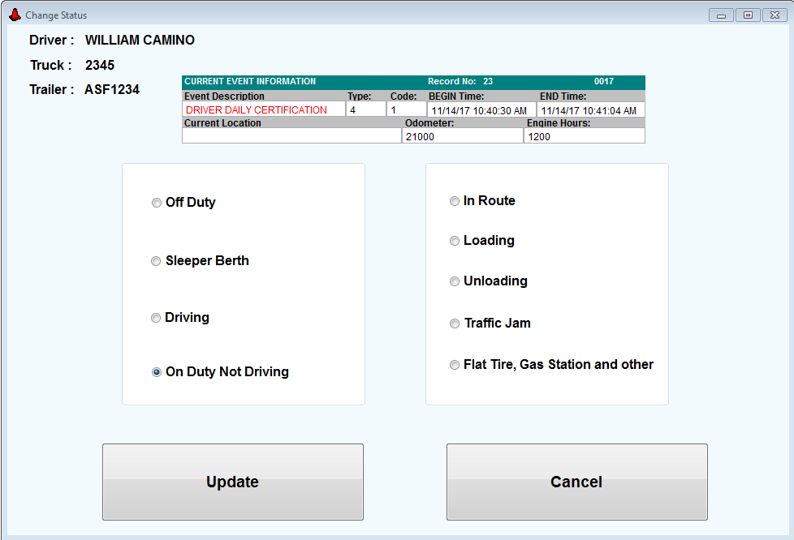
Figure 2.2 Change Status

You will update your status when your shift actions change. Whether you are performing the Pre-Trip/Post-Trip Inspection, loading, unloading, Off Duty, etc., you will need to let the system know.

Change Status Guide

- Press the “Current Event Status Change” button on the Main Menu (Figure 2.1). You will be taken to the Change Screen (Figure 2.2).
- Select one of the options in the left column.
- For the column on the left:
- Off Duty – Select after a trip is done and you are back at the base/waiting for your next trip.
- Sleeper Berth – Only applicable if the job requires a sleep section.
- Driving – Select when you are driving the truck. This option will also automatically update if the system detects that the truck is continuously moving.
- On Duty, Not Driving – Select while on duty and on the road but currently not driving because of natural stops or having to perform truck maintenance (this section will open the column on the right side).
- For the column on the right:
- In Route – Select while currently on your way to your destination.
- Loading – Select when destination is reached and when the truck is being unloaded.
- Unloading – Select when destination is reached and the truck is being unloaded.
- Traffic Jam – Select when heavy or stopped traffic is creating a delay.
- Flat Tire, Gas Station, Other – Select when stopped for fuel, maintenance, repairs, etc.
- Once you select the proper option, click the “Update” button on the bottom left of the screen to process the status change.
- If you accessed this screen by accident, or need to cancel the status change for any reason, press the “Cancel” button on the bottom right of the screen.

2.3 Logs Maintenance

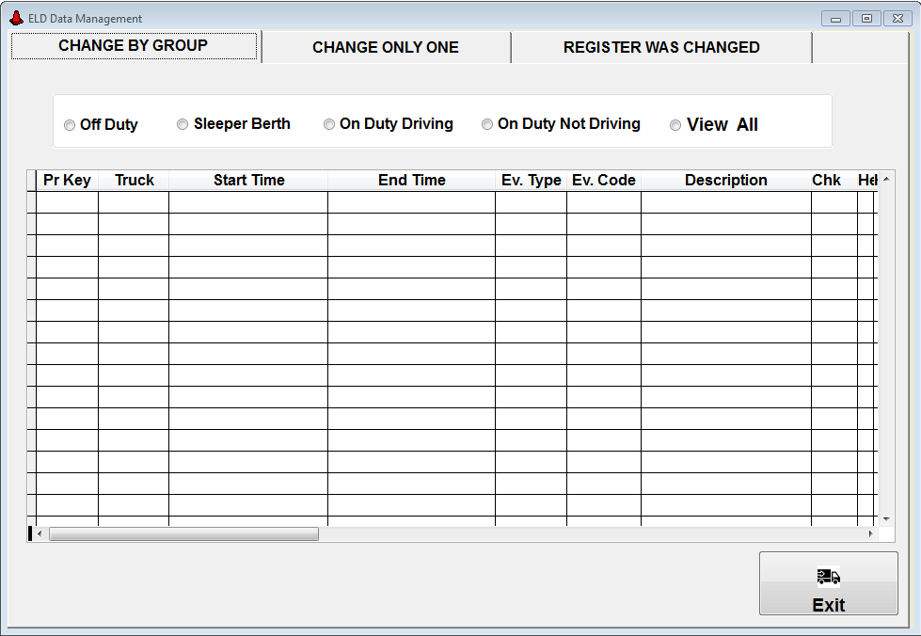
Figure 2.3 Log Maintenance

2.4 Connection TEST

2.4 Official Roadside Inspection
Figure 2.4, DOT Inspection Mode

During roadside stops by law enforcement or DOT officials, you may enter the Inspection Mode. You will need to be able to display and/or transmit the logs for your truck and travels for the last 7 days to this official.
- Press “Inspection Mode” button on the main menu screen (Option 5 in Figure 2.1). The DoT Inspection Screen will now appear (Figure 2.3).
- Select the “Begin inspection” button to start the inspection
- Select “Send Logs” button to send required information.

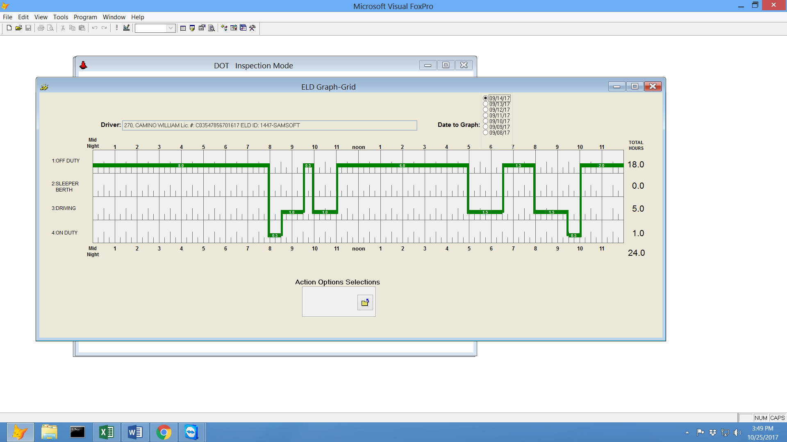
Chapter 3: Making Data Changes

In this chapter, you will learn how to make any changes or updates to the data in the system.

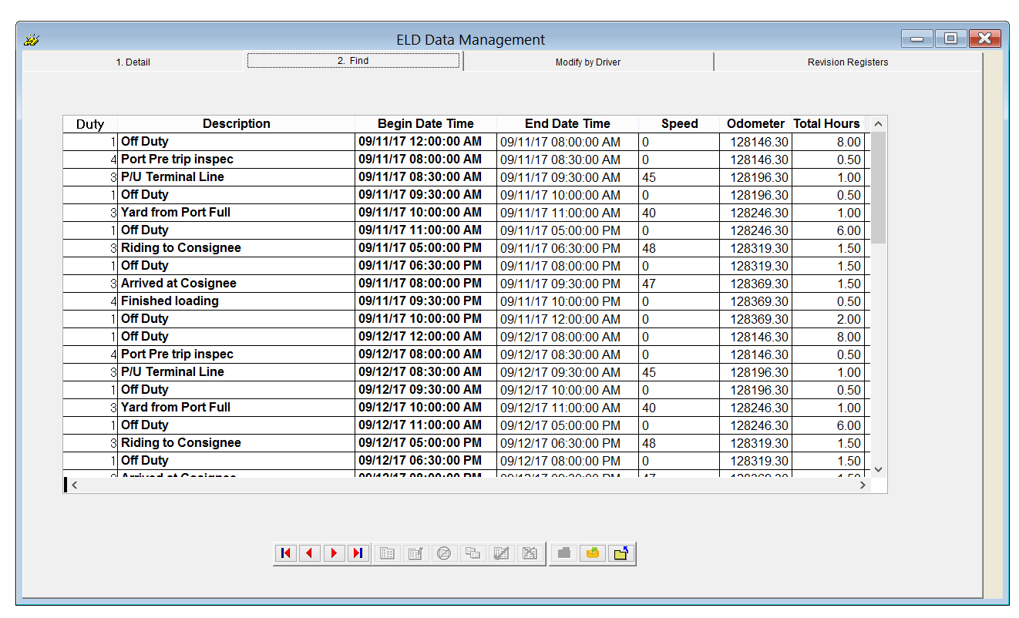

Chapter 4: Shift End

In this chapter, we will demonstrate how to sign out of the device and end operations for the day.
4.1 Signing Out of Device

You should log out of the system when it is time to close the current job or the end of your entire shift. You will be required to perform a post-trip inspection to ensure the proper state of the truck, chassis, and container.

Steps to Log Out of the System

- Press the “Log Out” button on the Main Menu (Figure 2.1). You will be taken to the Log Out Section Screen (Figure 4.1)
- If you are simply closing out the software at the end of a job, select the first option “Log out/Close Current Job.”
- If you have no more jobs scheduled for the day, you will instead end your shift. Select the second option “Log Out/Close Day.”
- Either option will require you to make a post-trip inspection to finalize.
- If you entered the Log Out Section Screen by accident, you can select the “Cancel” button to return to the main menu.

Chapter 5: Troubleshooting

In this chapter, we will cover common hardware and software issues with the system and ways to resolve them.
5.1 Hardware Issues
5.2 Software Issues

5.2 Software Issues
Section 1.3 (1) Steps to Log into System: If If you do not have login information, or have forgotten yours, contact the Information Technology Department (IT).
Section 1.3 (6) Steps to Log into System: If any information is incorrect or missing in the left hand column, you must contact the Safety Office/Point of Contact (POC) immediately with details and for guidance. All Information In the right column should be available in the truck, and on the chassis. If you need assistance, contact the Safety office/POC.

